**Learning memory and forgetting**

**Learning in LTM: Levels of processing**

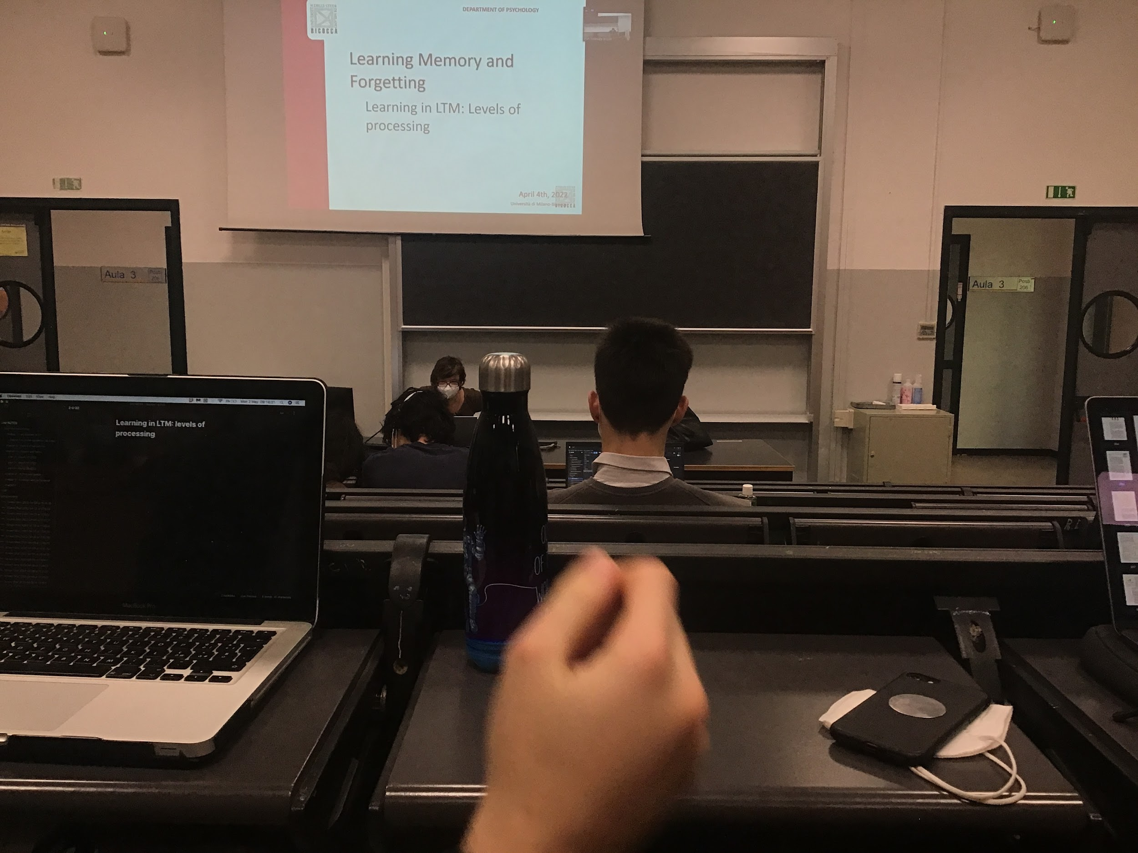

How we learn and transfer the information: **theory of levels of processing**: information is processed at different levels.

With **deeper levels** of processing we **remember better**.

Deeper level of processing: not simply reading and repeating but trying to understand connection with others level

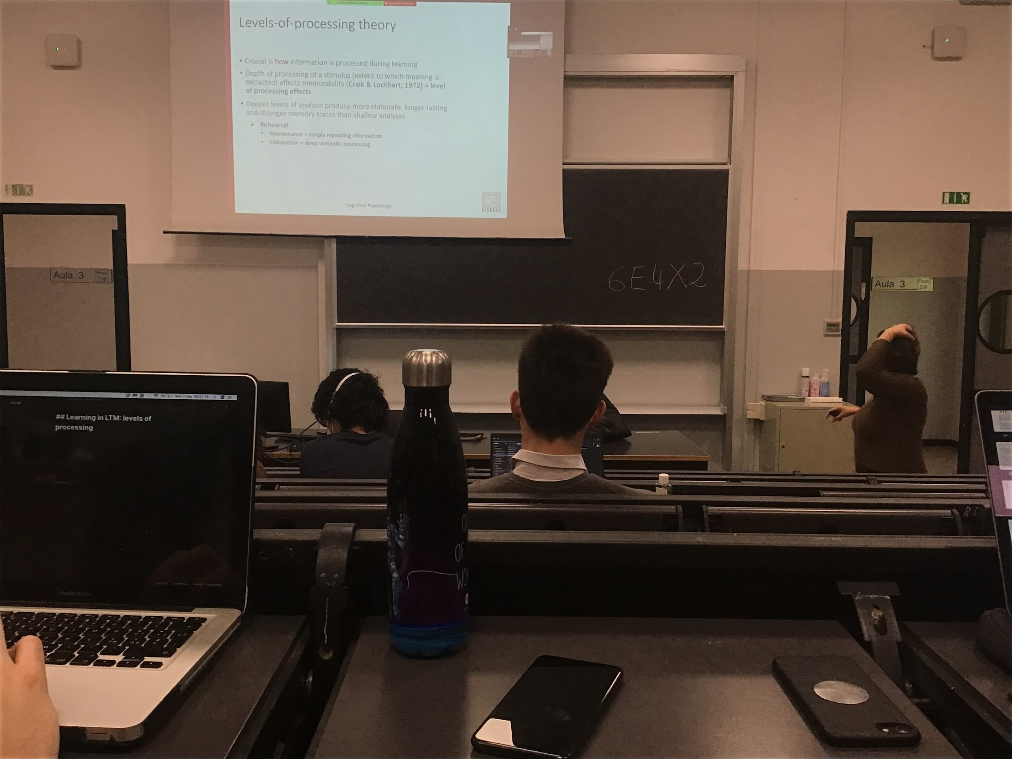

Rehearsal is not sufficient. Every time we encode and we try to remember something in long time memory and we want to be able to retrieve that information in the future we **need some deep coding**, we need to connect this information with something else

One way in which we consolidate our memory is thought retrieval. Try to recover information that we have stored. Not maximise our learning is important to test what we have memorised up to now

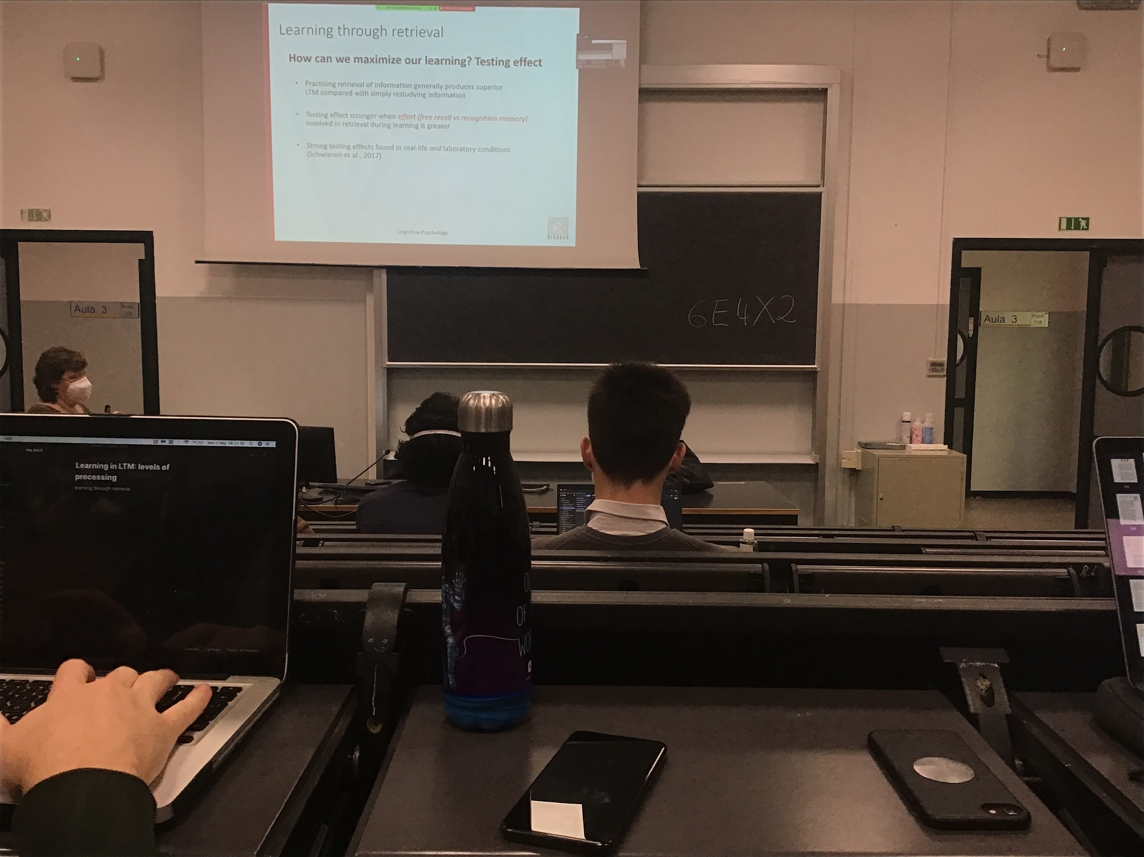

If you have to study one chapter of a book, you read, highlight… try to consolidate your memory. Re-study: re-ready and re-checking what is written in the chapter

If we compare this way of memorization with actually alternating studying and retrieving information and testing yourself on what you learn, testing helps you to remember much better. Testing effect is stronger, if you **need efforts to find out this information is even better**

The testing effect is important, find not only in the laboratory, is tested in real life, testing effect is very important

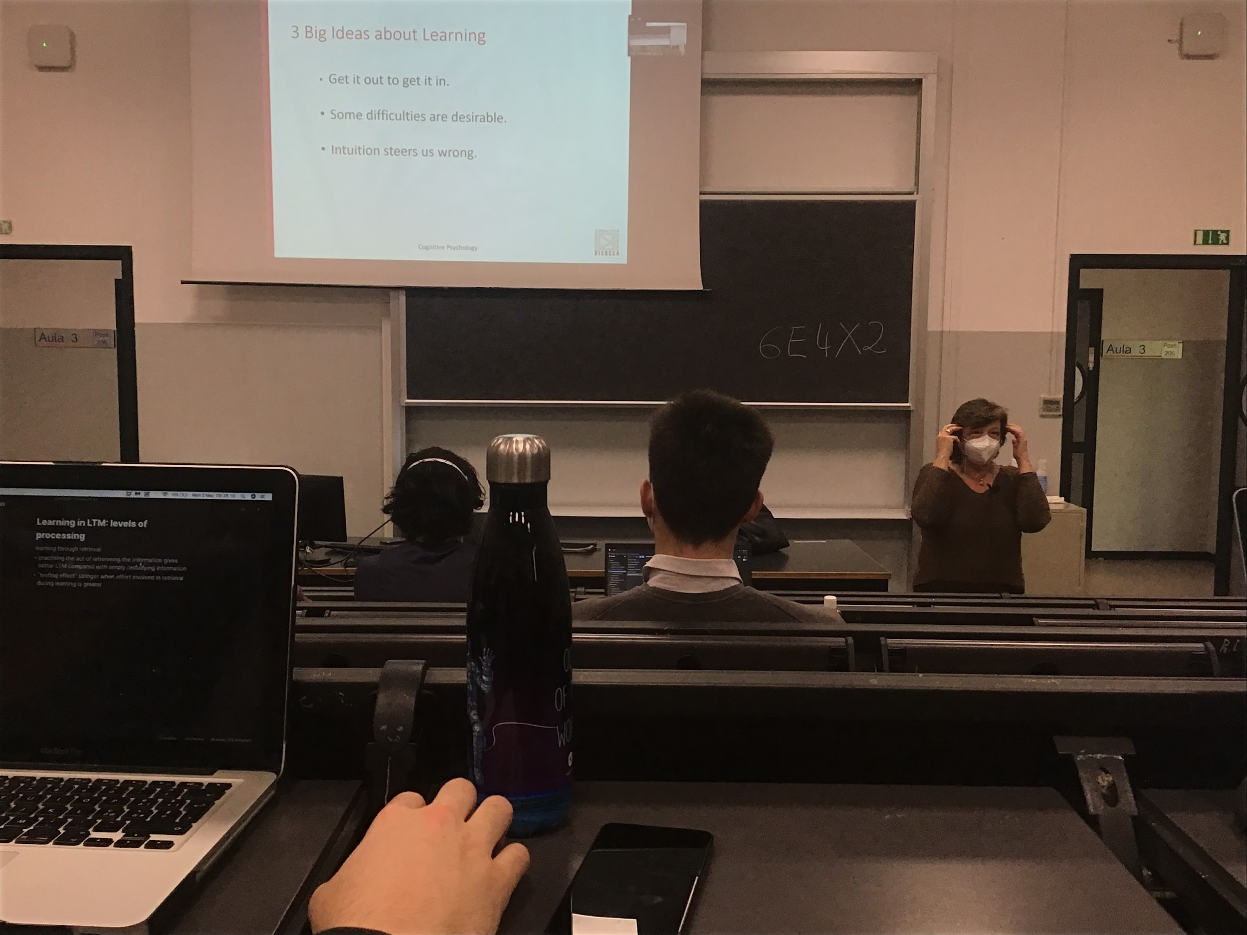

To remember what you have to study you have to retrieve it and answer questions, if the questions are a little bit challenging (not too easy) and you make some effort to try to retrieve the information that you remember is better. Sometimes intuitions does take us in the wrong direction

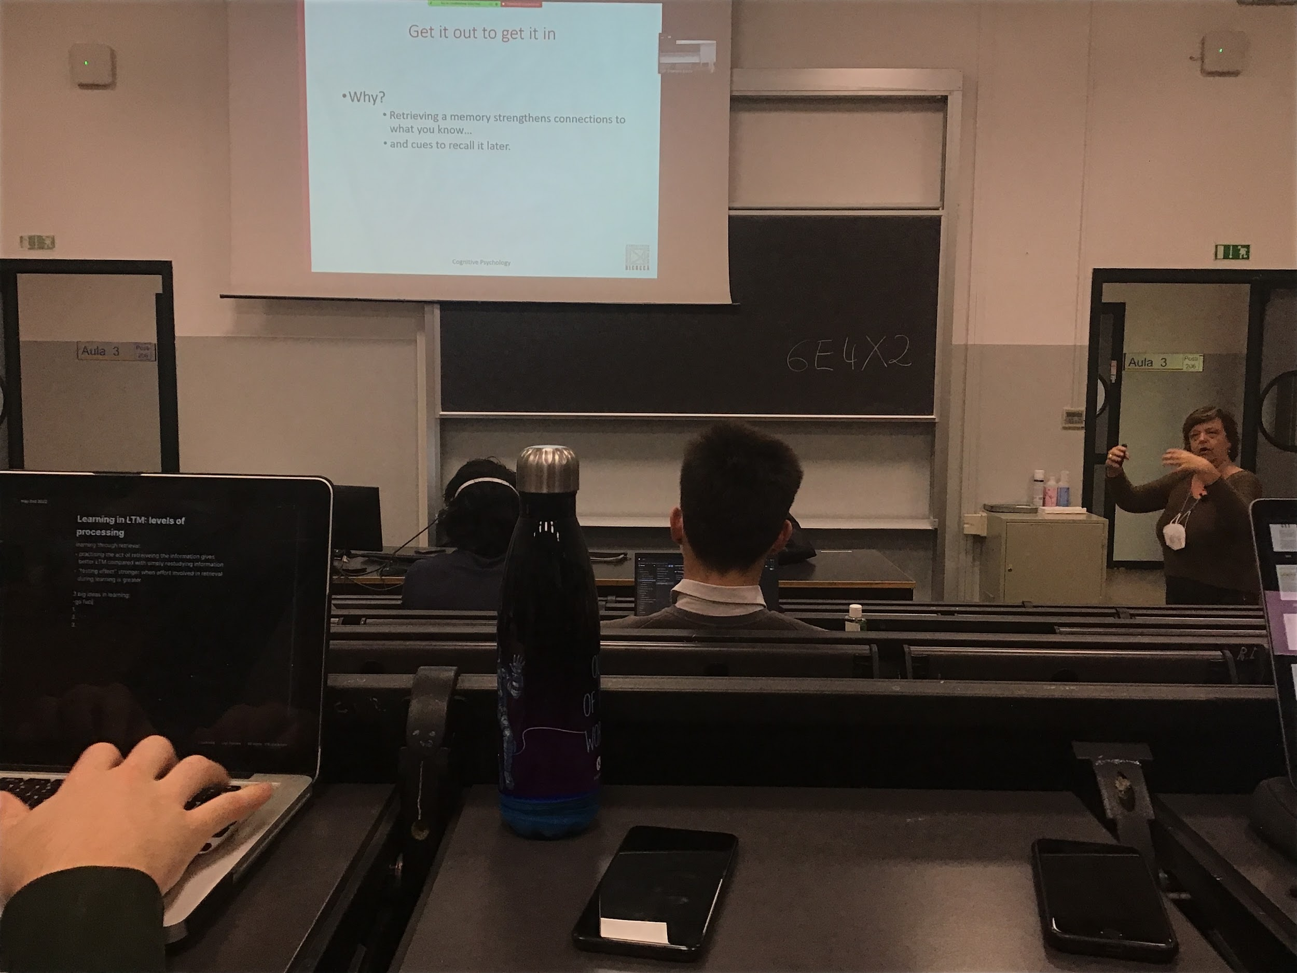

**Testing effect**: every time I extract a memory from the long time memory I strengthens the connection of what I know, find a way to retrieve the information and I strengthen the way, next time it will be easier to take it out

You know the path you have used to get the information, get some clues to retrieve the information later

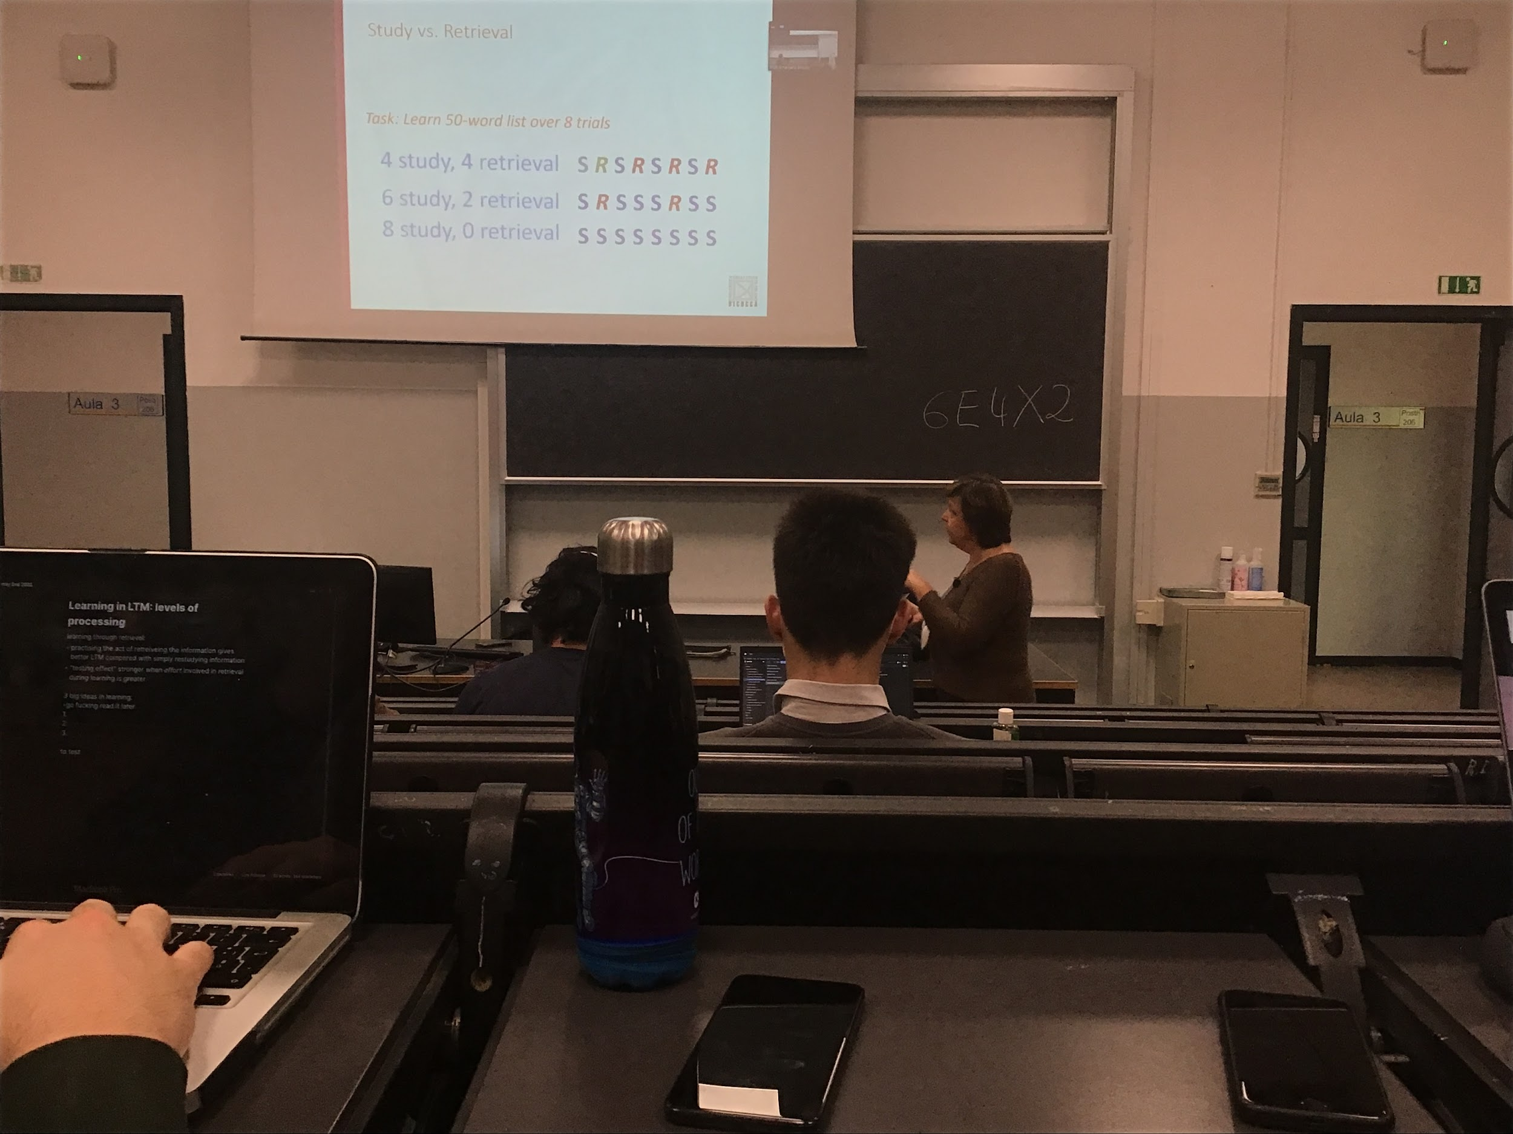

**Experiment**:

Have to learn a 50 word list. You have 8 trials (can try 8 times to study)

You can simply read it and repeat it 8 times, 8 sessions. You can study and repeat…

The amount of time for the 50 words list is the same time of studying, using the time in different way (sometimes you study sometimes you retrieve the information)

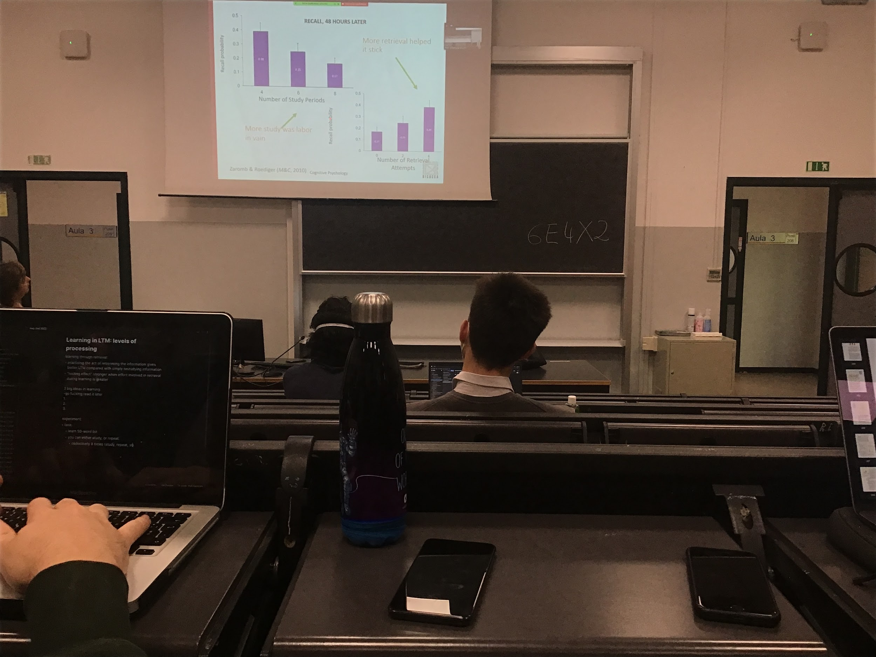

48 hours later

First graph: how many time you studied (with respect to studying + testing = 8),

You **recall more words when the time to study is less and you use the rest of the time to retrieval (testing)**

More retrieving you do more memorises you remember

Reading and repeating without testing your memory is not as efficient as studying and testing. Same amount of time, but you member more if half of the time you test

Reading without testing your memory takes a long and is not as assifucent as doing studying and testing

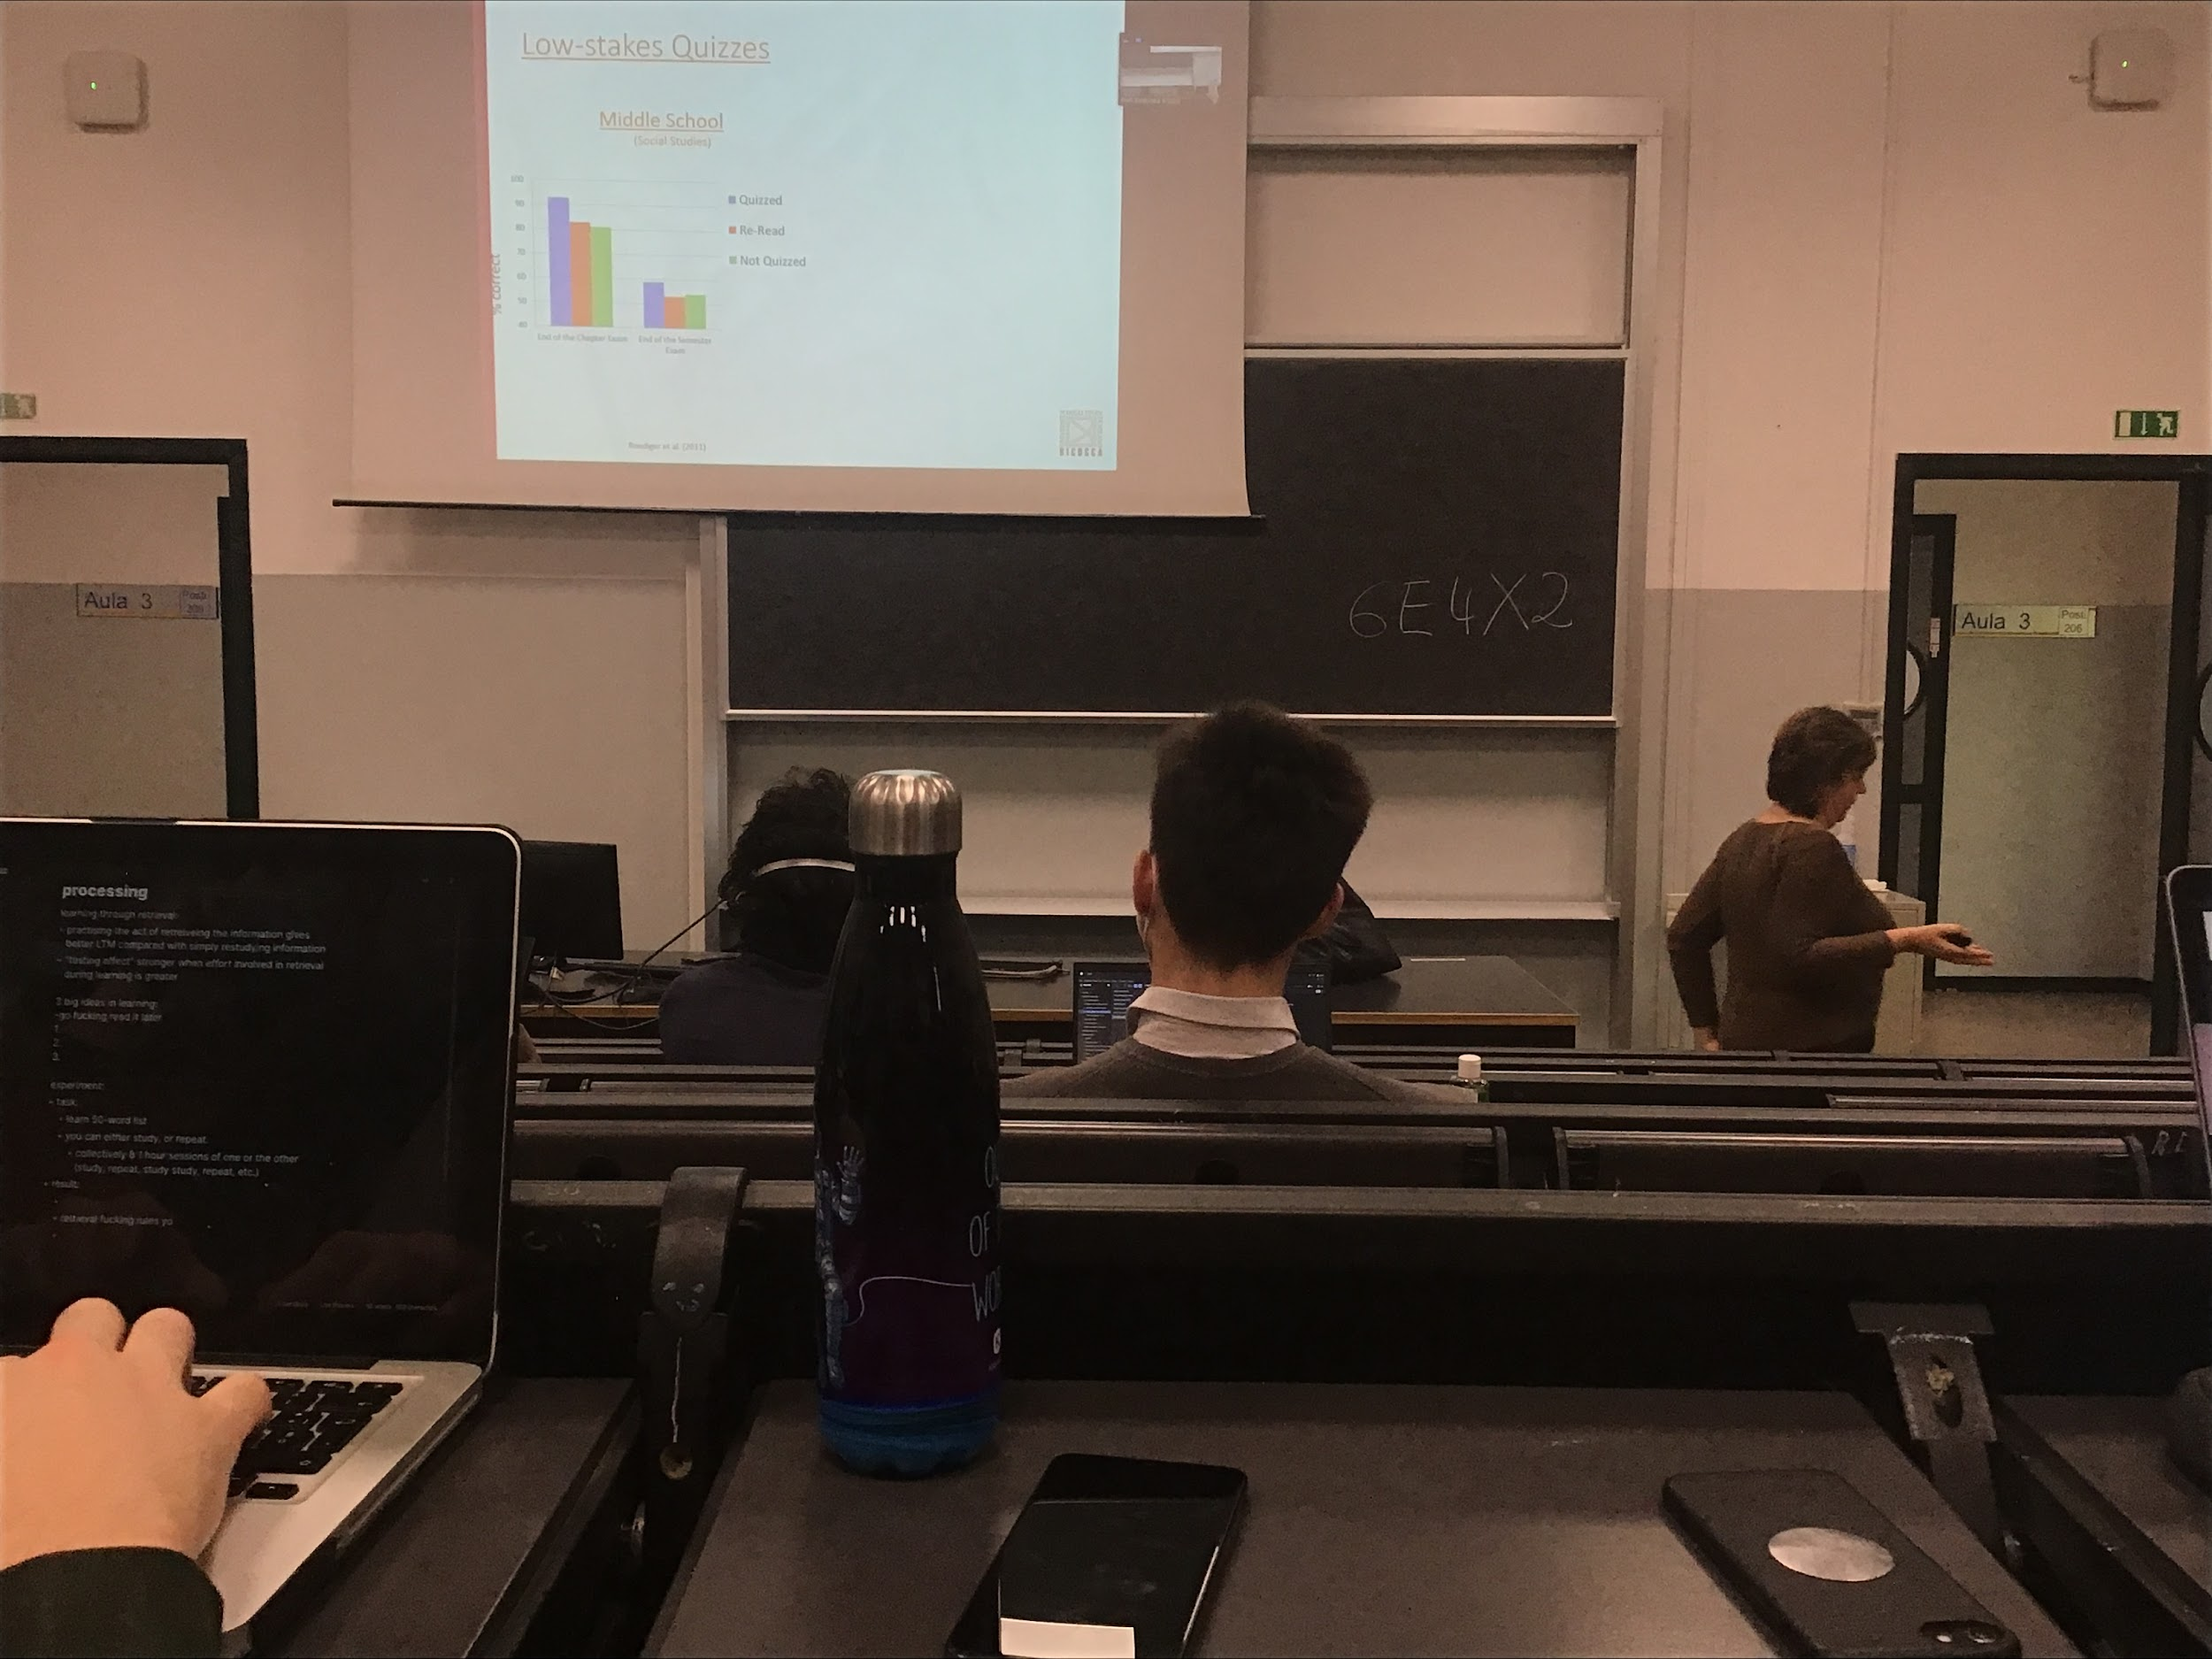

The best way to remember when is when you have (even very simple) **queezes**, **help you to go in memory and try to retrieve what you have stored**

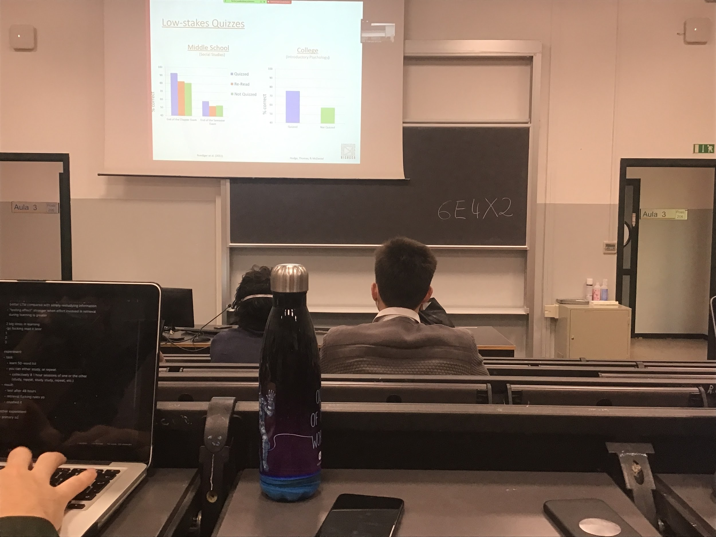

Same results in middle school and in college

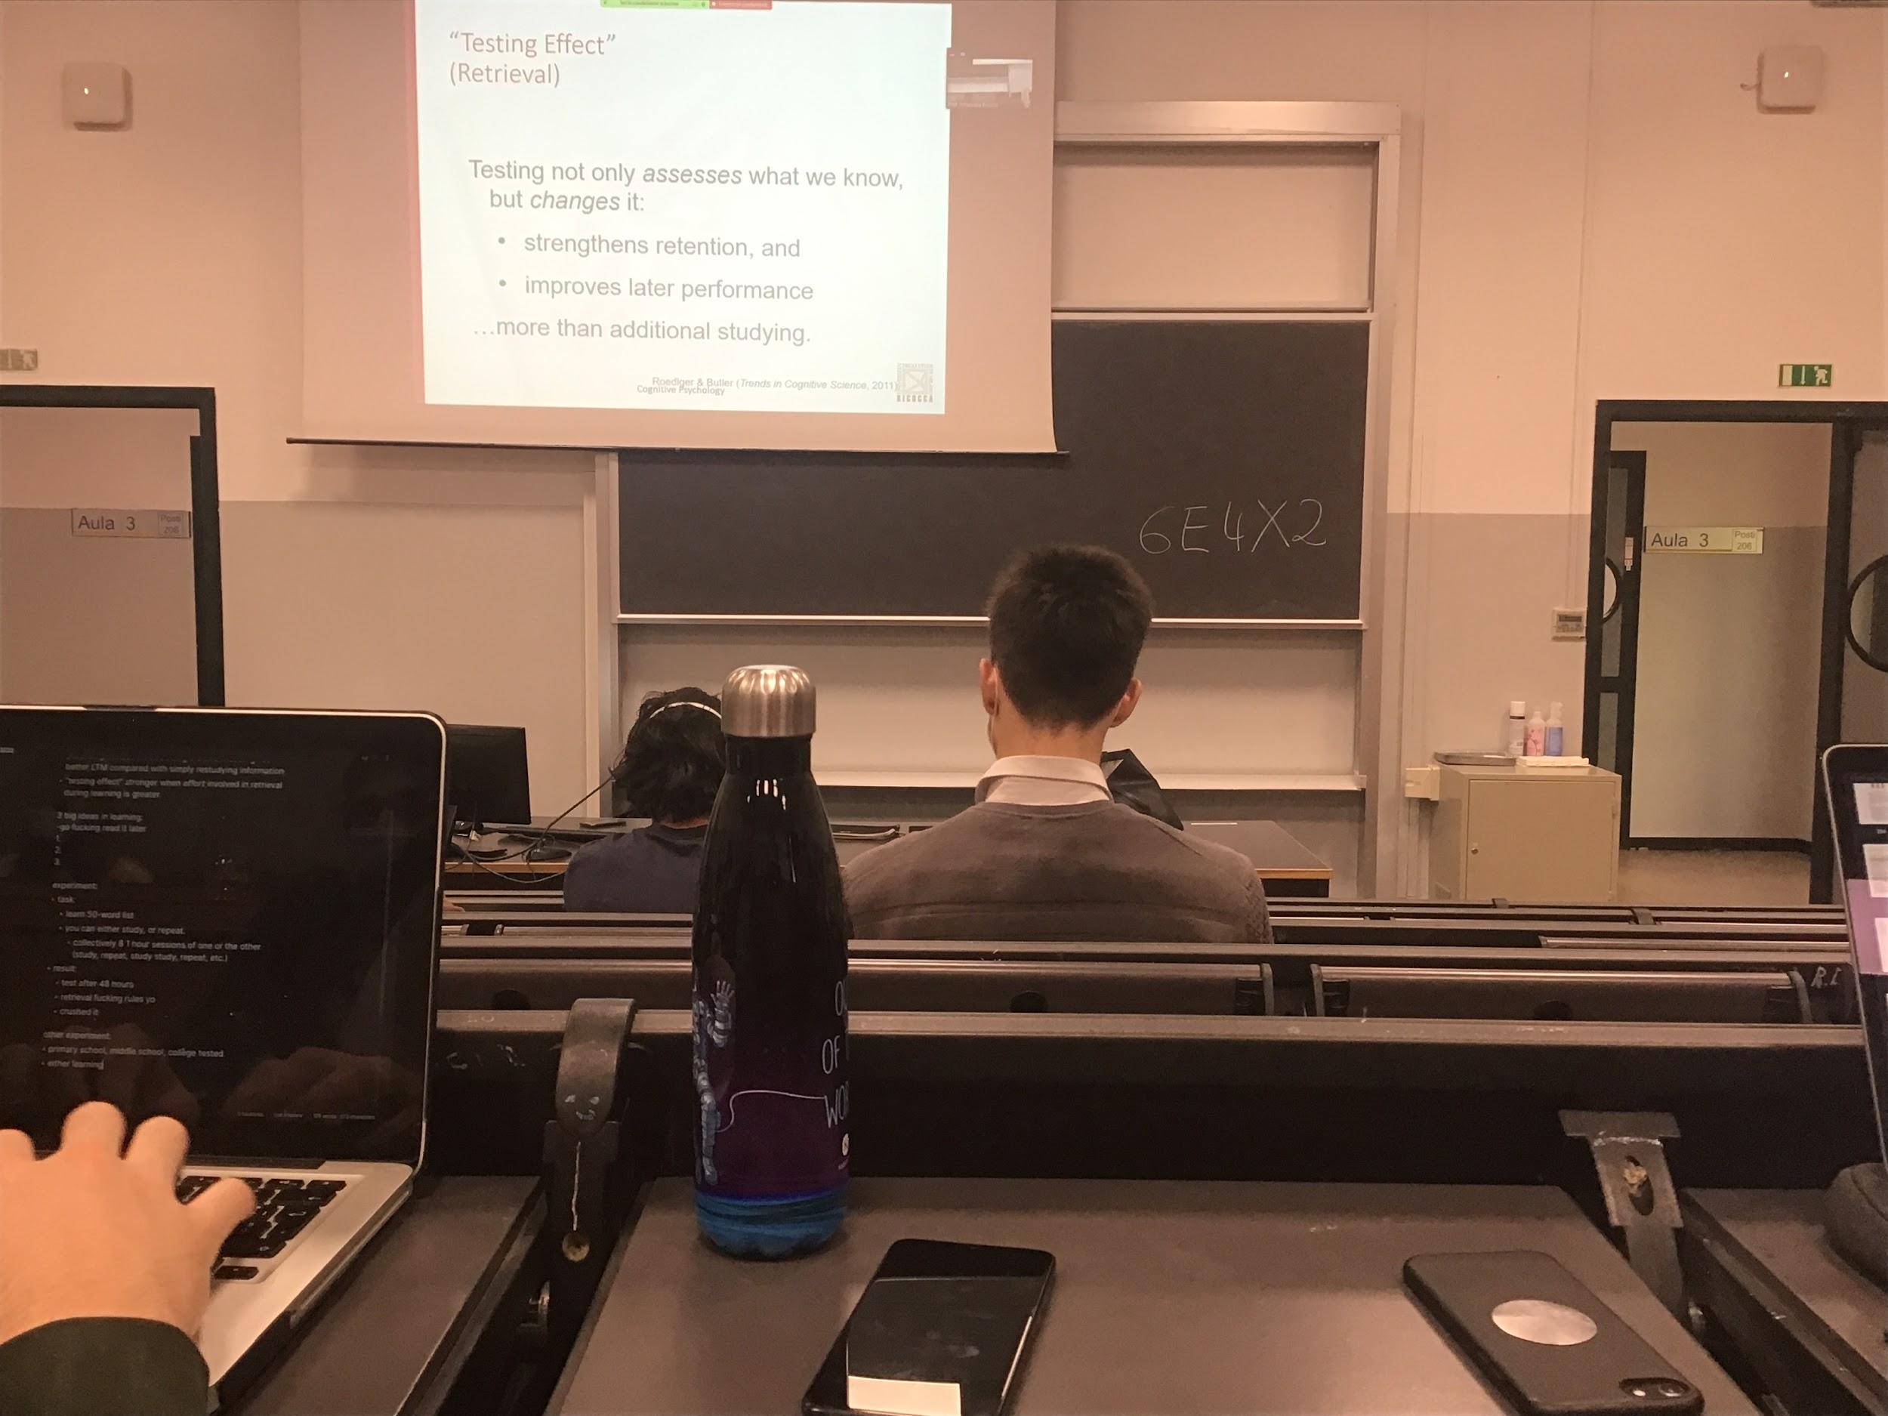

Every time we go and **access some information we reinforce the trace**, we maintain that information for a longer time, we strengthens retention

We access information and we try to reproduce and recall it

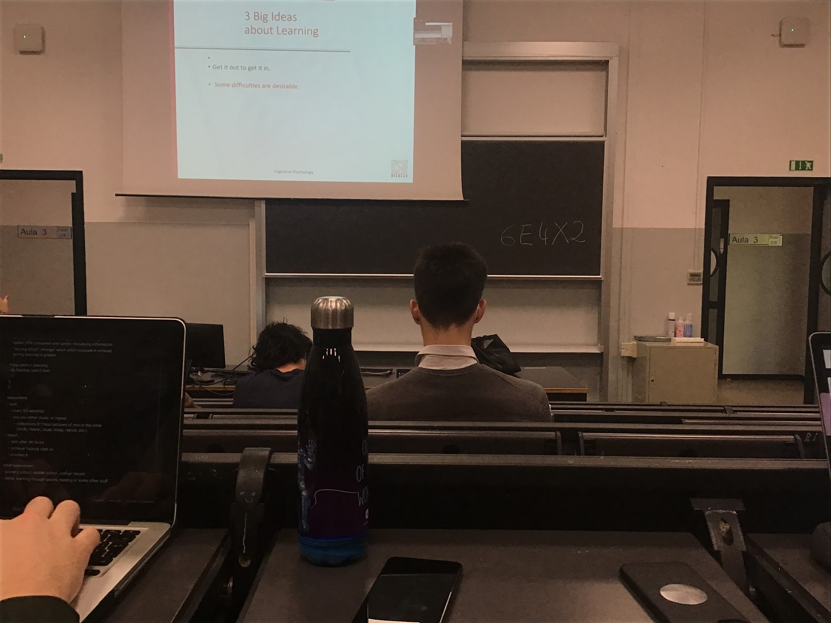

**Get it in is better then get it out**: to be able to remember is better to try to think about it.

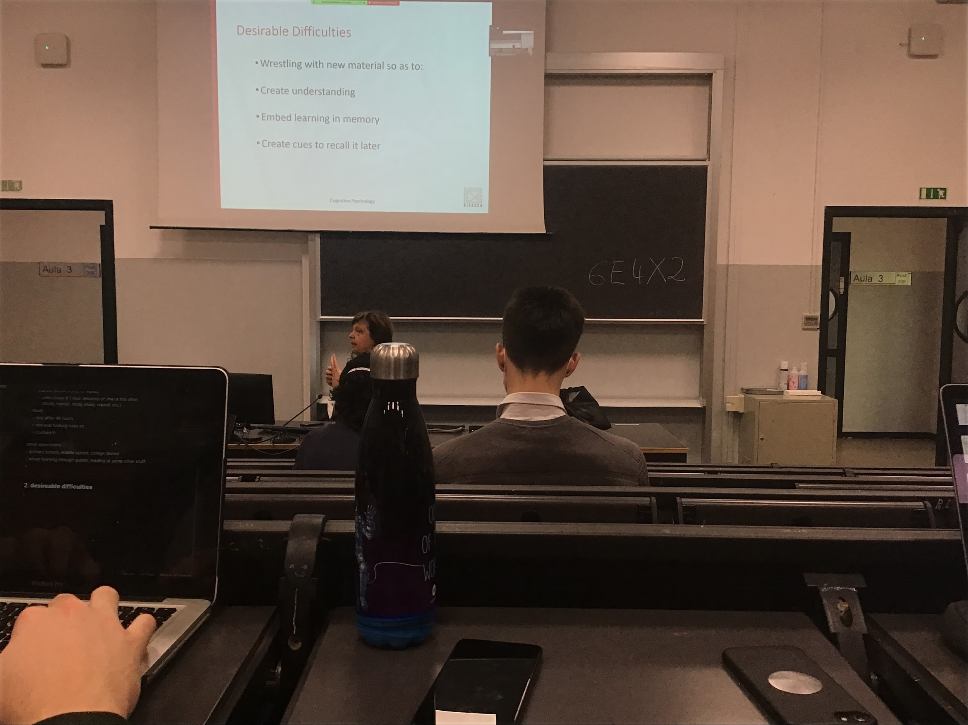

The **easy test not so efficient**, need some difficulties to improve memory, should take some effort to put together the memory that we have and create understanding and insert additional information in the memory and create ques to recall it later

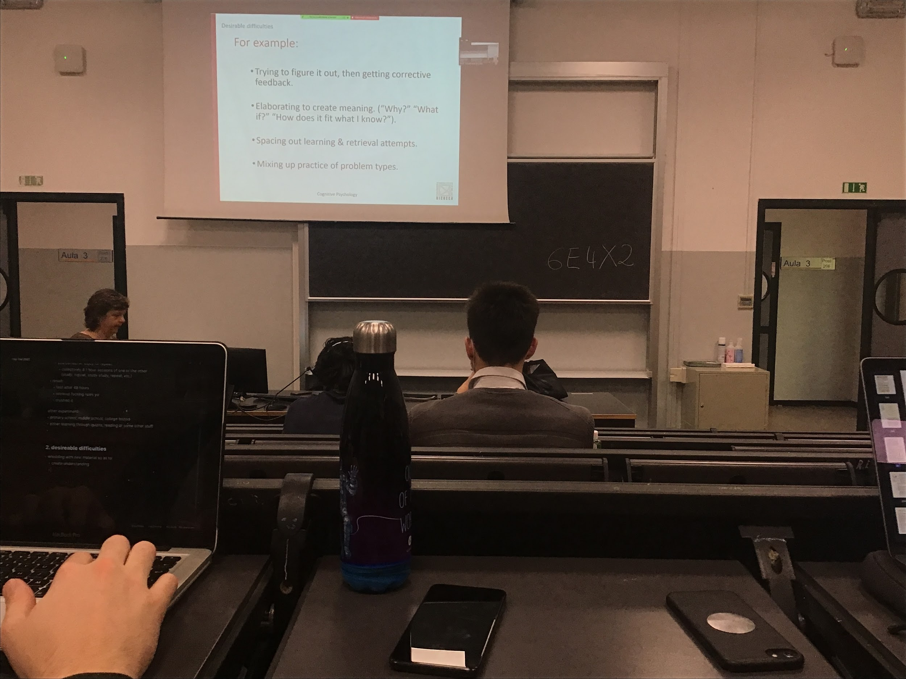

Important to look at a question, try to figure it out by yourself (reasoning about the different options) and try to understand the correct answer. **If you answer wrong you have to test why**

When you get an answer wrong usually we don’t check why we got it wrong, check why we got it wrong it helps you reset the correct information, reinforce the trace and integrate the information with many other option

Testing can help you also to understand why this information is like that

!!!!!!! Ask you what you did wrong in the written exam!!!!

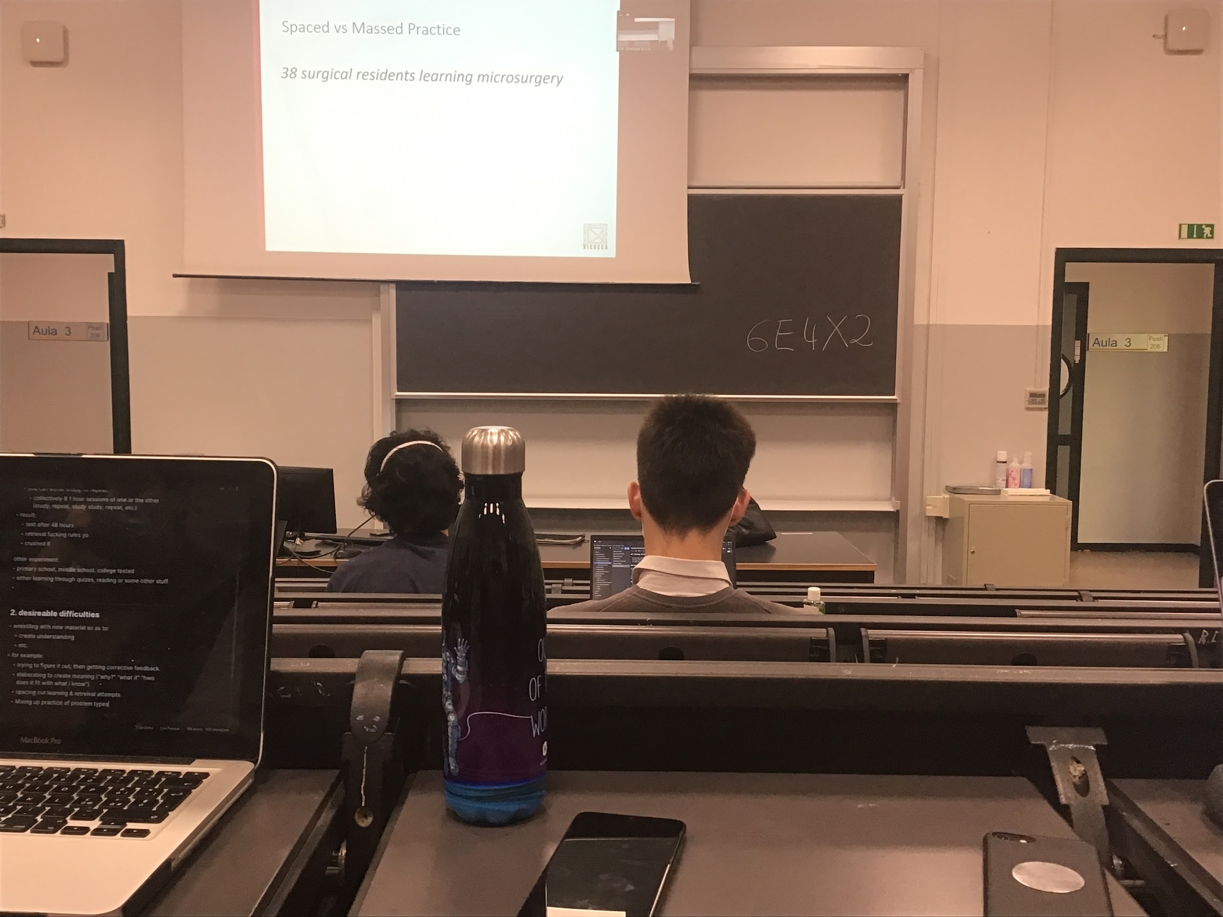

Important to space out learning and retrieval information. Studying need **time** to consolidate

Try to study a whole chapter in one evening even if you test it is not going to work. Need time for memory to consolidate.

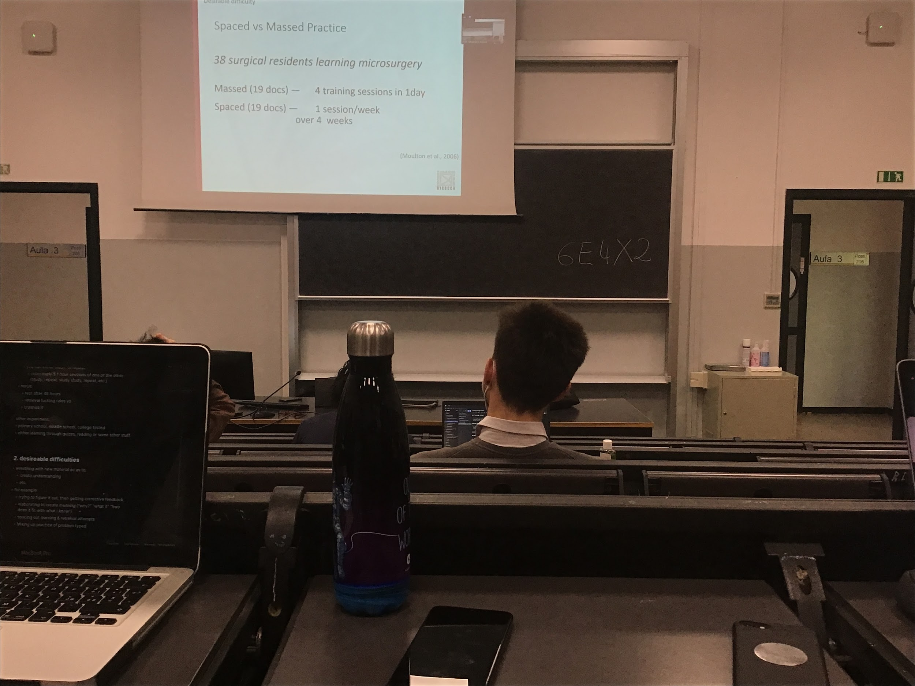

Experiment between **spaced and massed practice**:

Experiment done with doctors that are learning microsurgery.

* **Massed practice**: Some of them where training 4 times in 1 day
* **Spaced practice**: Same amount of doctors did the same hours of training but spaced out 1 week. 1 training a week

Amount of time dedicated to learn this new technique was the same, but 1 month later they have to demonstrate their microsurgical skill.

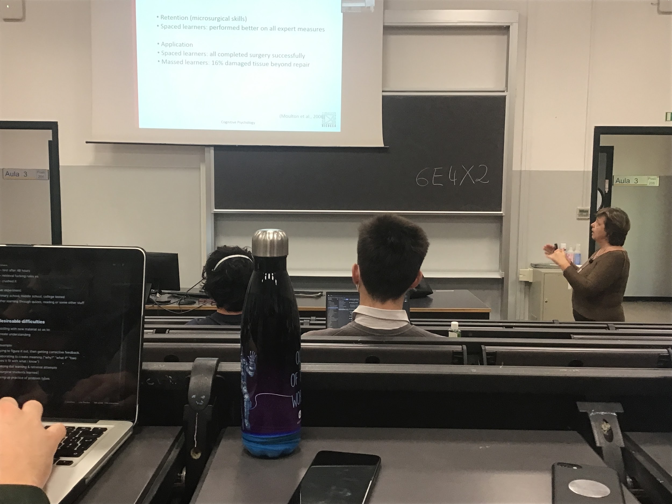

Result: the people who did **space training** (1 hour every week) **performed much better than the others**. They also performed the surgery perficely. **People with massed practice they made important mistake**

**Memory needs time to settle**, the traces that goes into memory need to be reinforced over time to be able to be retrieved later and stays longer

Distributed helps memory to stay stronger

A little bit of time every week of studying can be very helpful

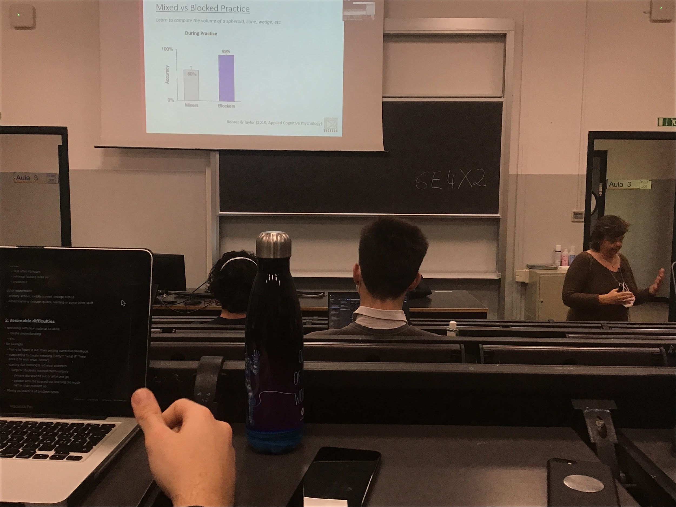

Experiment **mixed vs blocked practice**: have to learn different formulas of volumes of 3D objects

Different types of learners

* **Learn in blocks**: learn each formula one by one and do training
* **Learning everything**: do one exercise with the cube, one with the cone…

During practice it seems you are better if you learn one thing at the time (learn in blocks). This is the feeling that we have.

But when **tested later** if you are a **mixer you maintain your ability to recover (all) the information**. If you were a blocker and you learned one at the time you lose it very easy

Studying things not in blocks but trying to combine different types of information helps you to obtain a better result at the end when you will be tested

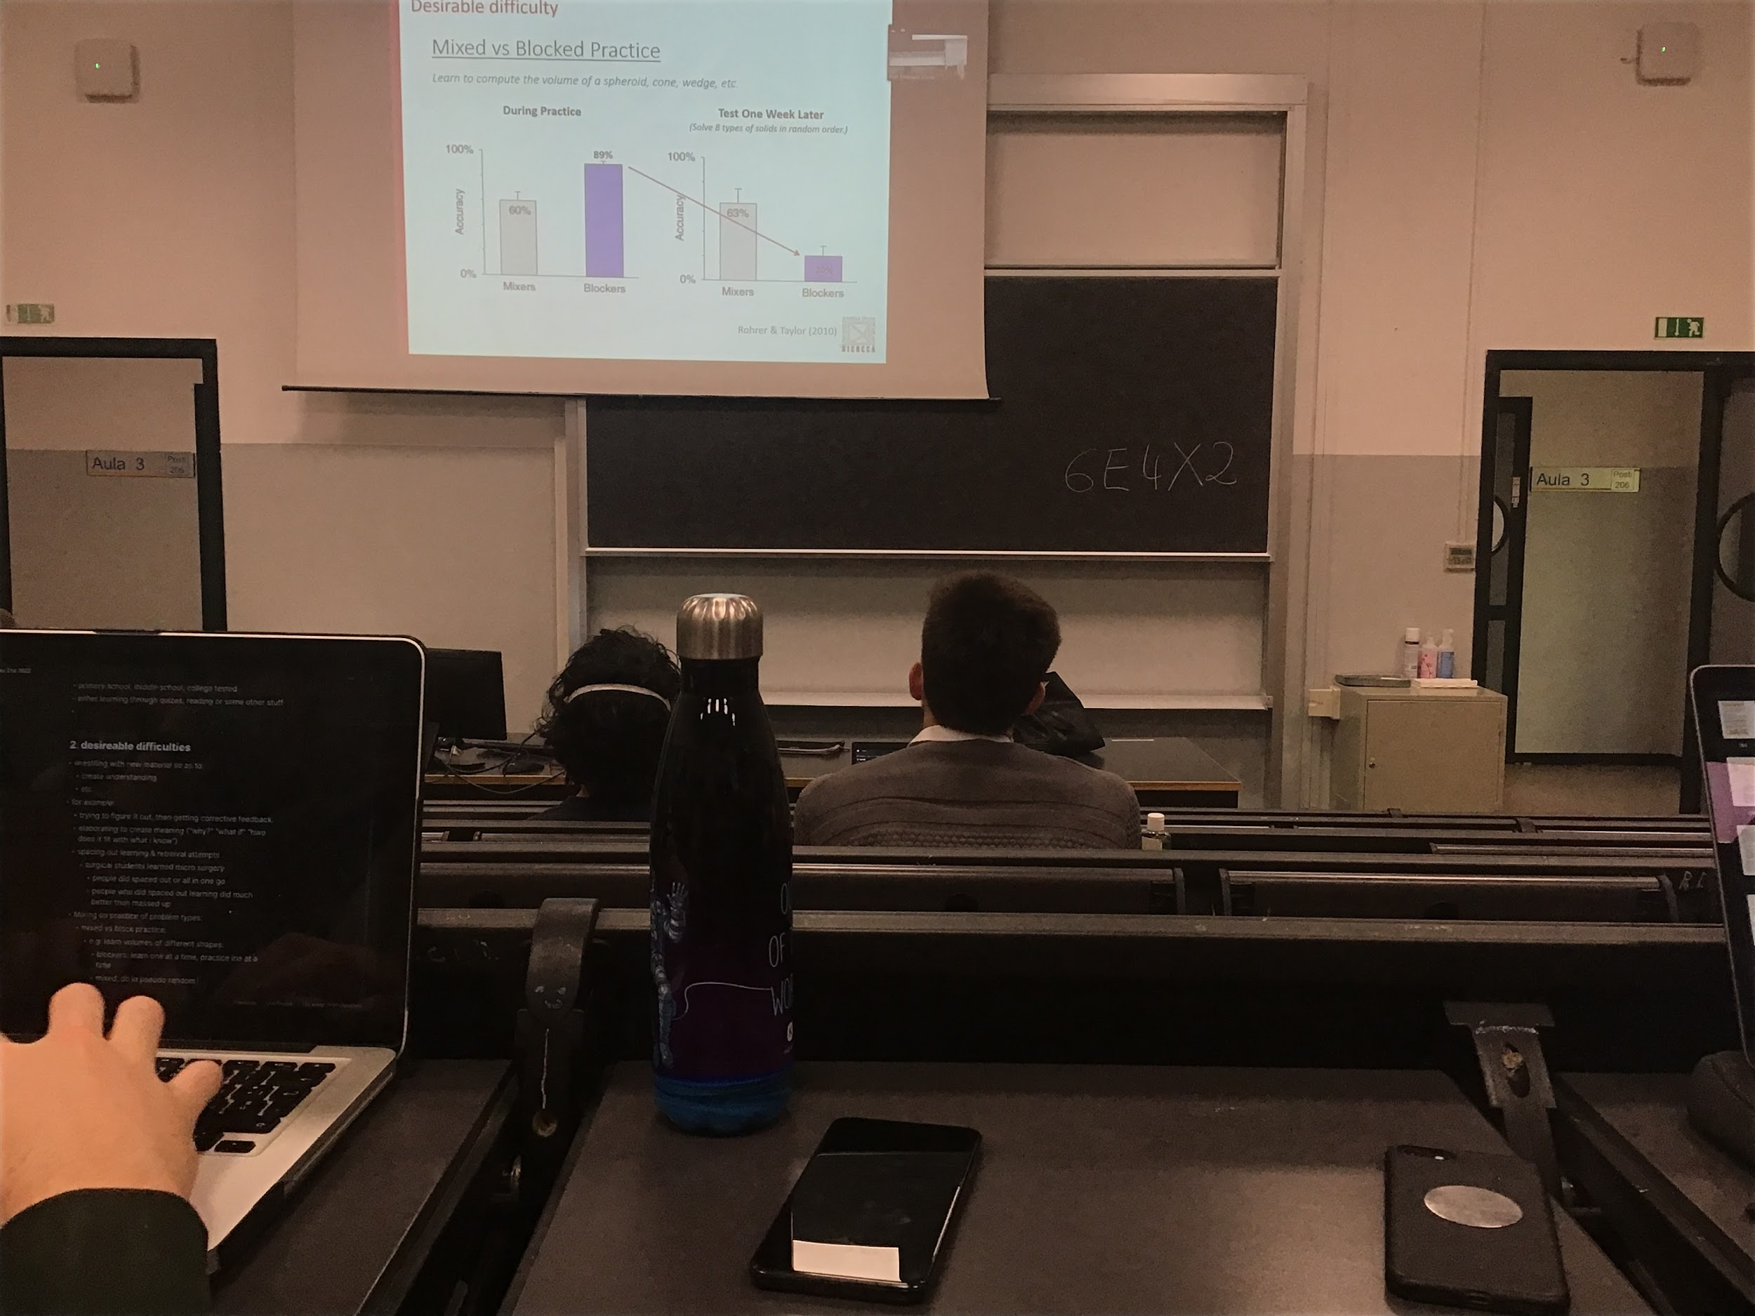

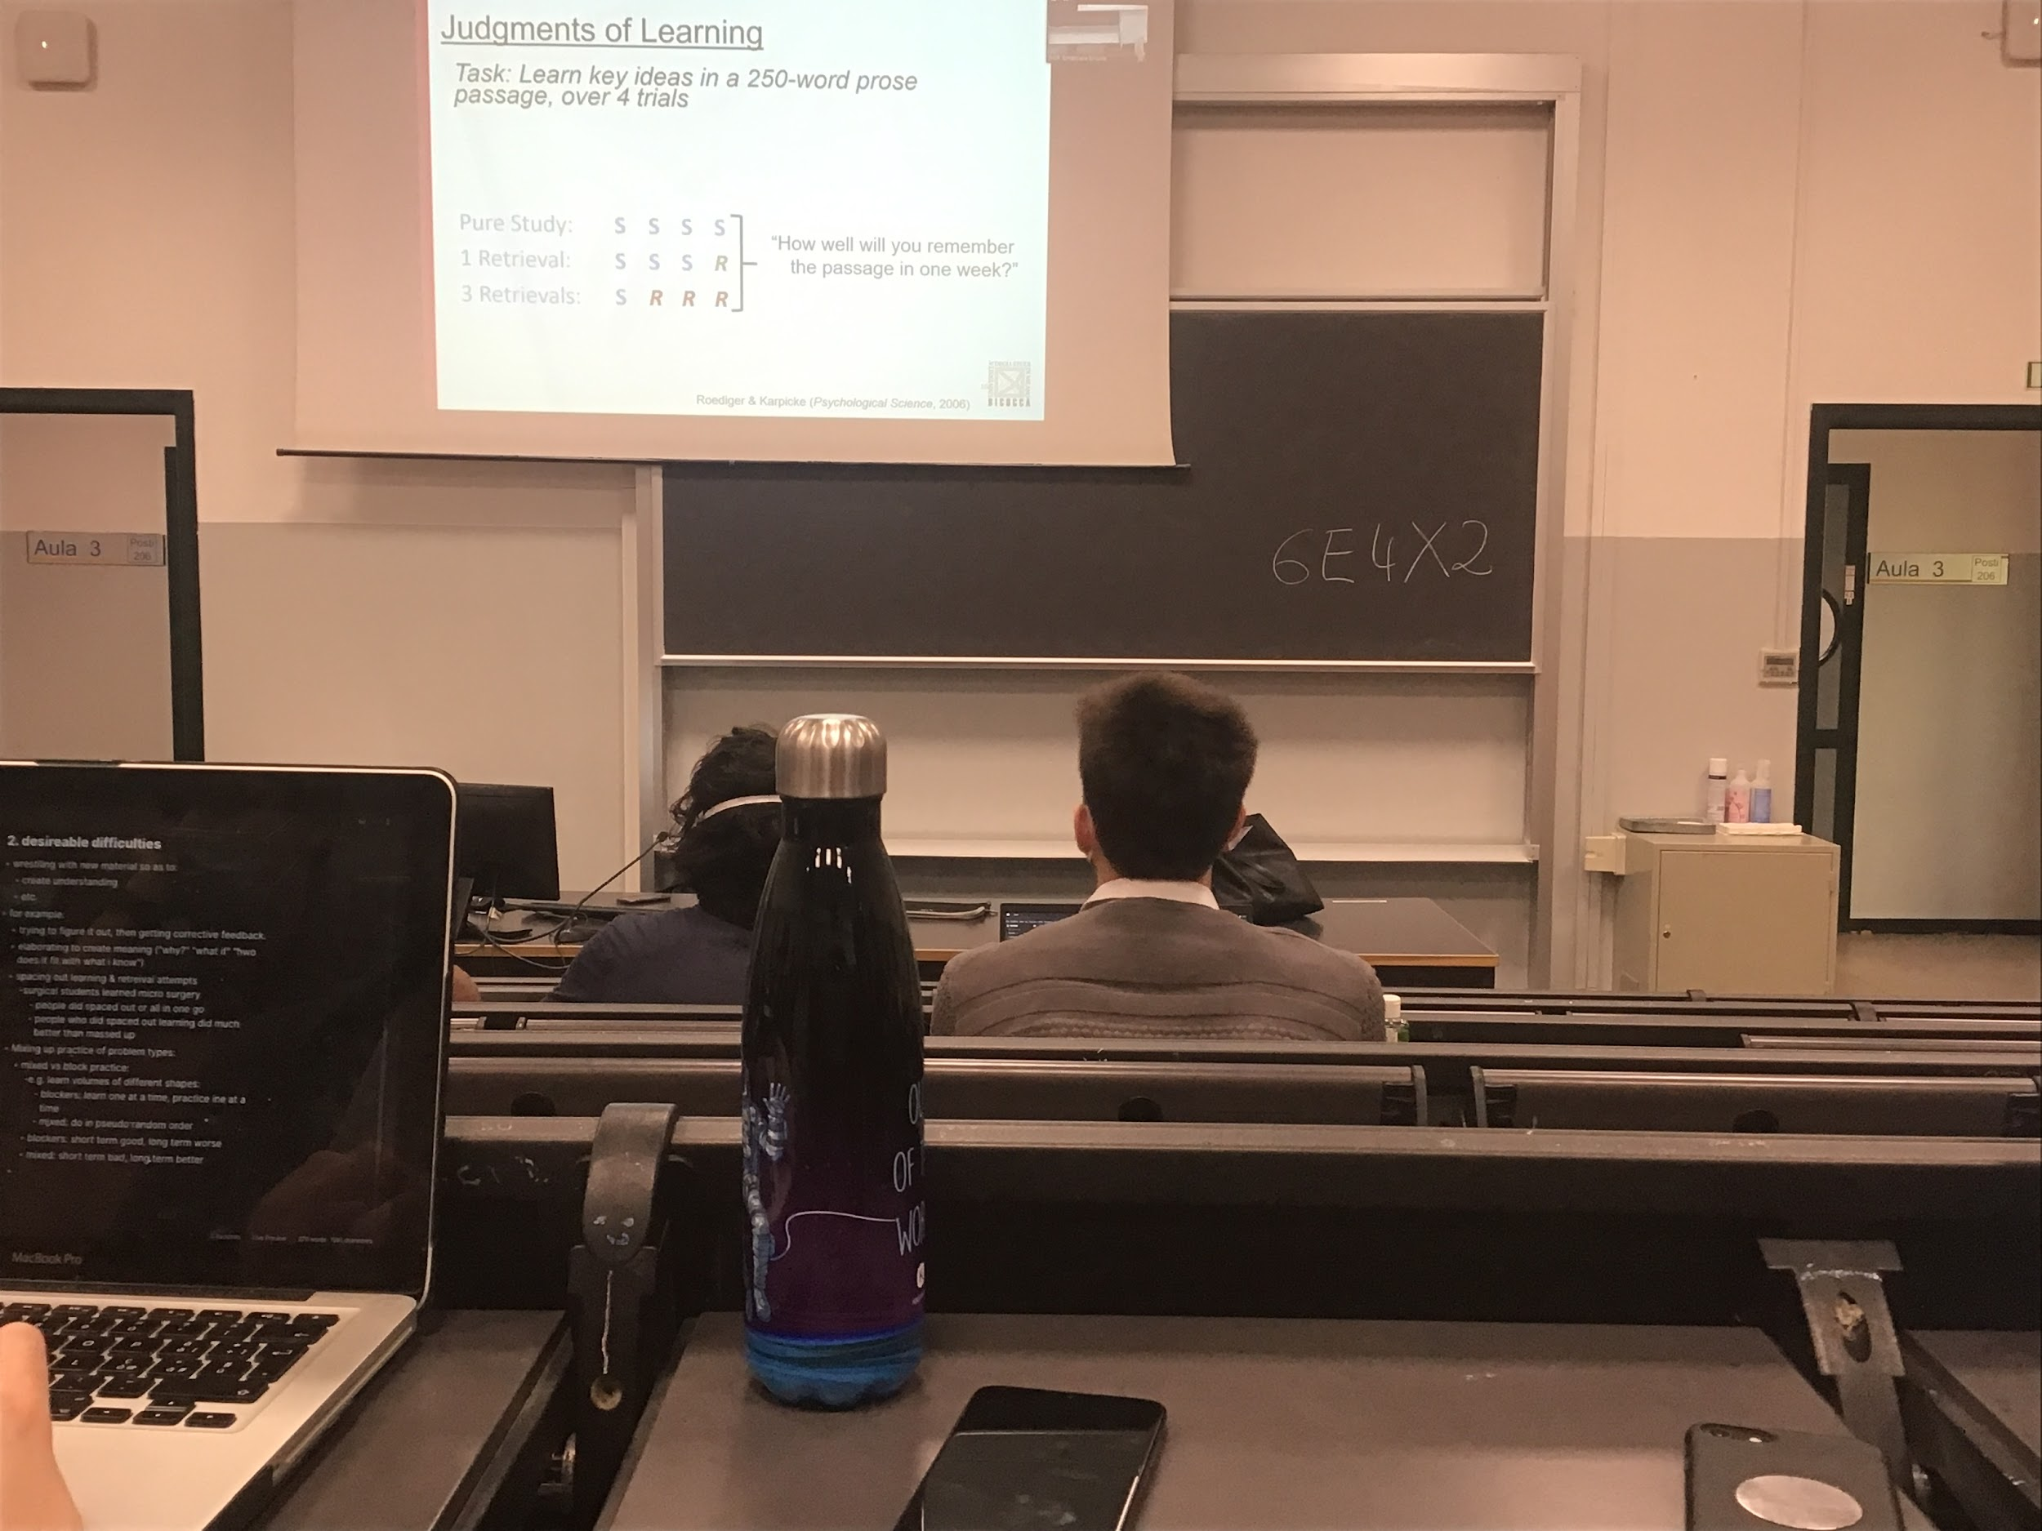

Experiment: Study 250 words and what are are the keys ideas (text comprehension)

Can chose

* 4 study session 0 retrieval
* 3 study session 1 retrieval
* 1 study session 3 retrieval

In theory what you judge you learn. You remember much better if you are tested

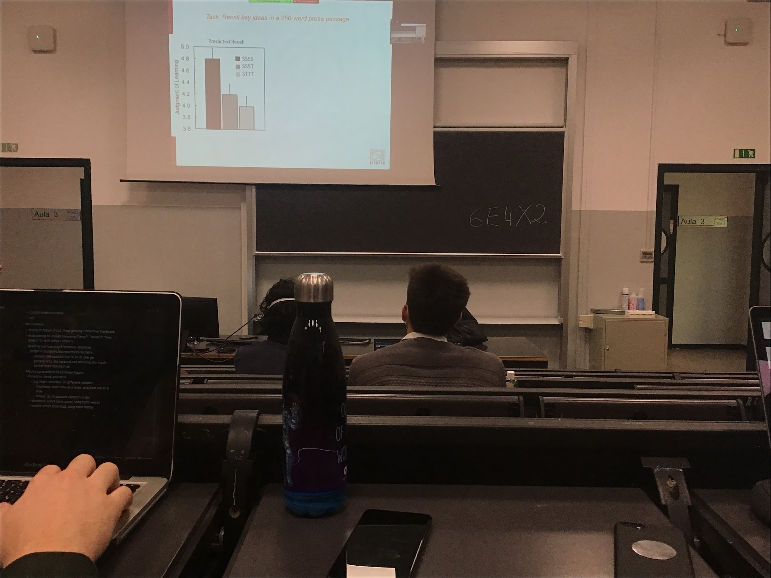

*Perception* of being better if you have pure studying (4 study, 0 testing). This is your feeling

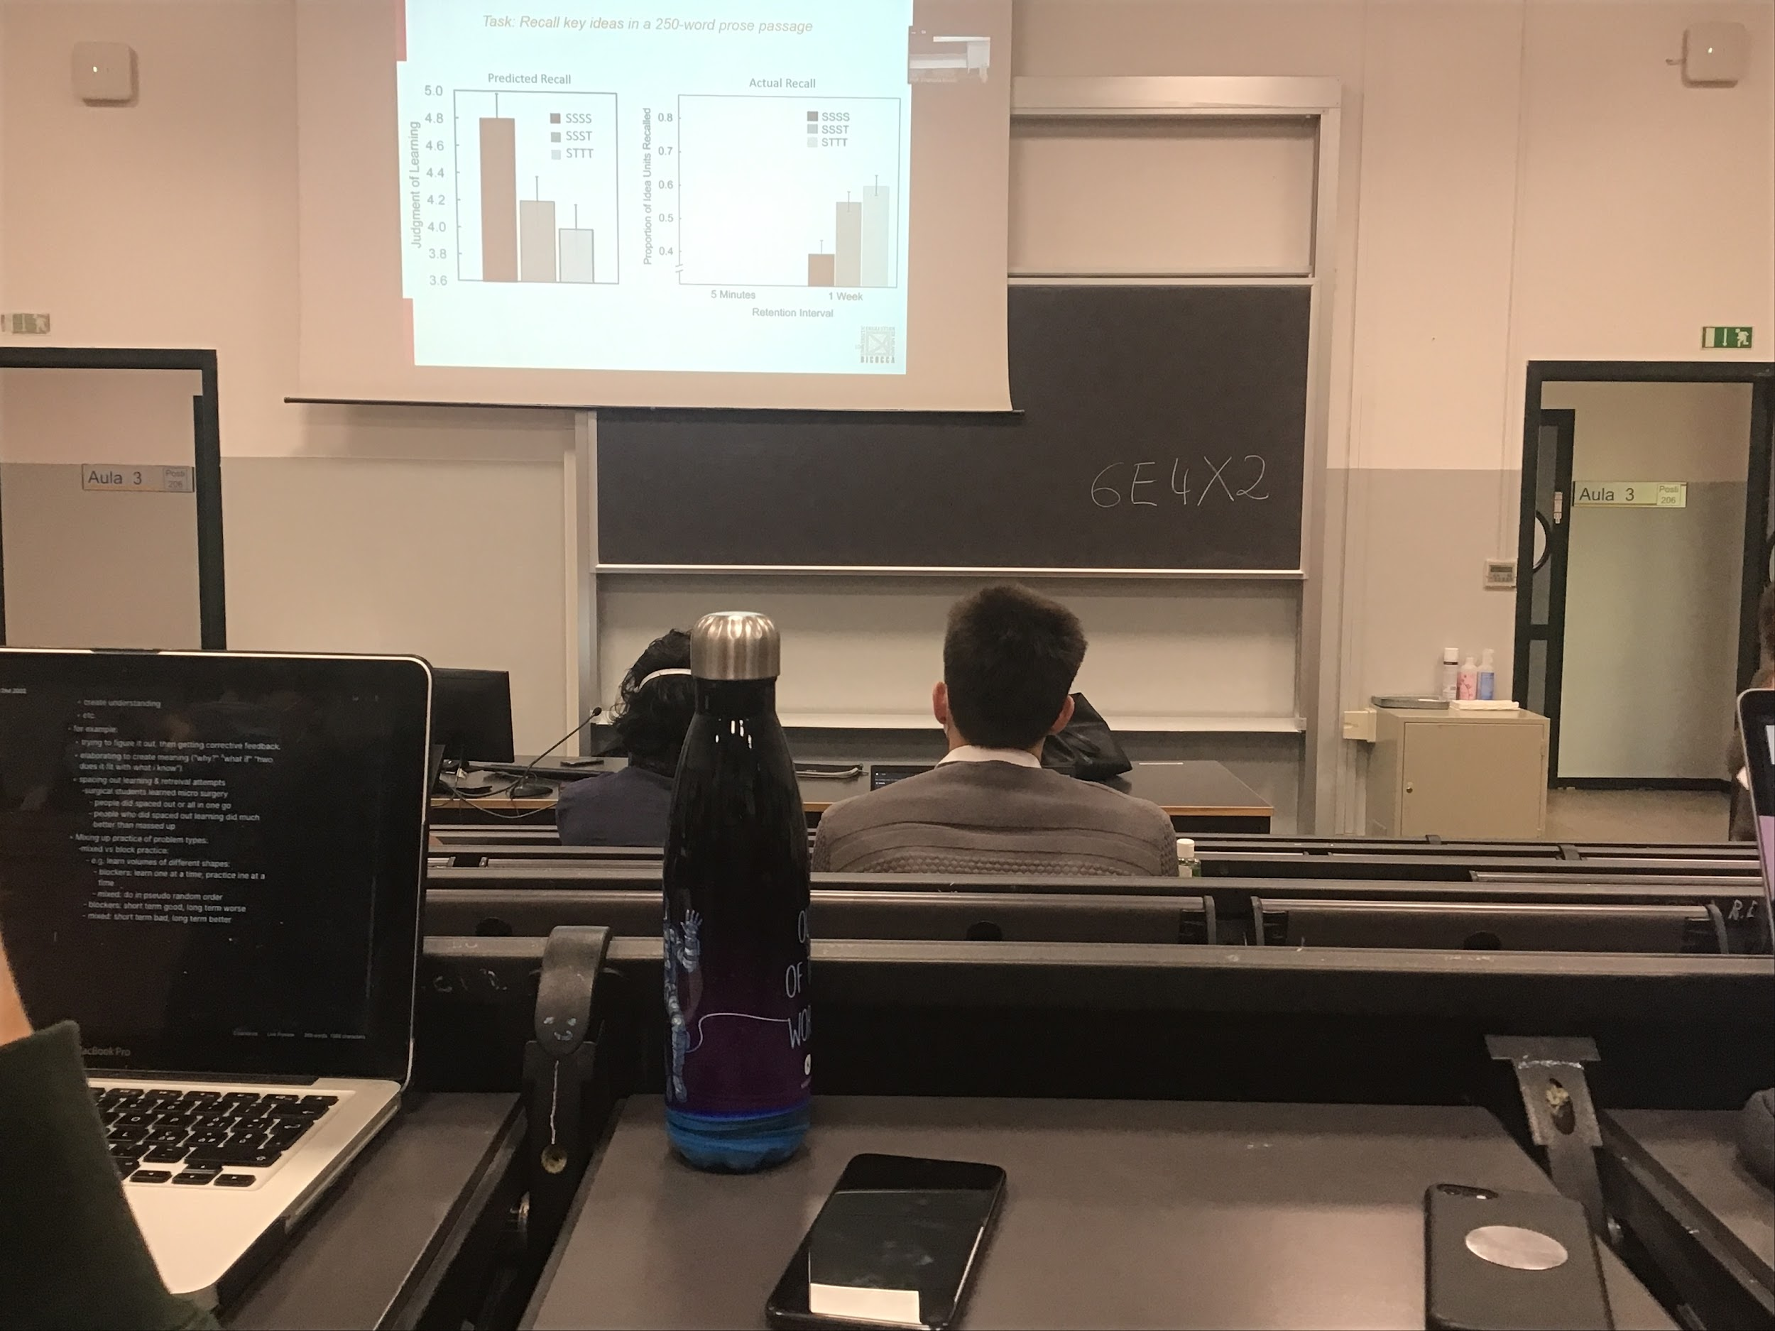

What actually happens is the other way around, you are **much better if you test yourself after the studying the first time and check in what you learn**

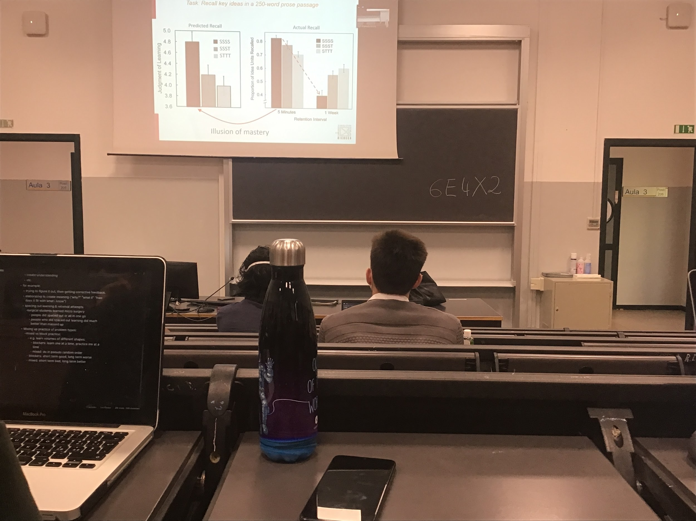

Your intuition are not confirmed by the actually testing that you have

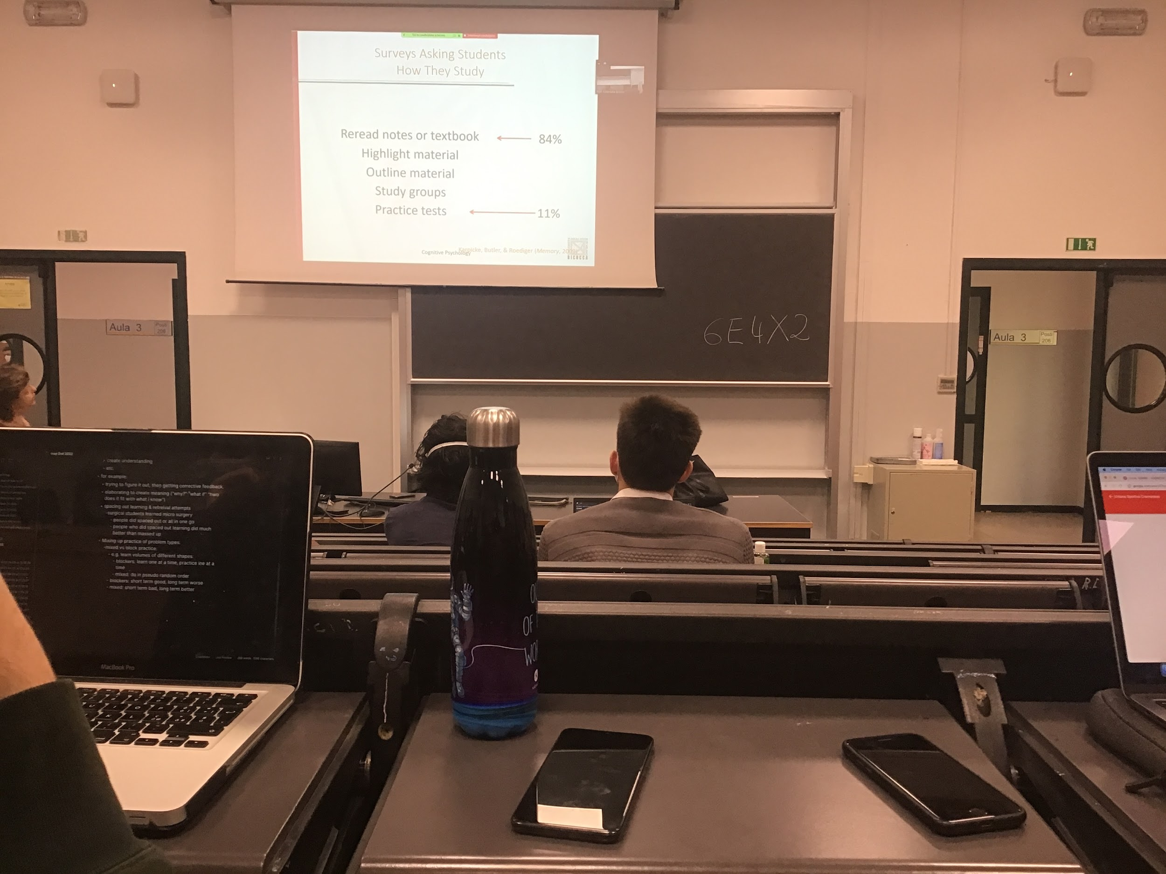

**Most important way to study is to do practice tests**, even study groups are good. You can ask questions to eachother

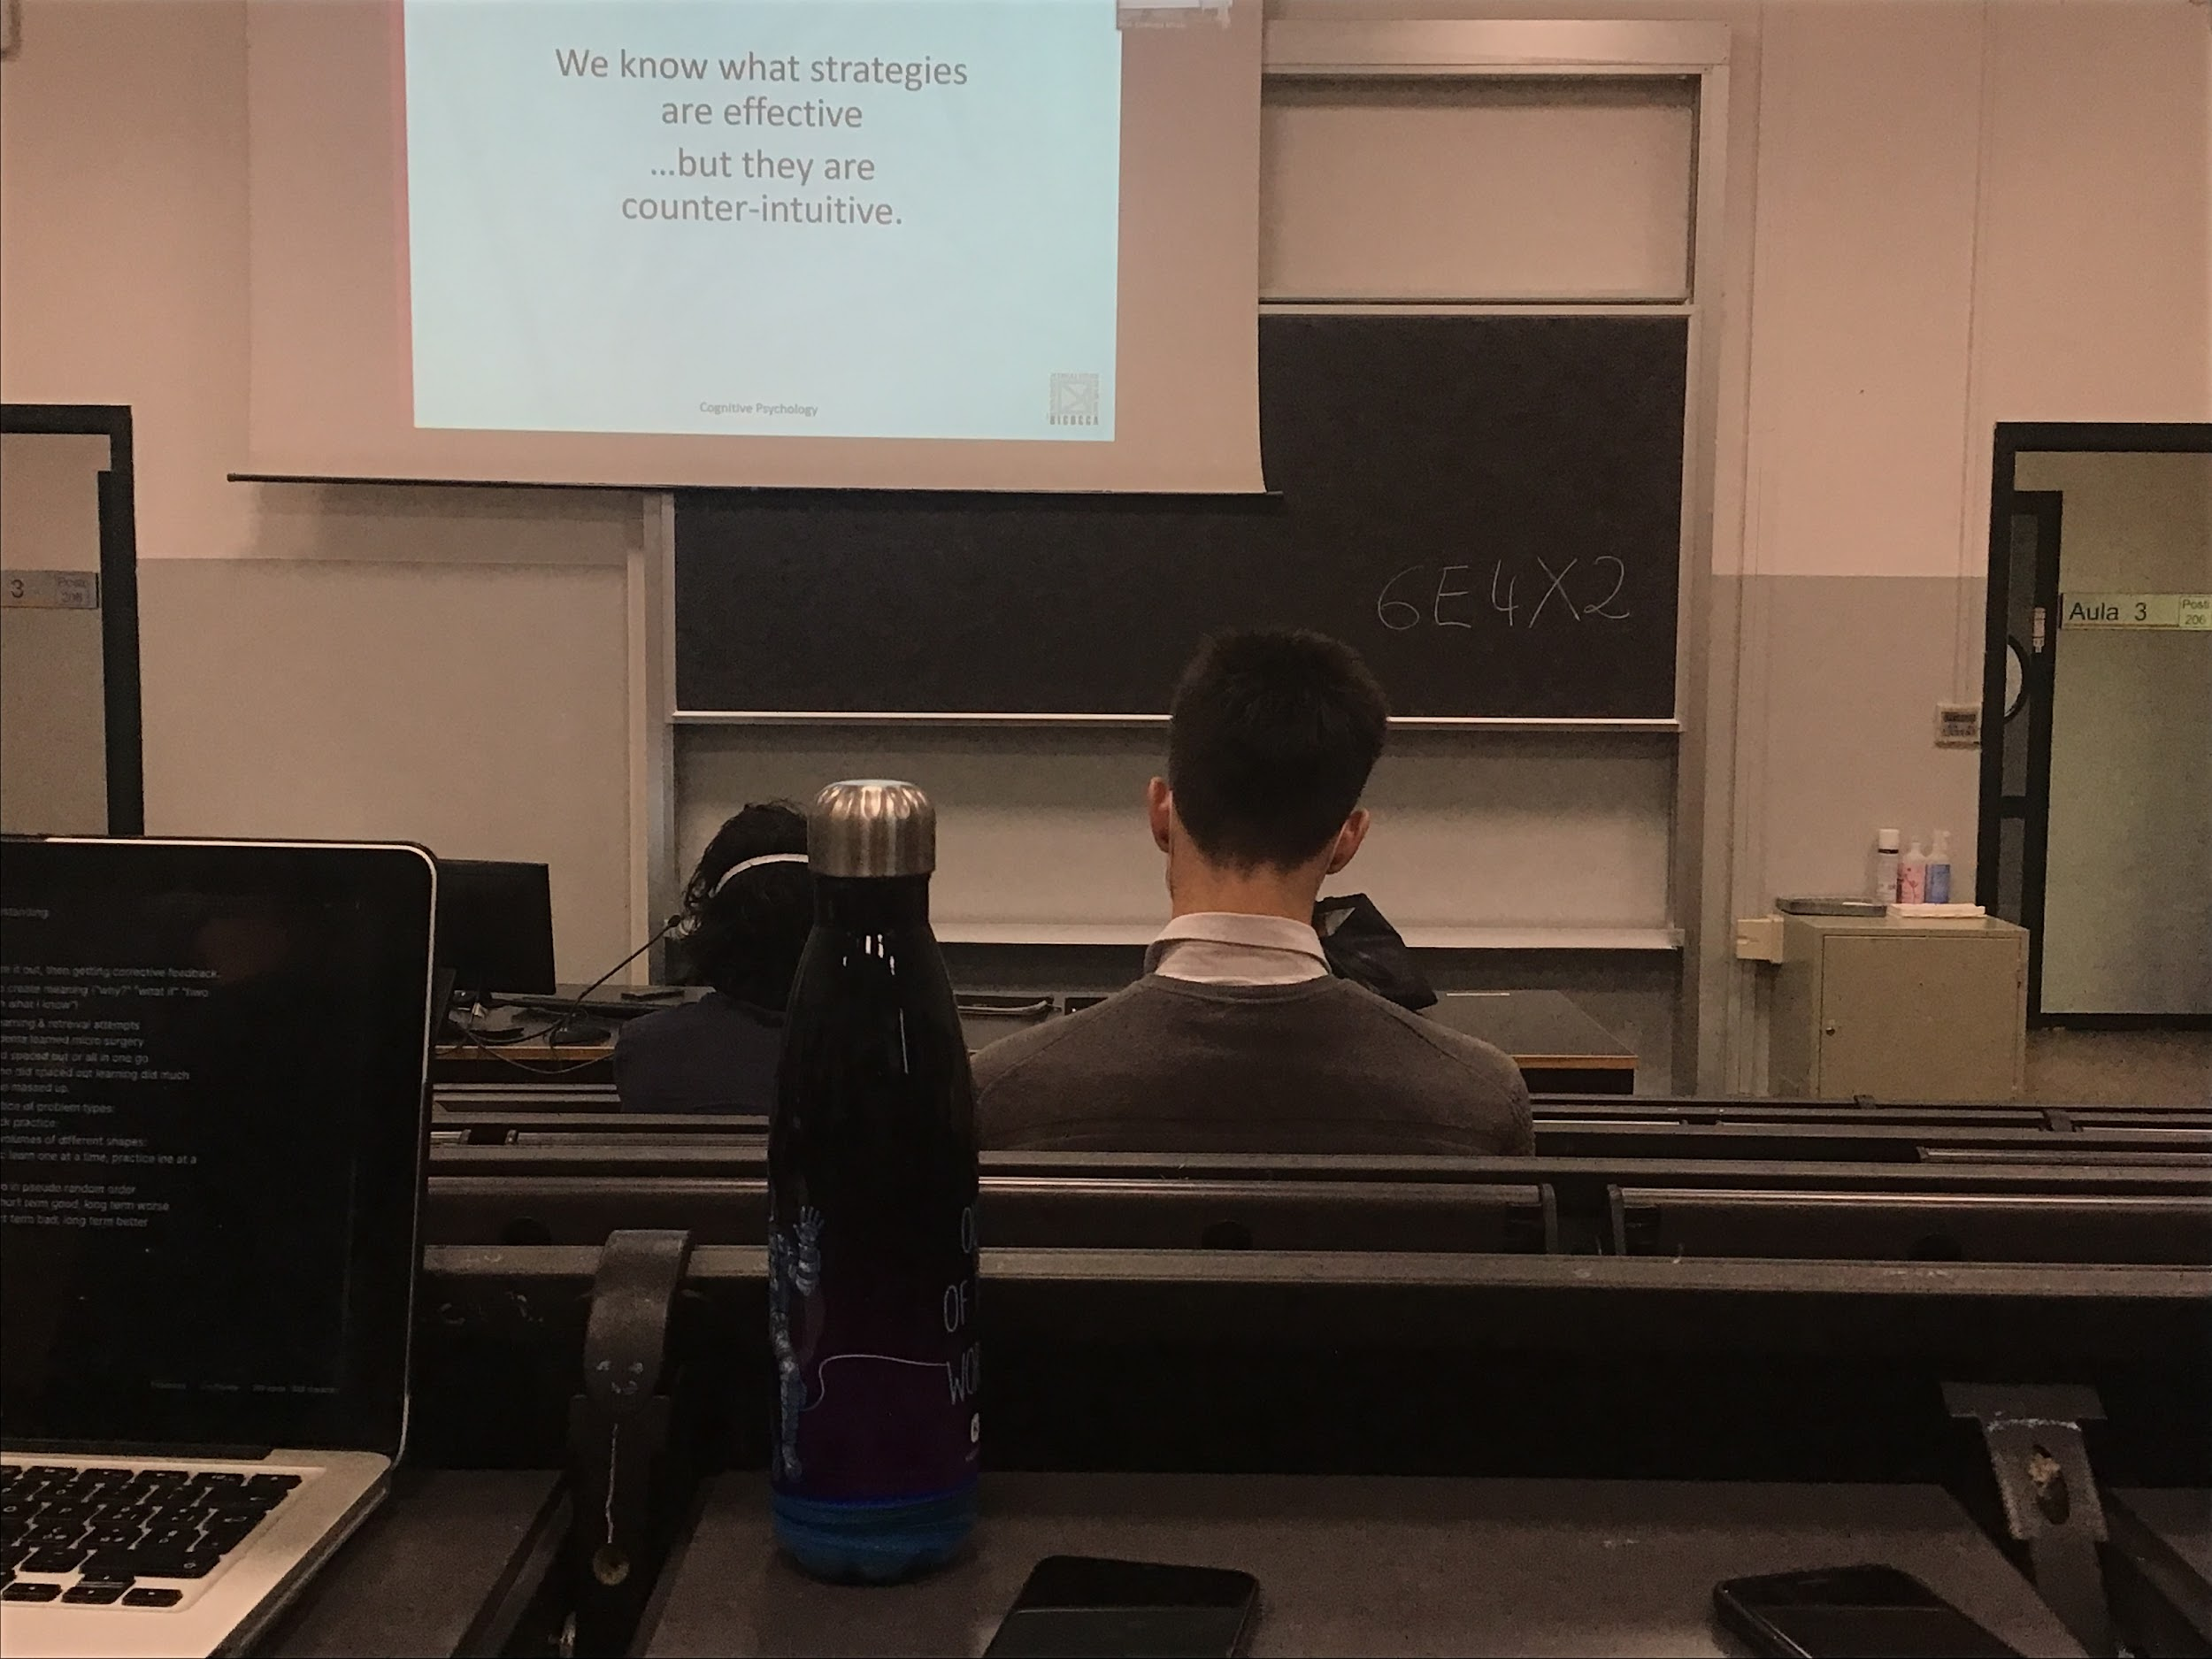

We have clear what are the best techniques to learn, but it **seems counter intuitive**. You feel you can learn better repeating, but is not correct

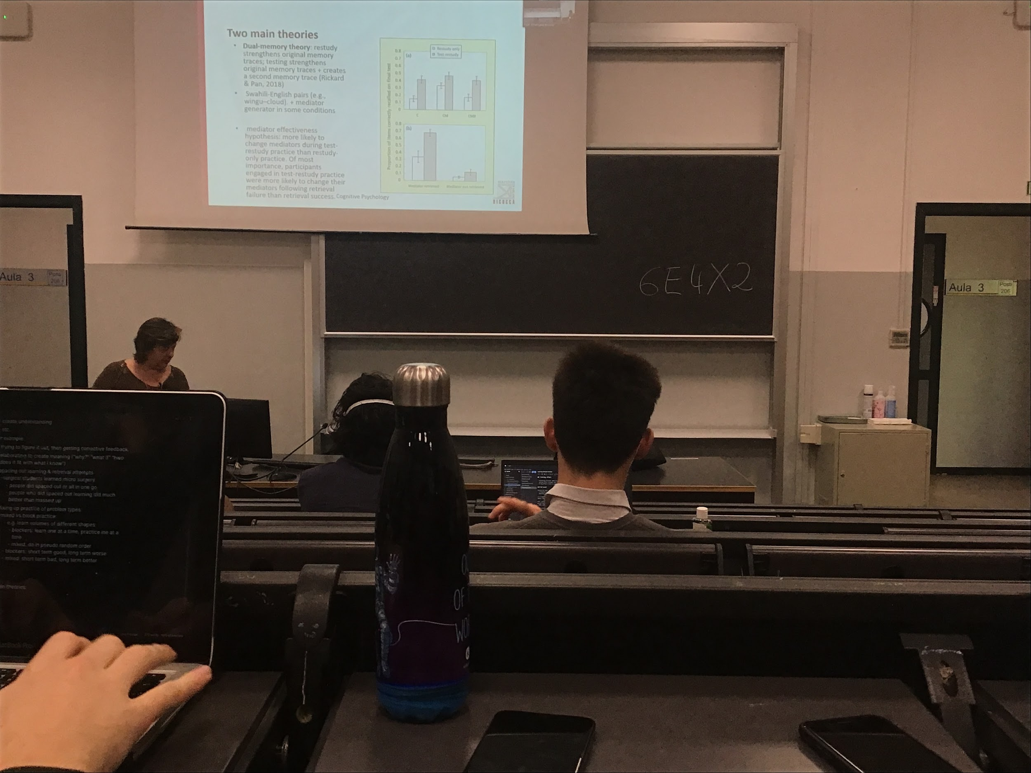

Two theories on why we have better results in retrieving when we do testing

* **Dual memory theory**: when I restudy (reading the same thing and try to repeat it) the only thing that I do is that I have a memory trace and reinforce exactly that memory trace. When I do **testing** I **create a different memory trace** and I have a **double memory trace** (one given by the studying and a new memory trace)
* **Bifurcation model**

If you ask people to learn association of Swahili (that you don’t know) and English and you study and test and check the ability to recall you see that the test is better than study only.

If you add to this task a mediator (a way to associate the first word to the second word). Wingou = cloud, you remember it sounds like wing, so cloud. You associate the Swahili word with another English word that is easier. **Even if is better with the mediator you still better with testing**

When testing you recreate a different trace an it become stronger

You can improve the way you store information. If you realise that when tested wing does not work very well as clue for cloud you can change it, creating another clue and finding another better, create a different trace

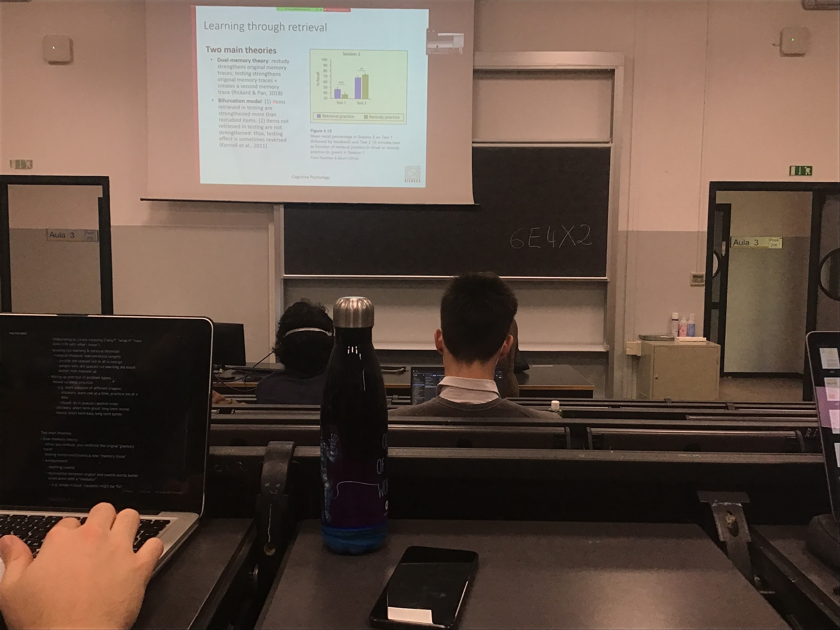

**Bifurcation model**: when you test some kind of knowledge you strengthen the things you are study so you are better

What you test is better but also what you don’t test is worst

If I test you about studying one book chapter and I give you 4 questions. The things that I tested in the quiz are going to be reinforced, the things I did not test you are going to be worst

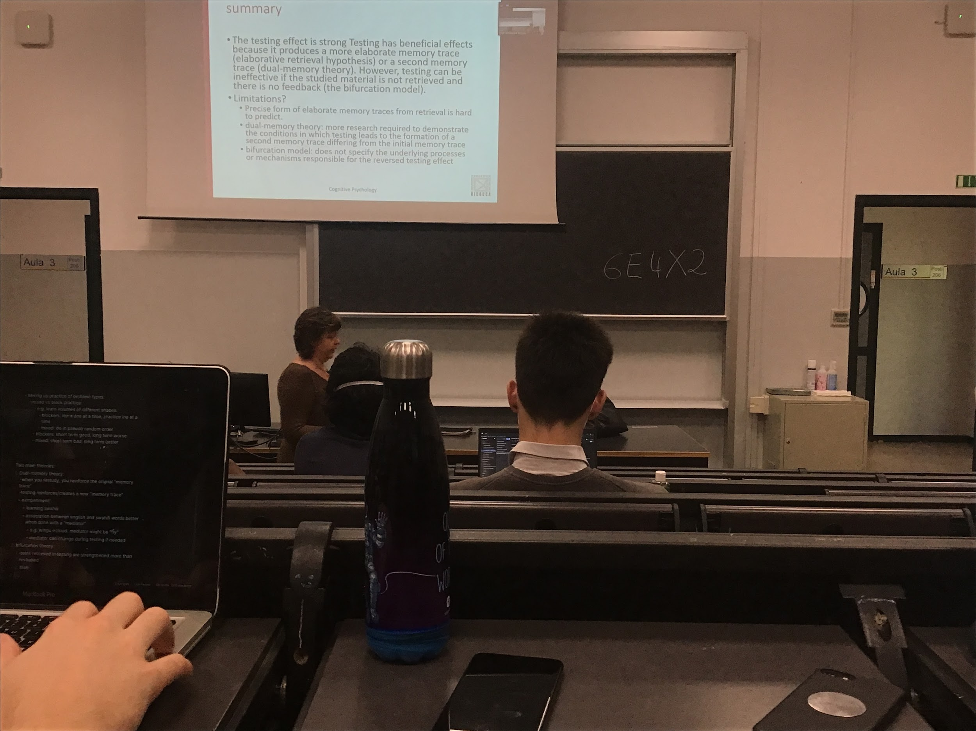

Testing effect is a strong effect, important we should take advantage of it when studying. Is a beneficial effect: **produce a more elaborate or a second memory trace**

Sometime can create a problem, you should be tested in everything you study

Don’t know well enough all the intermediate steps, don’t understand exactly witch trace are reinforced. Not clear when precisely the things I did not test loses strength

A trace is some kind of encoding information in a store. Before accessing the same kind of information you can create different connection, even slightly different coding information

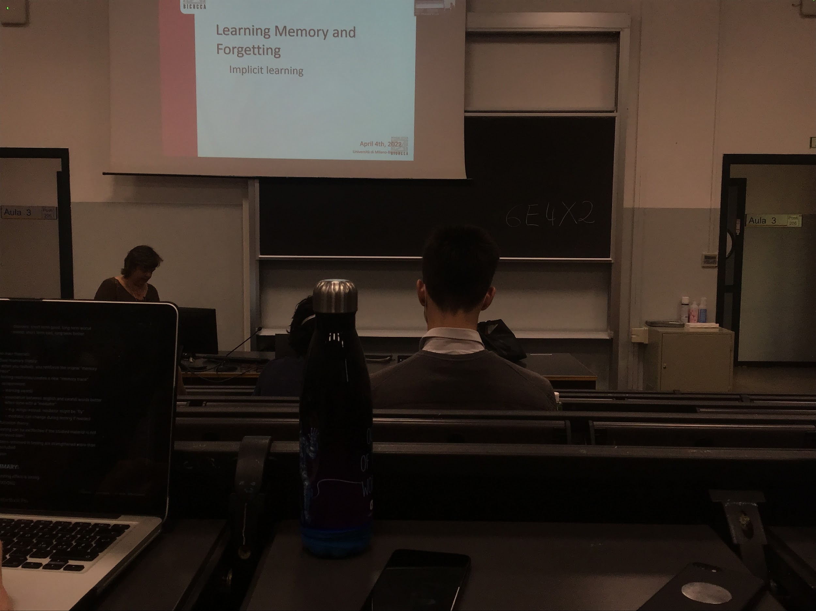

**Explicit learning**: you want to remember some kind of information, want to memorise that information because you need to be able to retrieve it later, aware of the fact that you try to learn some information. Conscious of the fact of learning

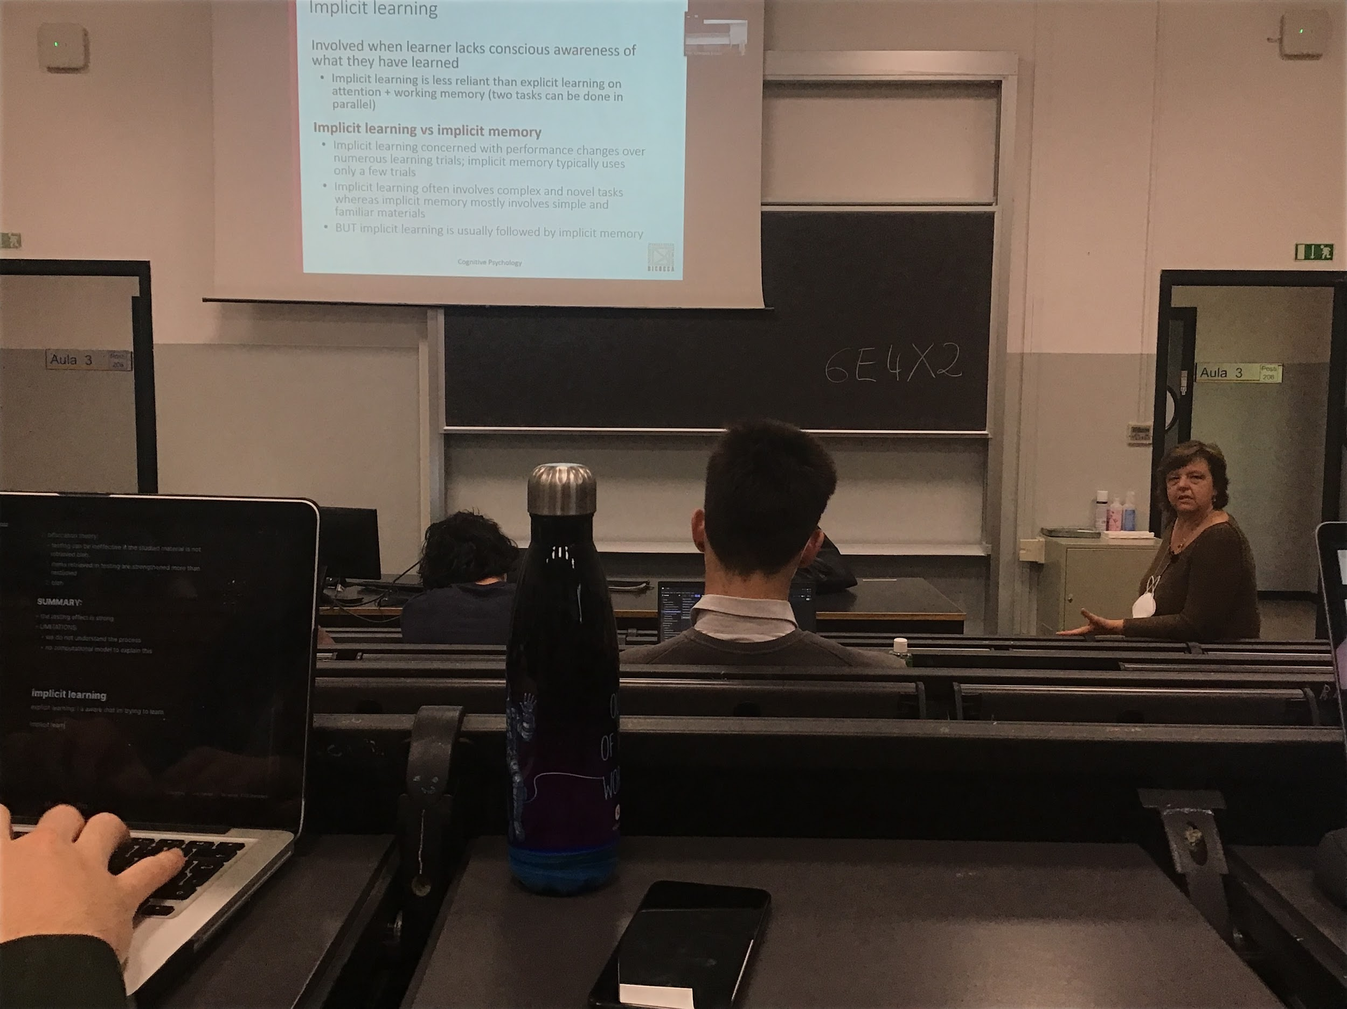

**Implicit learning**: learning something without actually being aware of learning

Ex: implicit learning is touch typing (or also doing every sport). If you learn to touch type, you don’t know what your fingers are doing. Can not explain consciously step by step what you are doing. The learning is implicit, you are able to do it, buy can not express literative the way you do it

Once you have learned some kind of task, you can do it in parallel with something else. Once you learn how to drive some movements become automatic

Different in implicit learning and implicit memory

* implicit learning: learn without being aware of a task
* Memorise something without being aware of memorise it

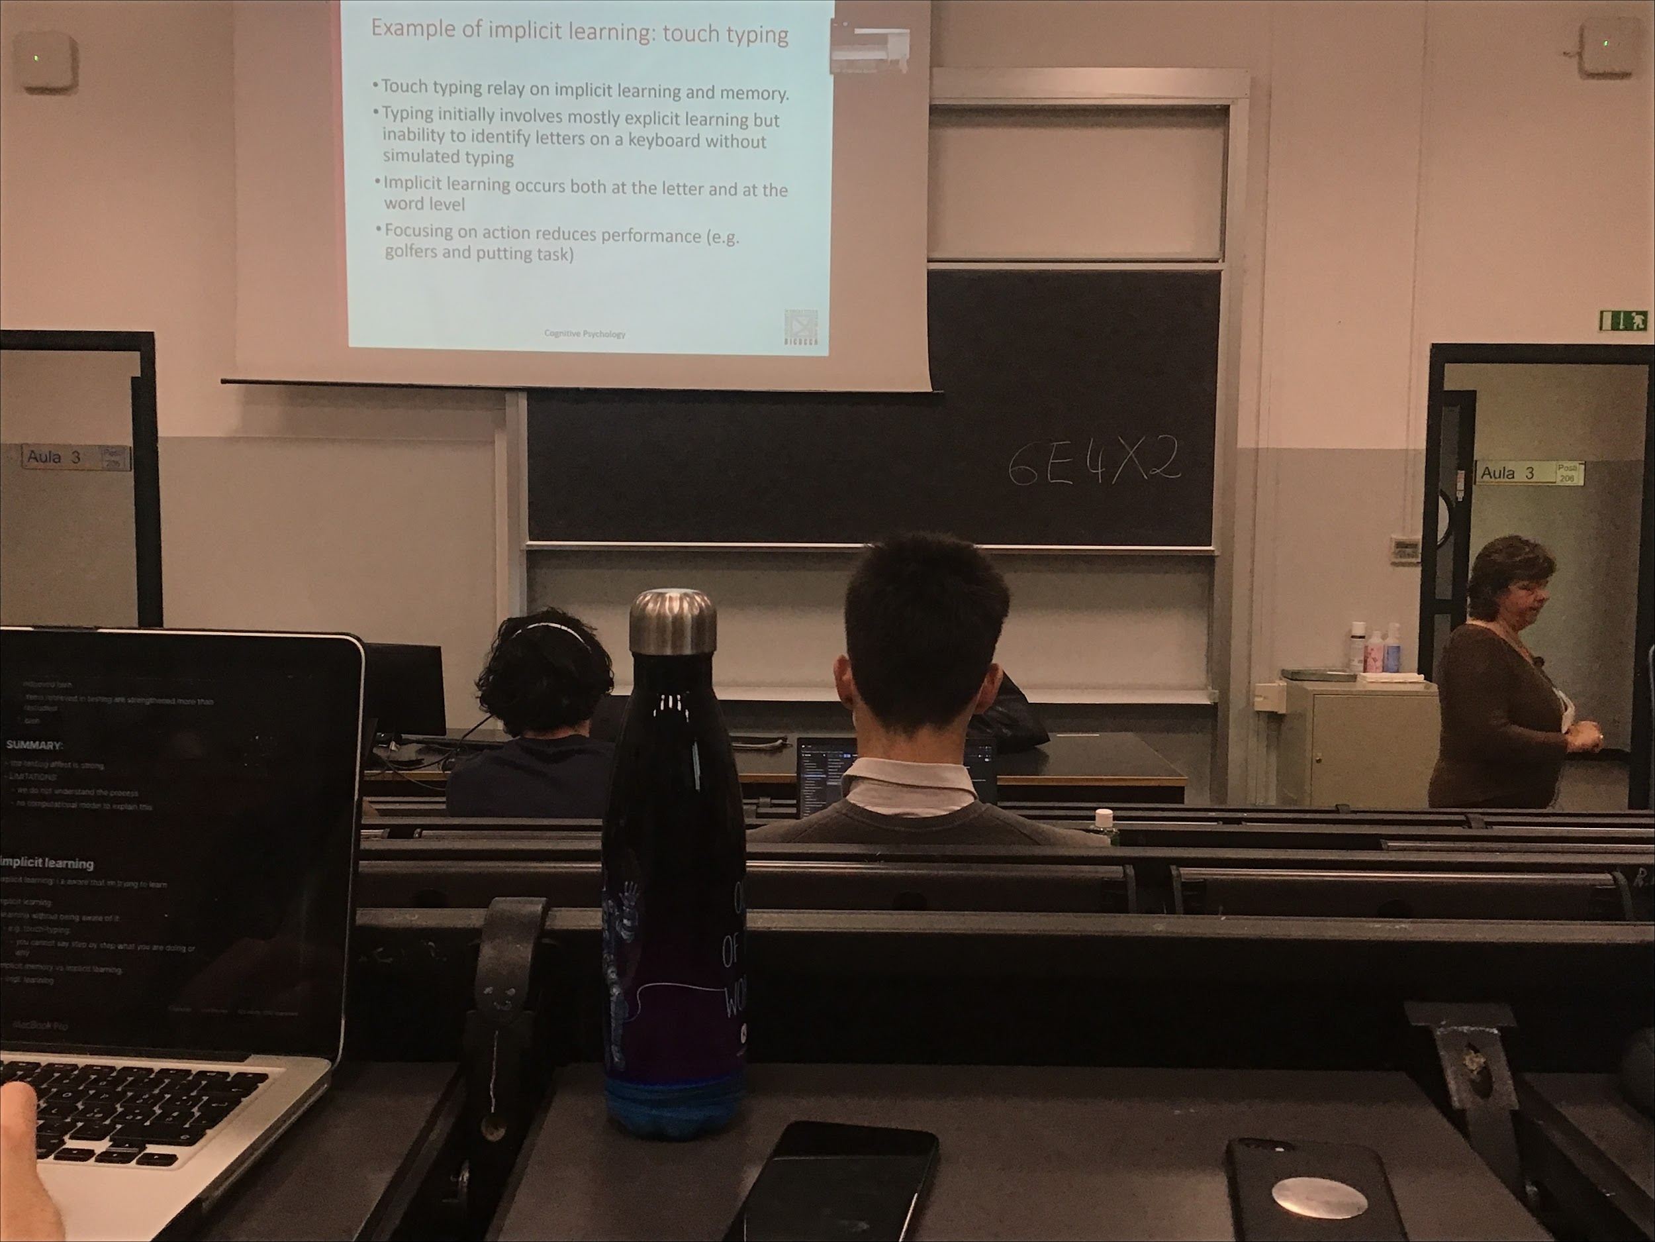

When you learn to touch type at the beginning you try to understand where to put the fingers (is explicit at the beginning) after a while you do not know where the letters are. If I ask you where is the letter *a* and you are a touch type you have no idea, you have to find a word that contain the letter a, is the other way around

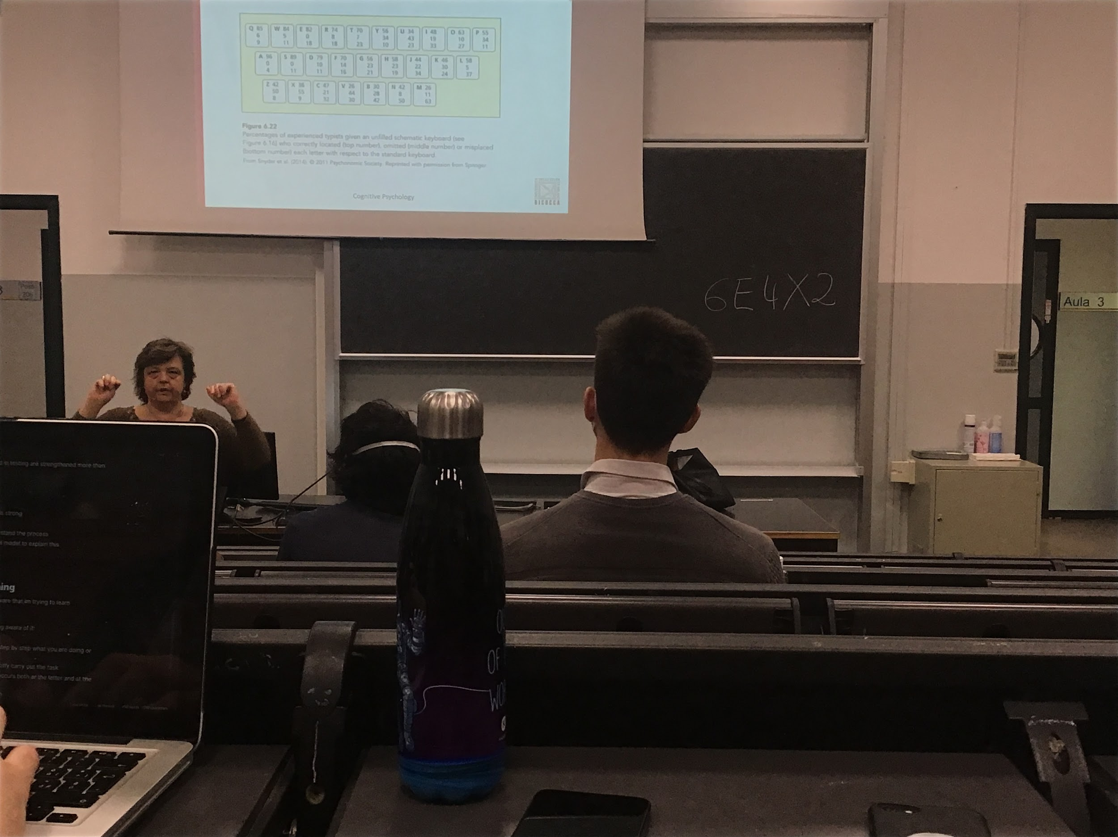

If I show you an empty keyboard and I ask you to put the letters in the empty bottom.

First number: percentage of people who put the right letter

Second: person who let the bottom empty

Third number: choose the wrong letter

A single person does no know where the letters are

————

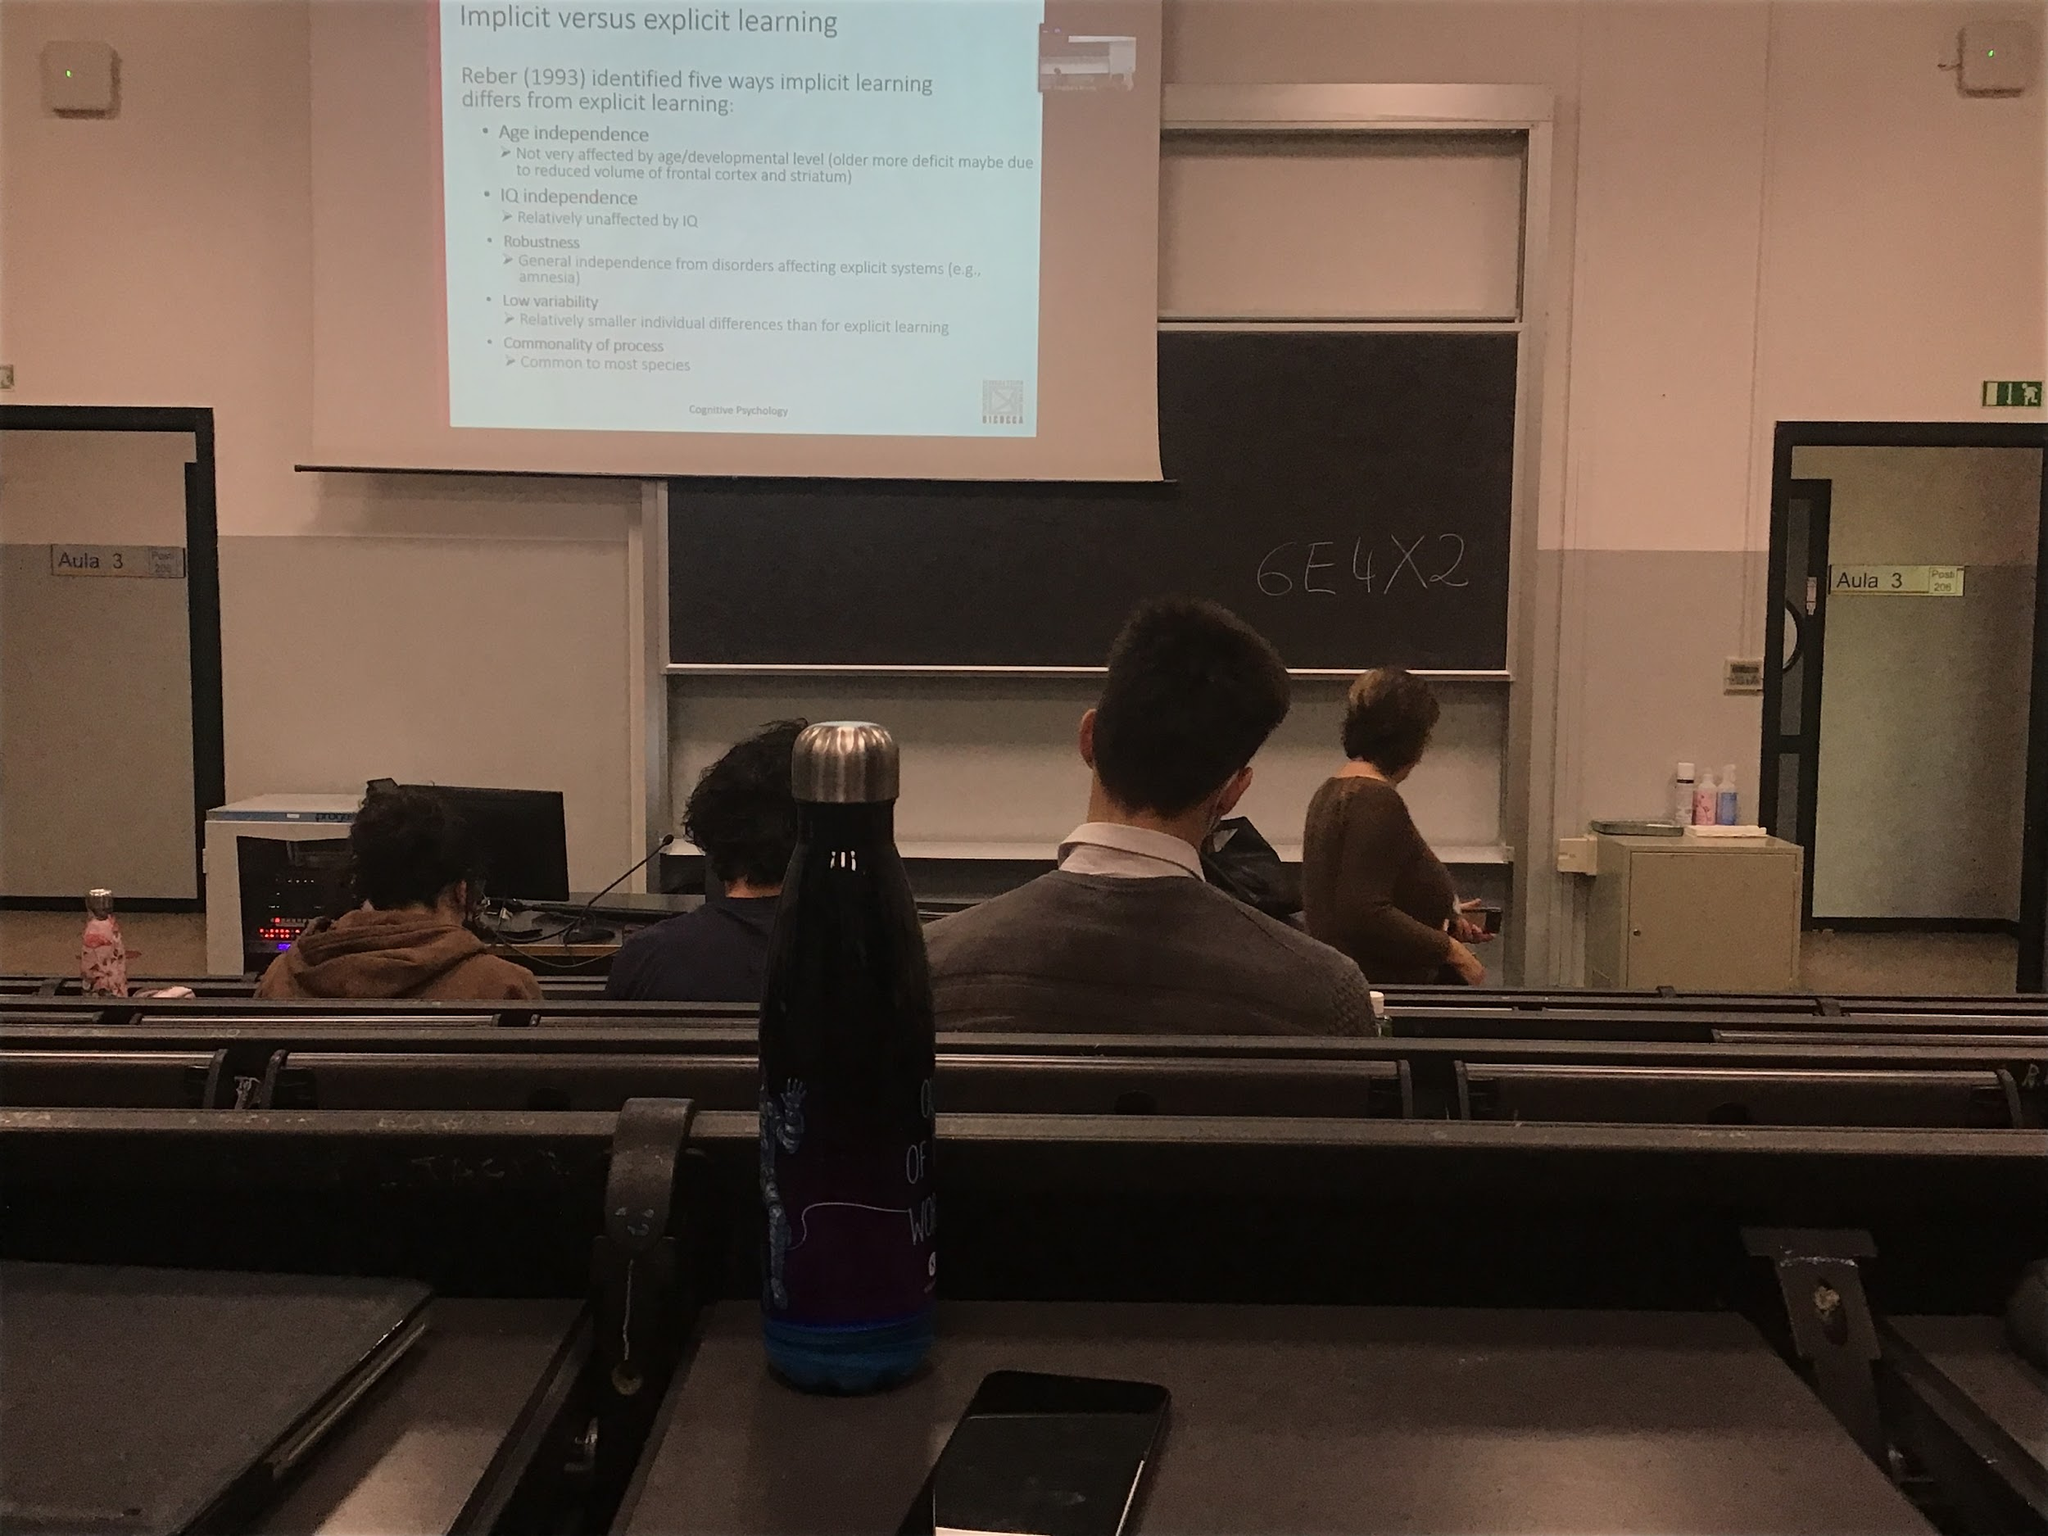

There are differences between implicit and explicit learning, it is age, young people are not better or worst at learning than old people, even if when we get older there is a small slight deducting in implicit learning

**Explicit learning is correlate with intelligence, implicit learning is relatively independent**

Implicit learning is more robust, less interference than explicit learning

There is a large difference in explicit learning among different people but there is a very low variability for implicit learning. Implicit learning is common for different species

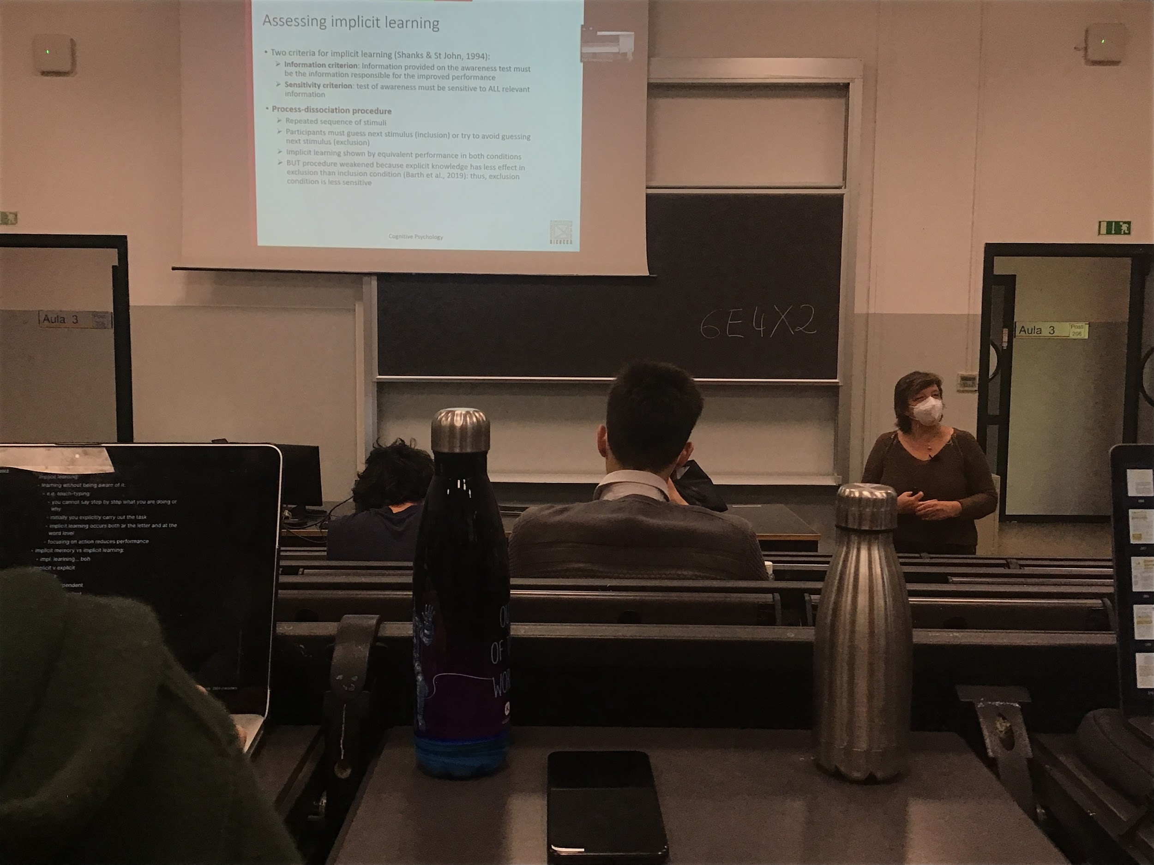

Different ways to assert implicit learning, important to test the people are not aware of learning. Important that what is tested is what helps to improve performance and the test of awareness must be sensitive to all information, not to miss interpret explicit learning to implicit learning

One typical example of implicit learning is the dissociation procedure. You repeatedly a sequence of stimuli to the subjects and you ask them to guess what is the object (letters, items…) that you present. Inclusion procedure. If with guessing (means with inclusion) it means that you know which are the rules, means that you explicitly learn the sequence. While if the two conditions are the same it means that you learn something without understand

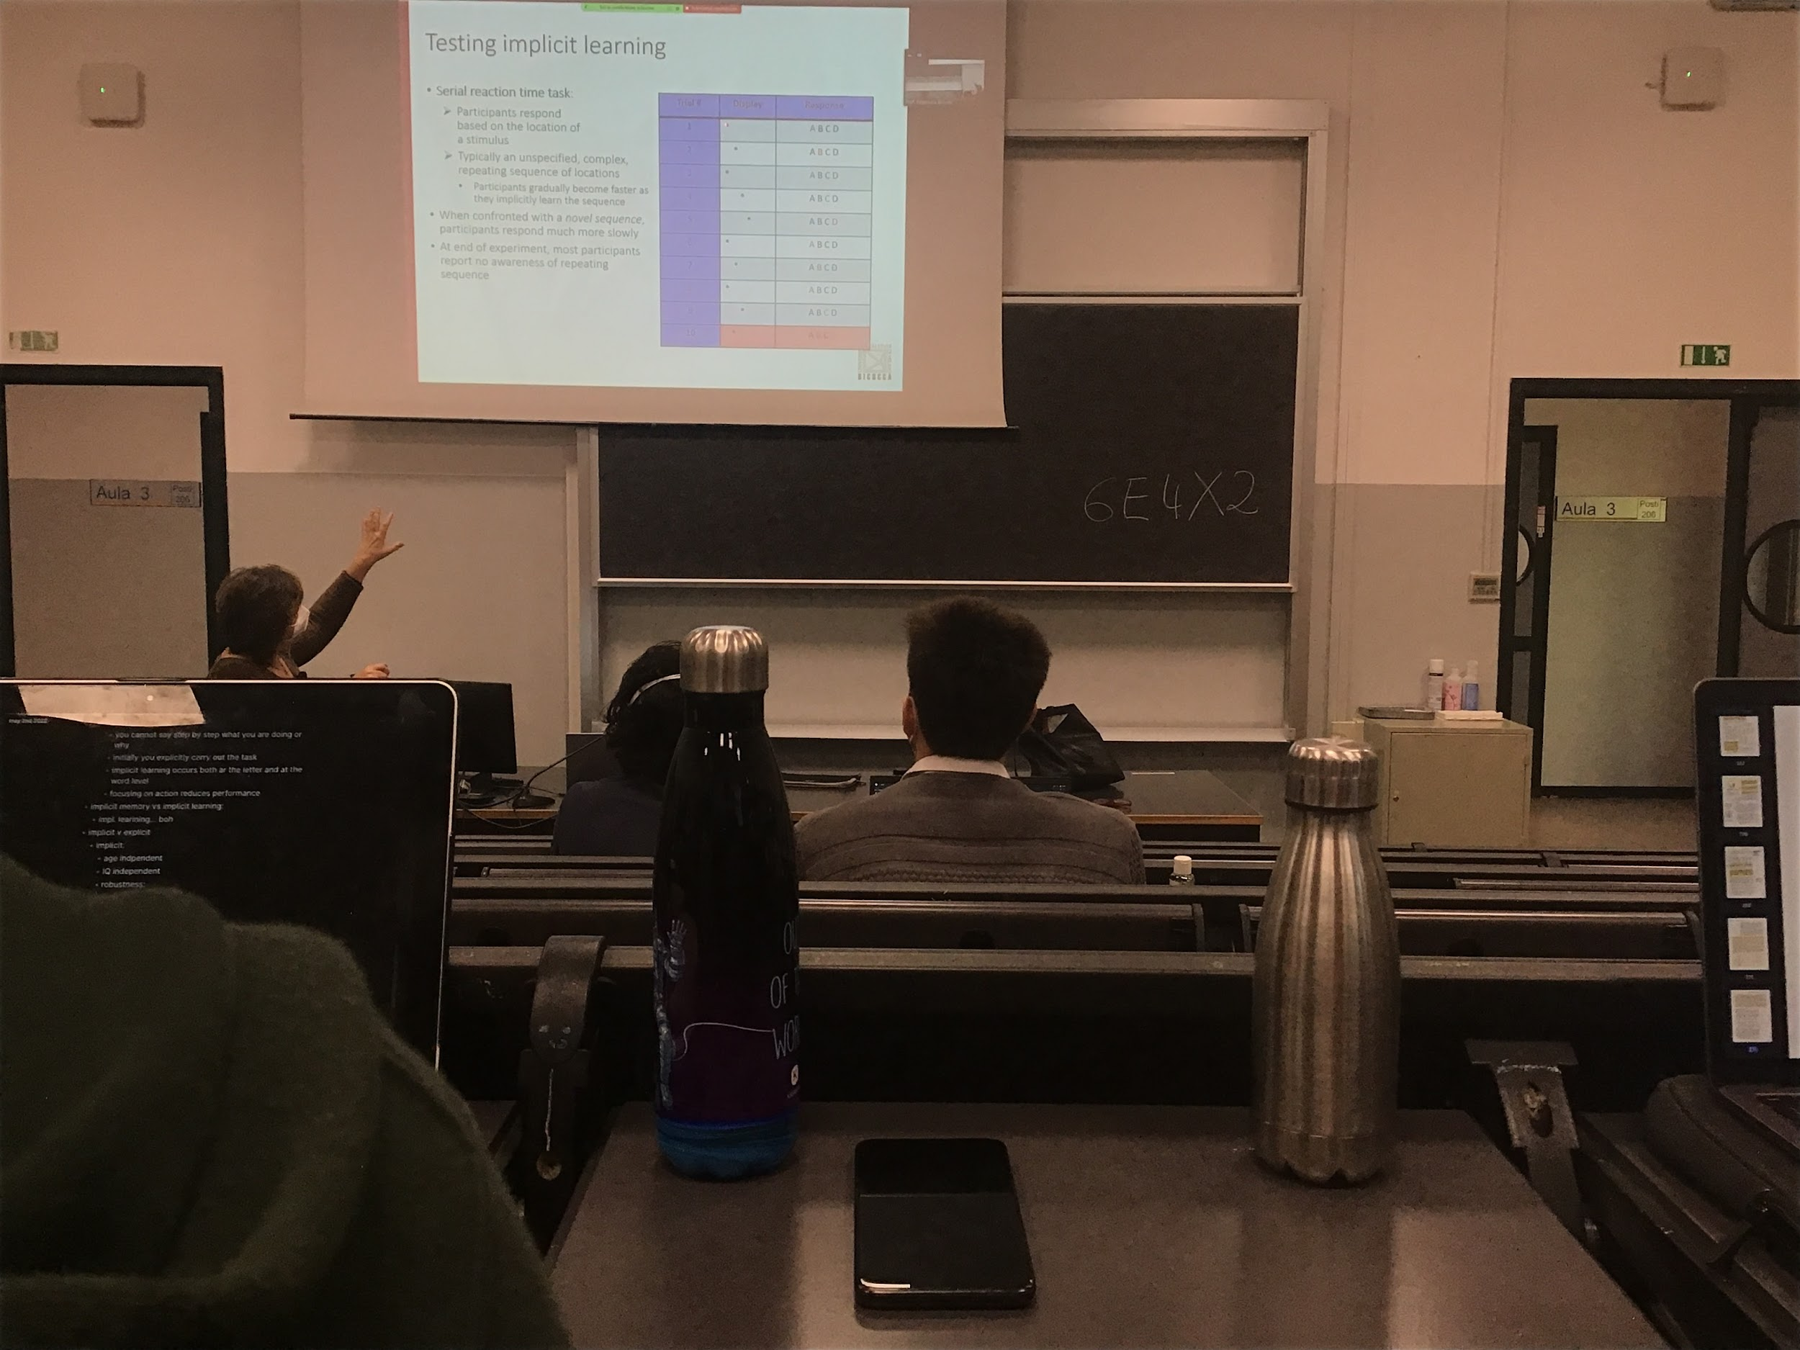

Experiment:

You have response to a sequence of items, you have on a display * appearing in one out of 4 positions. Your response is to press one of the 4 letters ABCD depending on where the * appears. Position that you associate to letters

If the association is not completely random but there is a sequence (like ABCD ABCD… or ADCB, ADCB…) sometimes people learn the sequence without actually knowing what they learn (implicit learning). People become faster and faster to answering and pressing the bottoms

If at a certain point I change the sequence then people slow down. Some people (when asked) told that they understood the sequence, while other did not

There are people getting faster without realising that there is a sequence

There is an underline sequence of movements that you have to do. You actually learn it (because you are faster in answering) but if I ask you what the sequence is you don’t know it. You implicitly learn

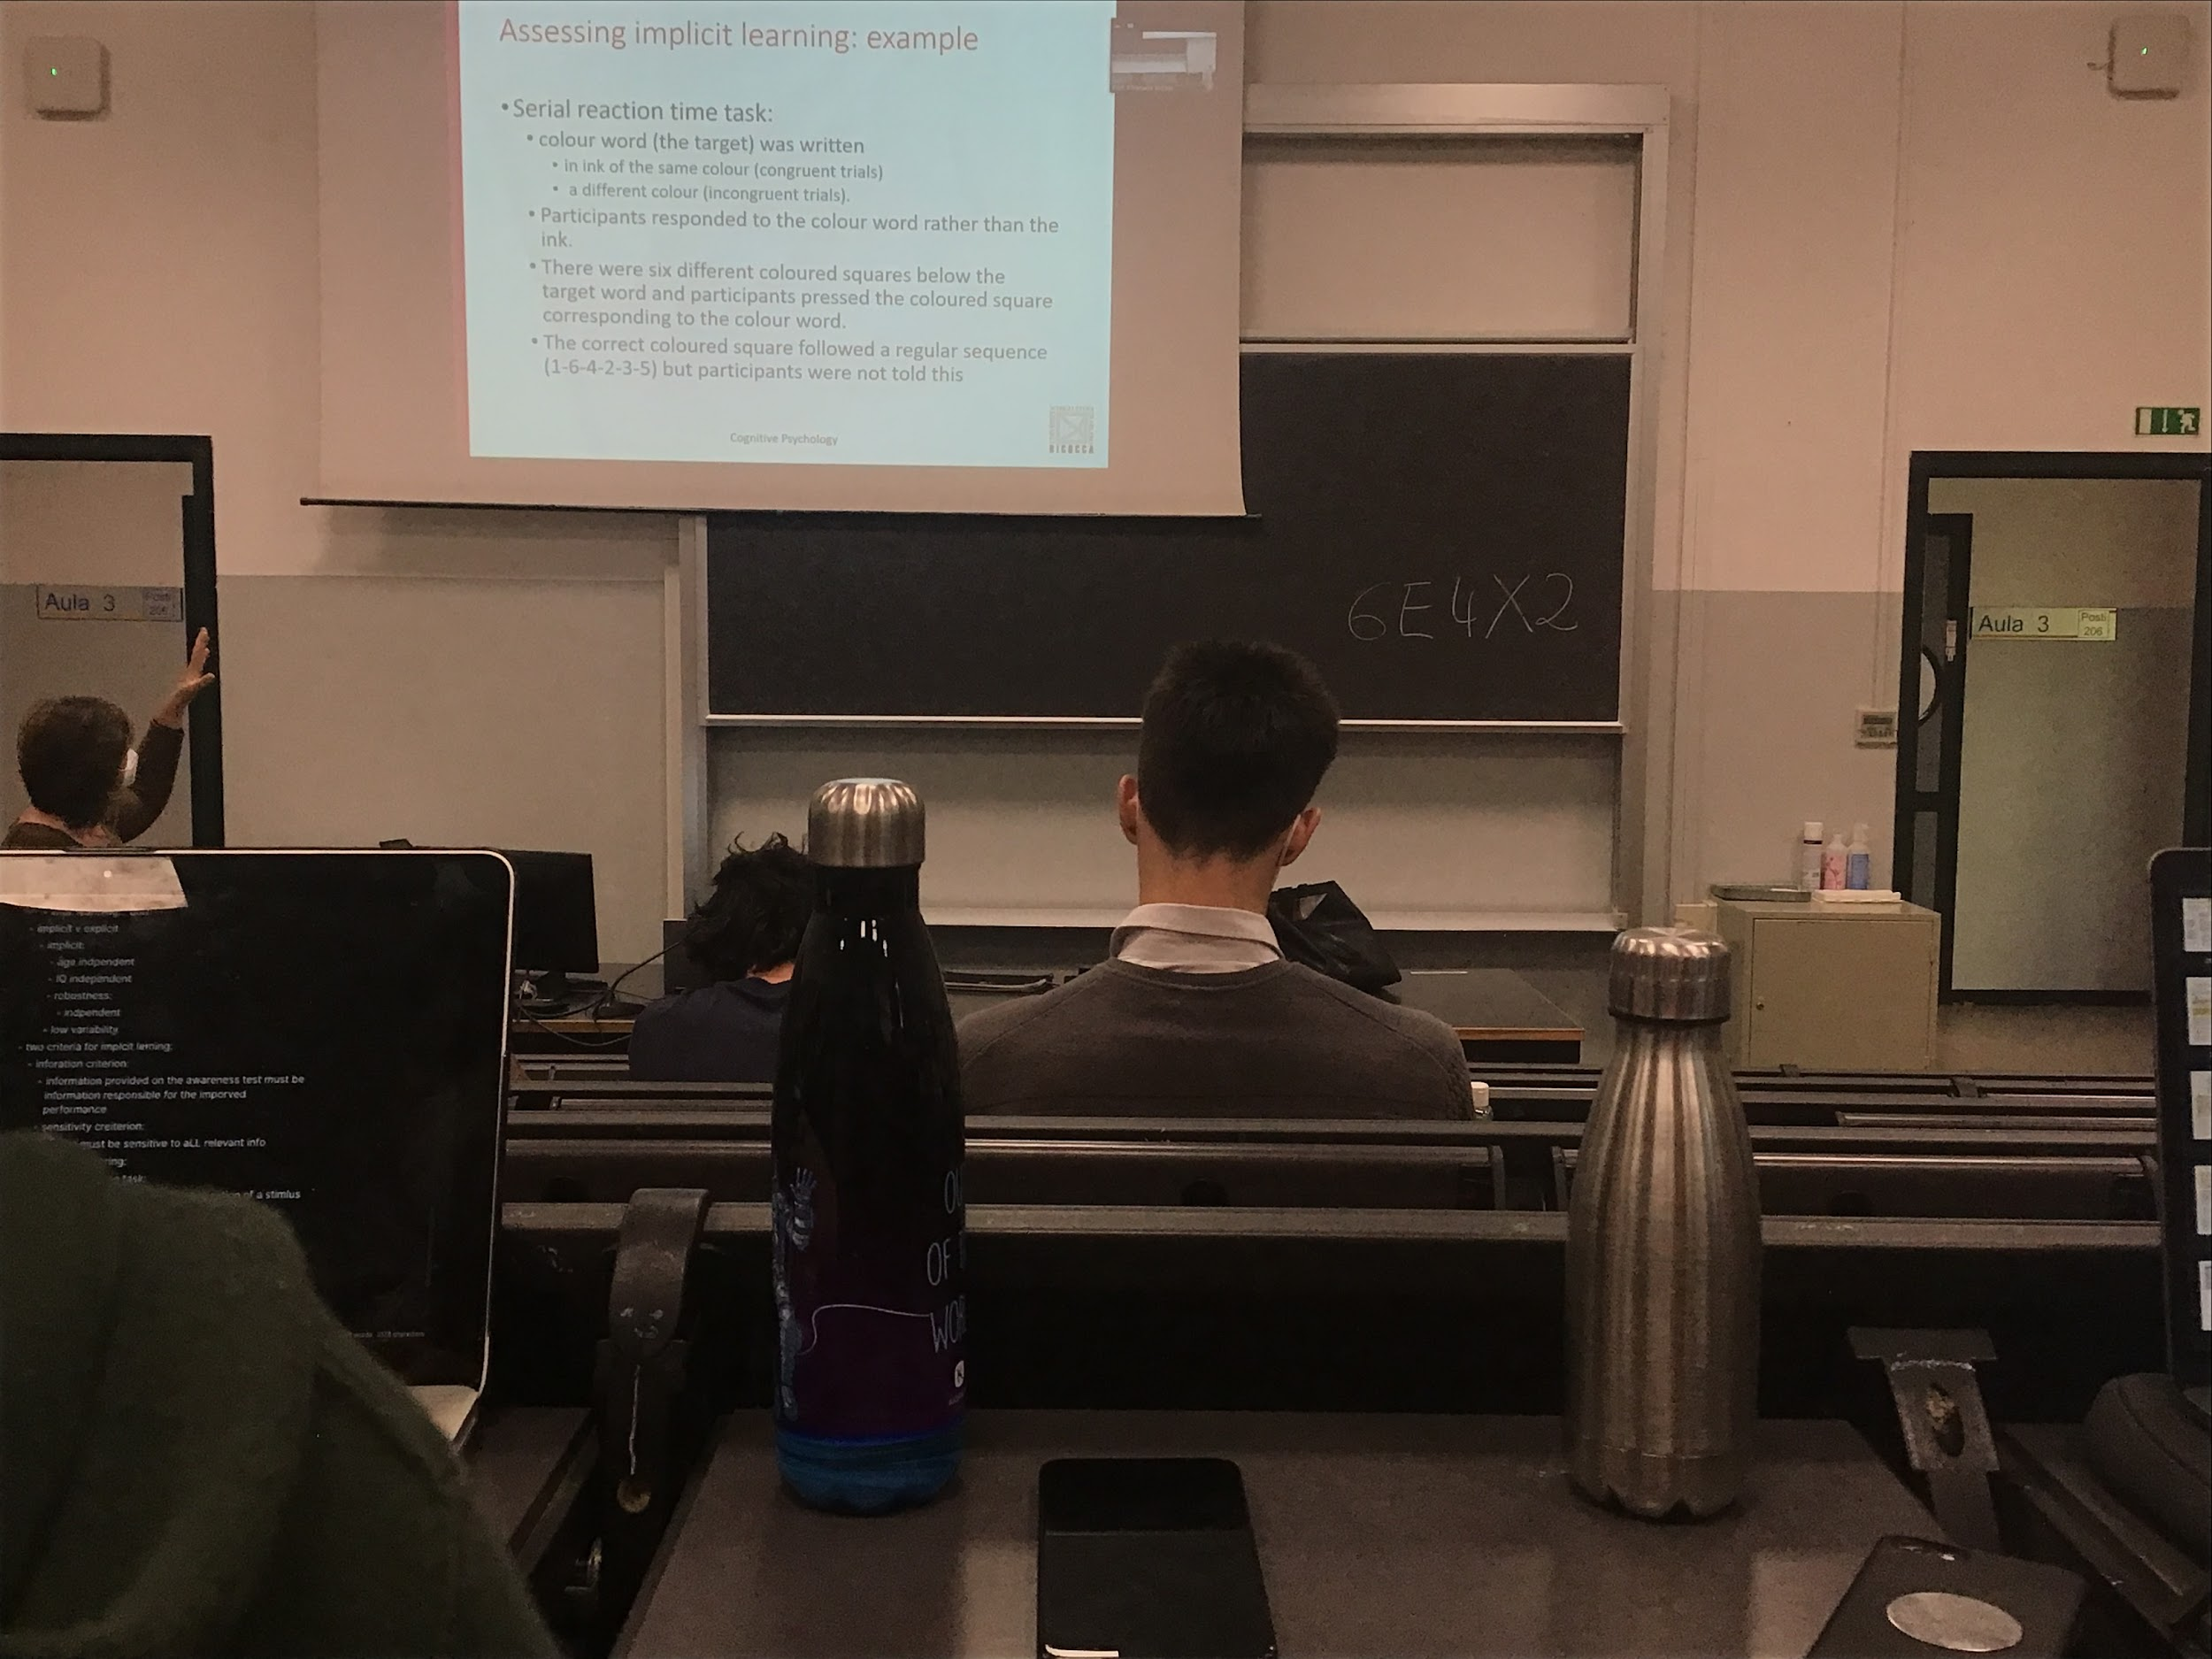

Experiment:

The word can be colour of the same ink (similar to stroop task), congruent trial (*blue* written in blue) or incongruent trial (*blue* written in red) you have to answer accordingly to the colour written and under the word there are some square and you have to press the one colured the same of the colour word

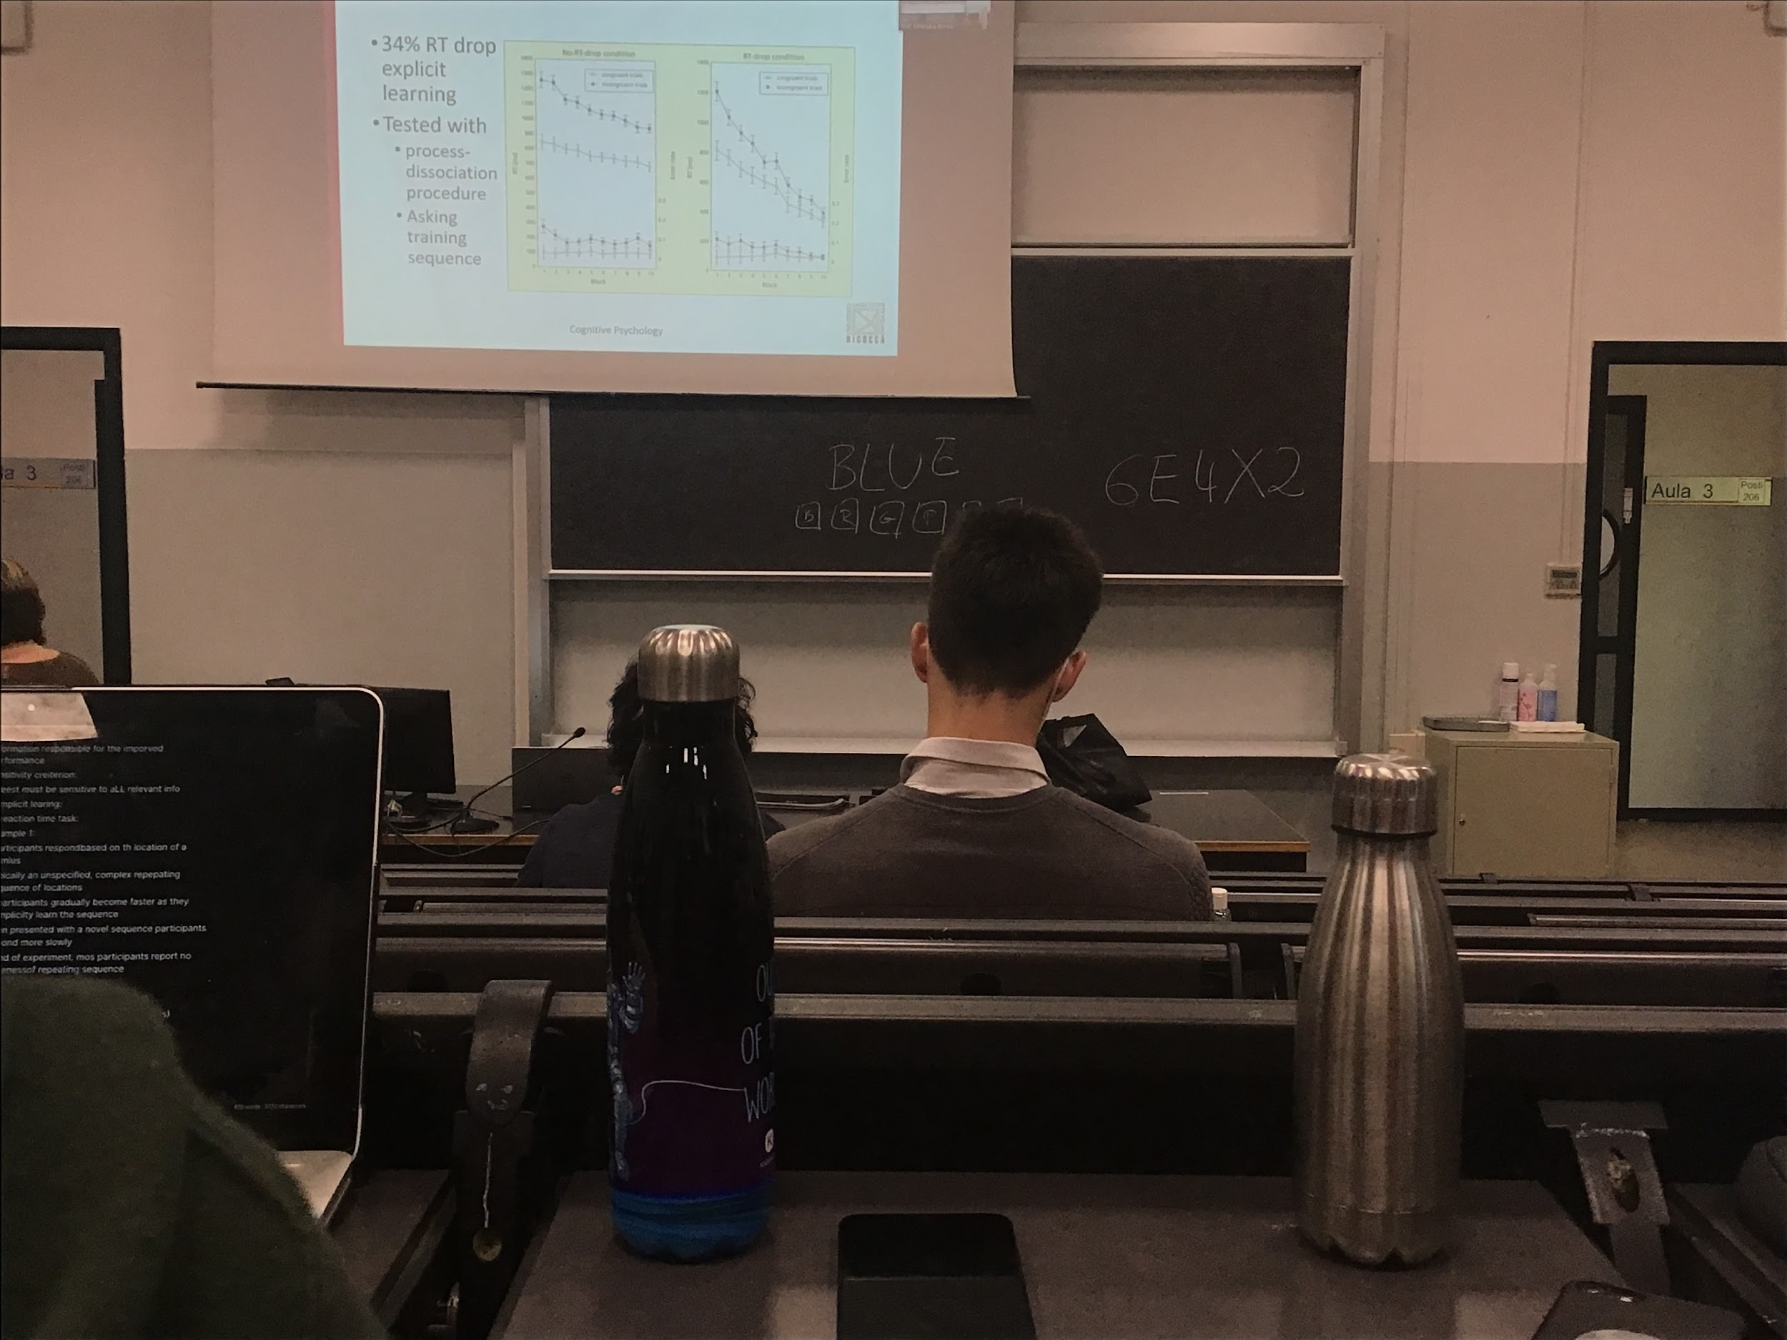

There was a regular sequence of colours, after the experiment you can group people by their performance

* Improve slowly with time.
* 34% improve their performance drastically. These people realised the sequence

Can have improvement of the performance even implicitly without being aware that we learned something. If there a difference between implicit and explicit learning we should have high differences in areas activated in the brain

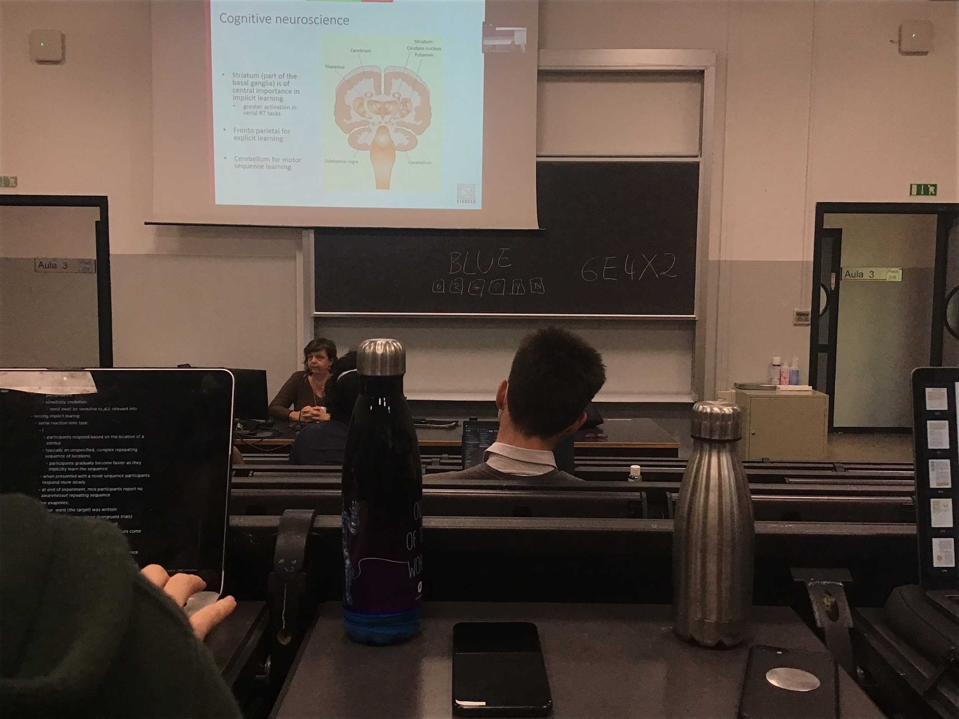

Find difference in the area activated in the brain

Striatum: oldest part of the brain, in this area there is activity when we implicitly learn tasks

Explicit learning: more activation in fronto parietal area

Cerebellum important specifically for sequence learning

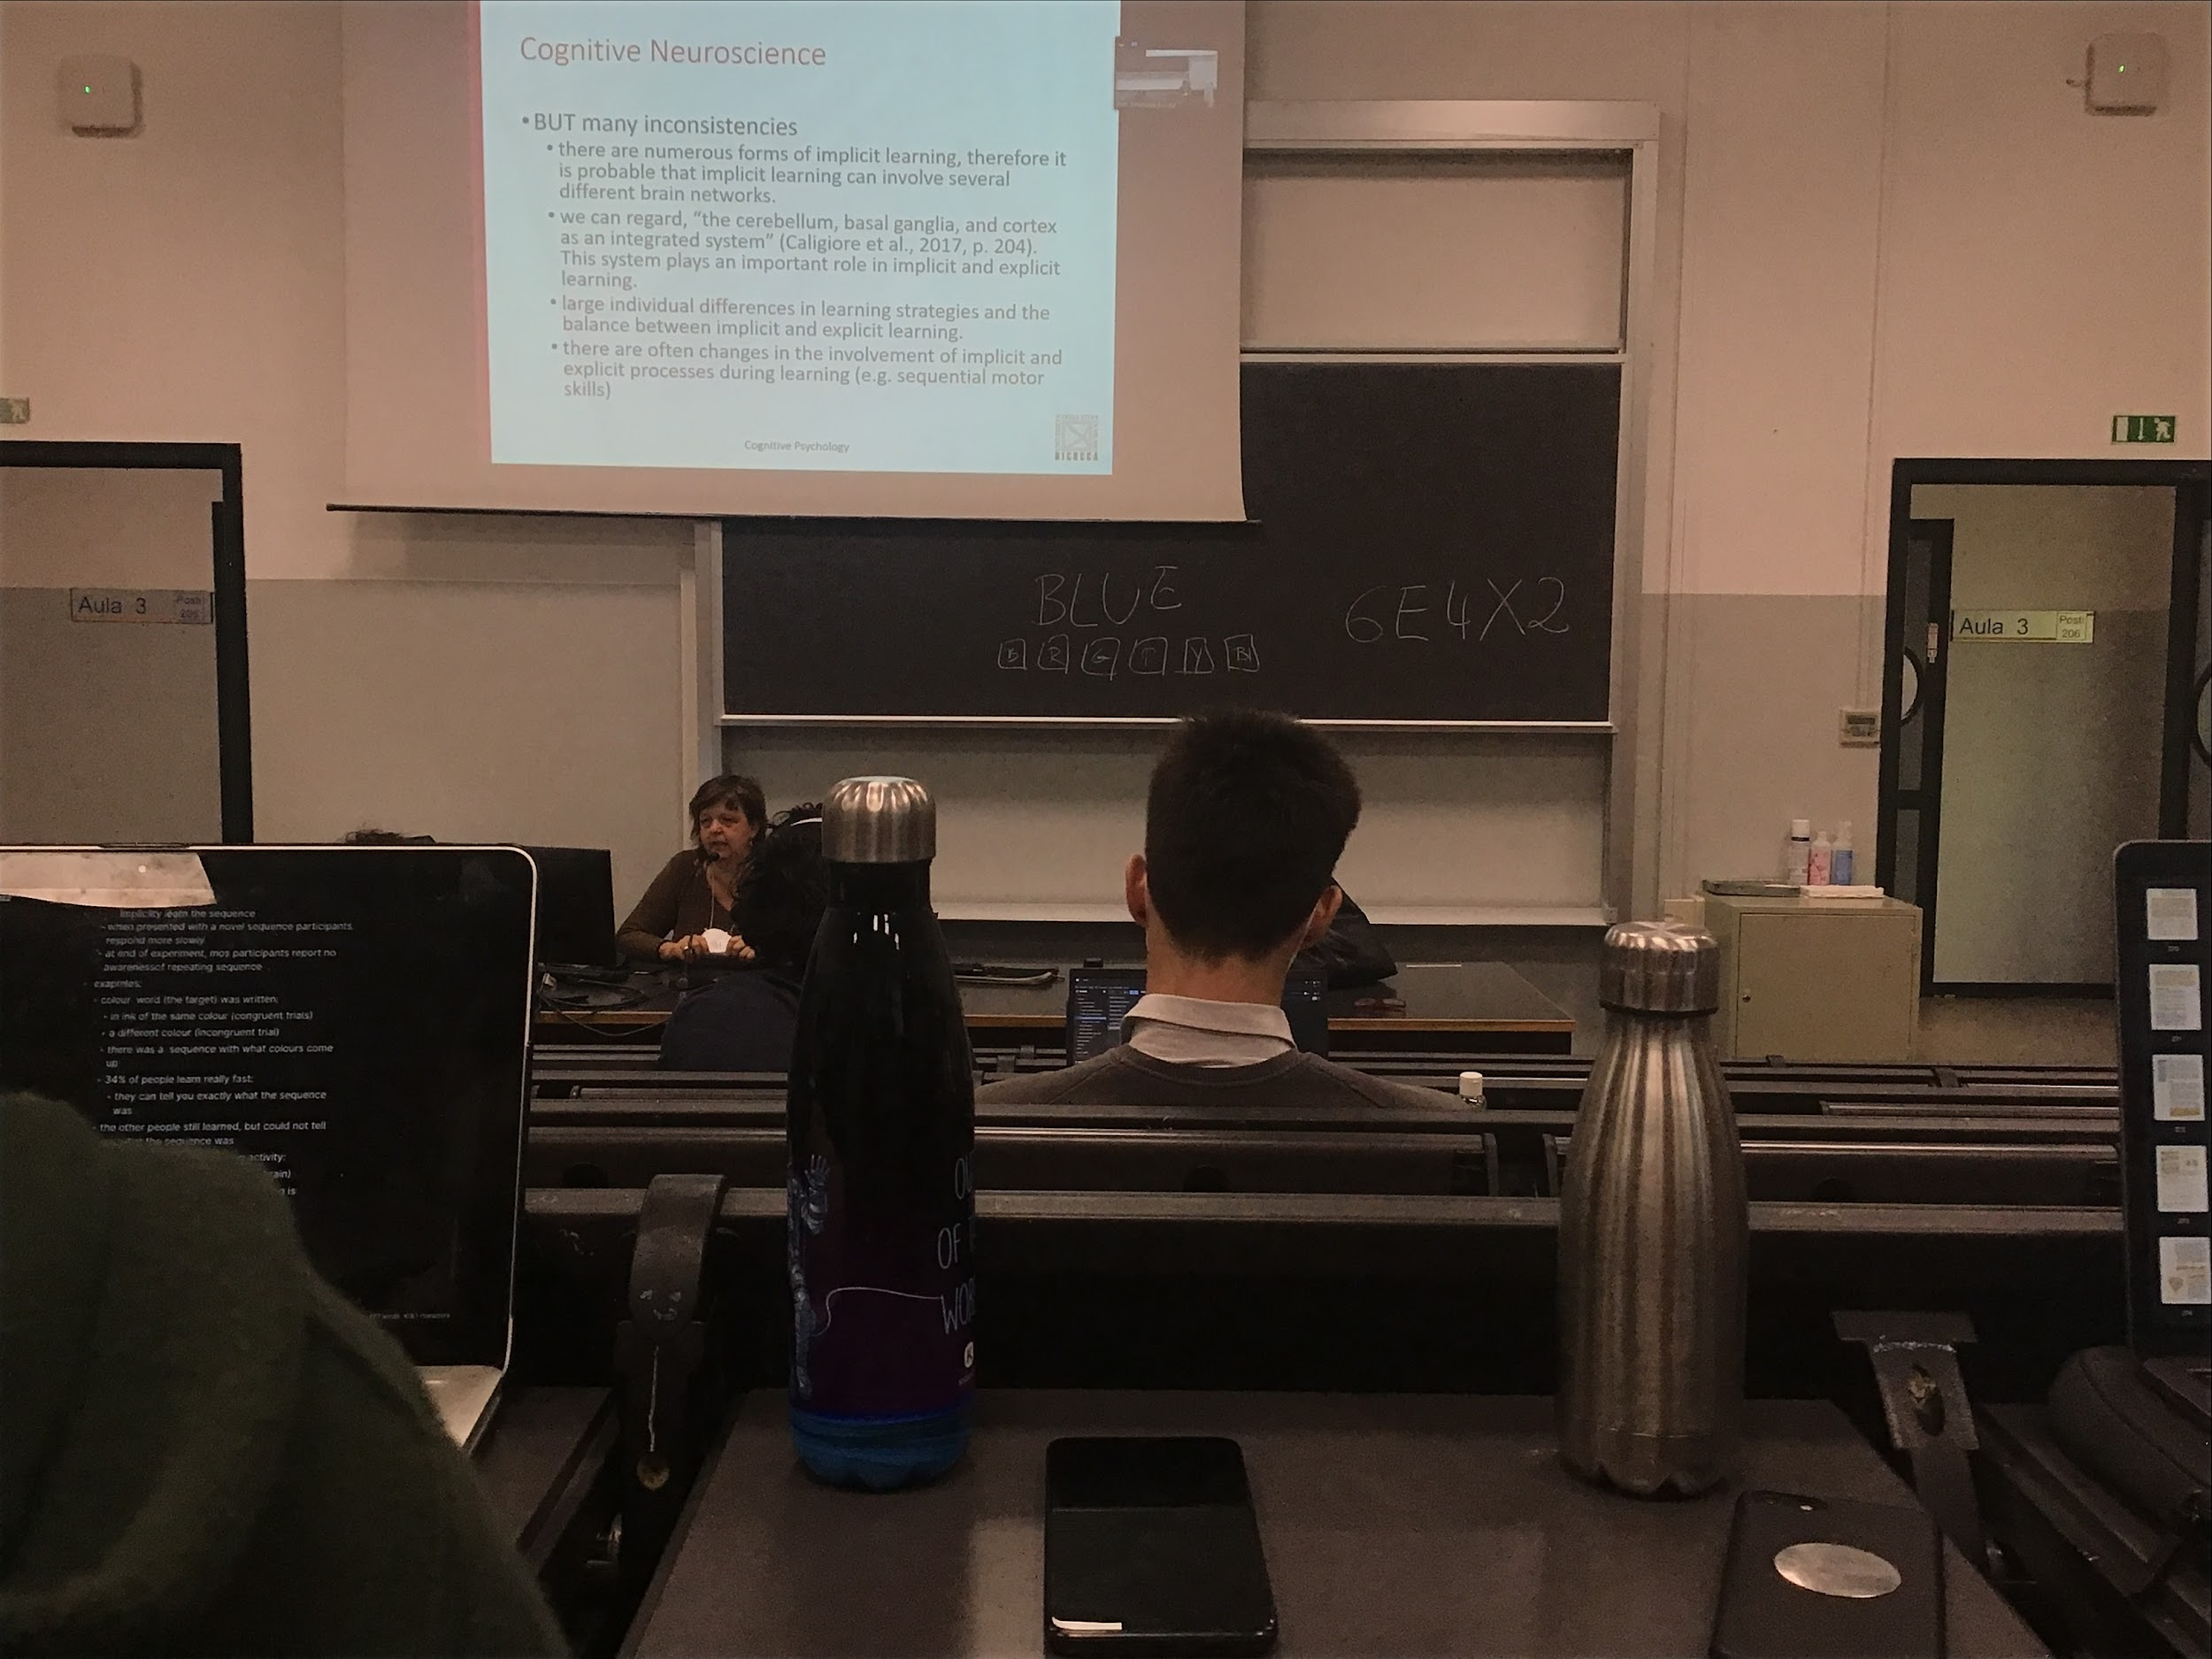

Implicit learning and explicit learning are different. They are coded in different areas of the brain. Probably interacts and activates partially the same areas. Also there are individual differences

Even **learning a given task can involve both explicit and implicit learning. At the beginning explicit and implicit at the end**

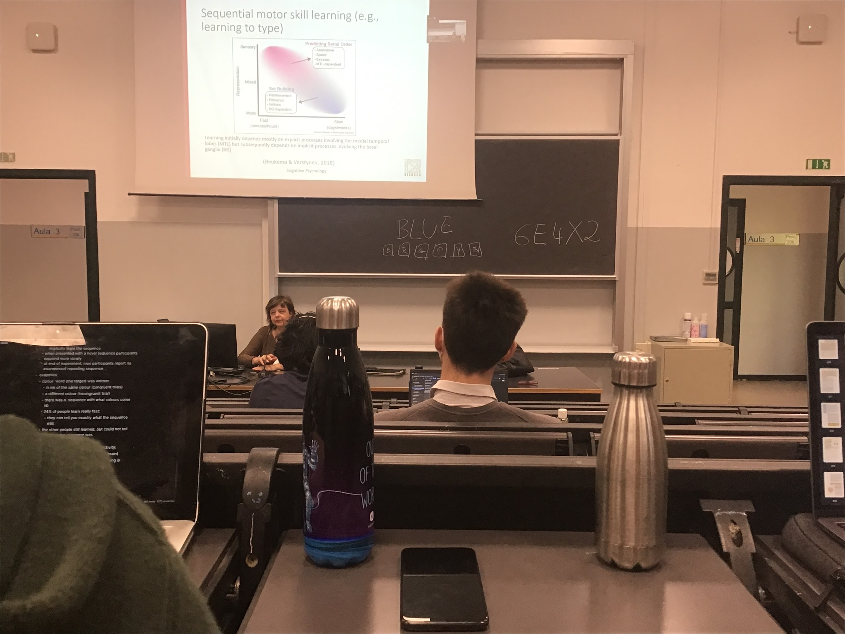

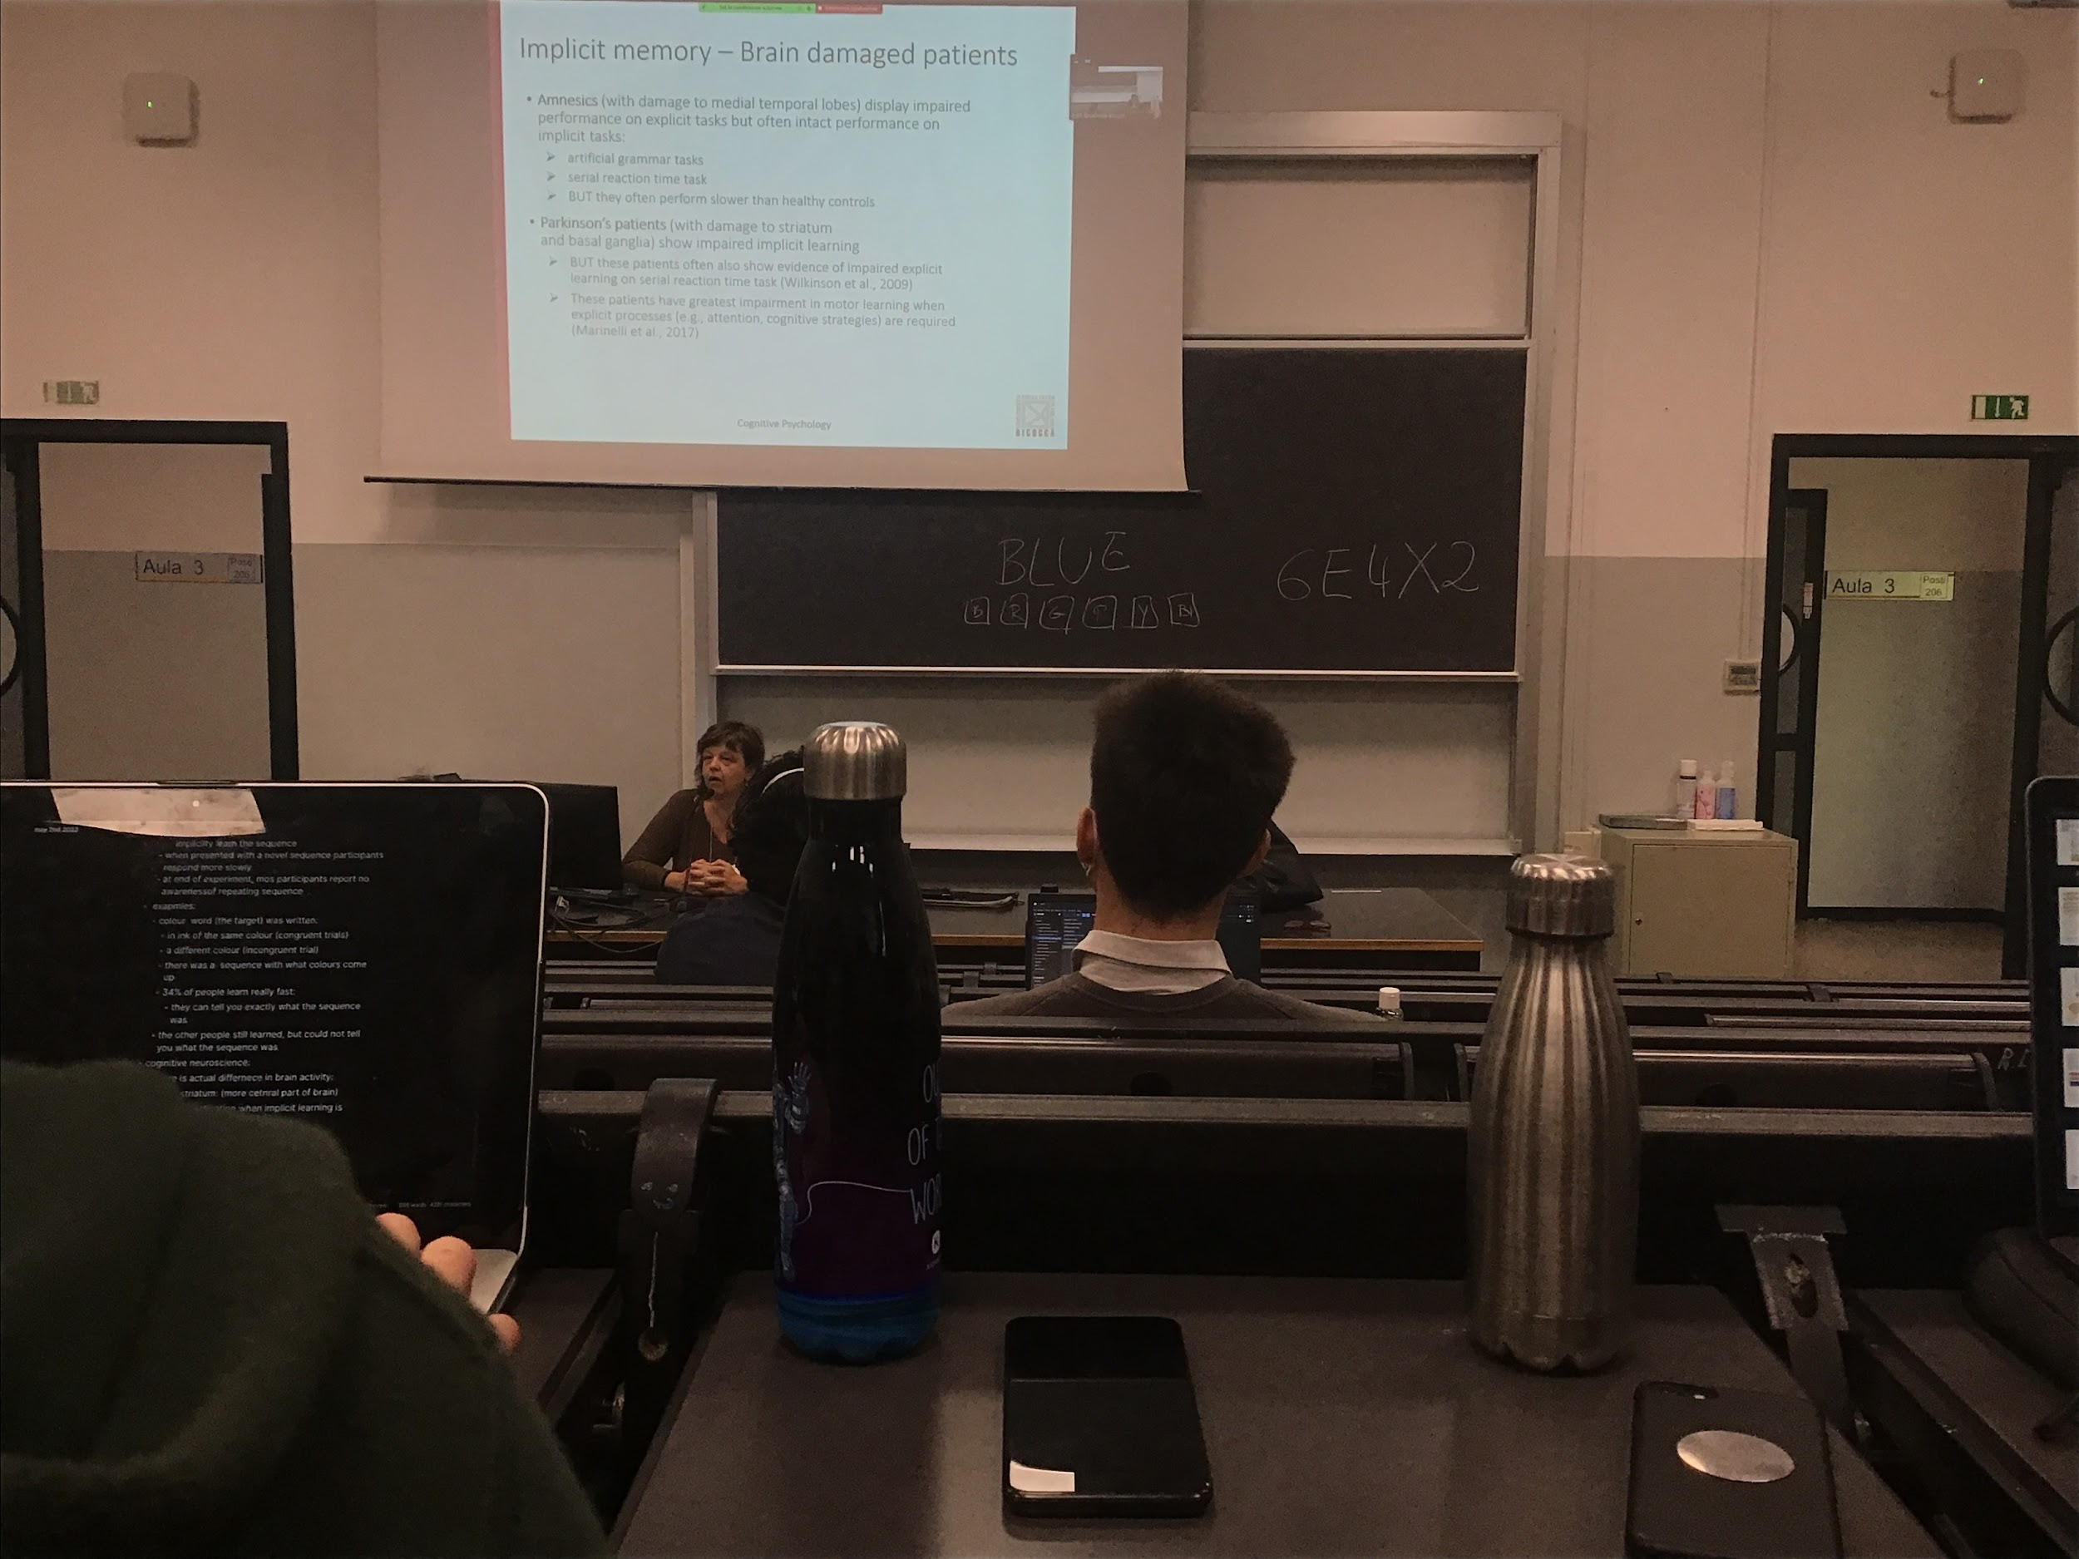

Amesnic can not remember new information. No explicit task. Often amnesia has an intact performance on implicit tasks. They can learn a series and improve their performance

Artificial grammar experiment:

Amnesic very good at it

You invent some kind of new language that follows some rules and you show correct sentences, present multiple examples. **People can tell you later if a new sentence is corrected or not, learn rules**

Amnesic do show some differences between explicit learning (that they can not do) and implicit learning

Experiment: drawing in the mirror, I show you a drawing (like of a star) you have to follow with your fingers, but you don’t see the star in front of you, since mirror do opposite way, learn the opposite association to be able to follow the image

Amnesic have some problem with implicit learning too, slower that normal people

Parkison patients: damage basal ganglian, show impared implicit learning but difficulty in starting movements and produce smooth movements

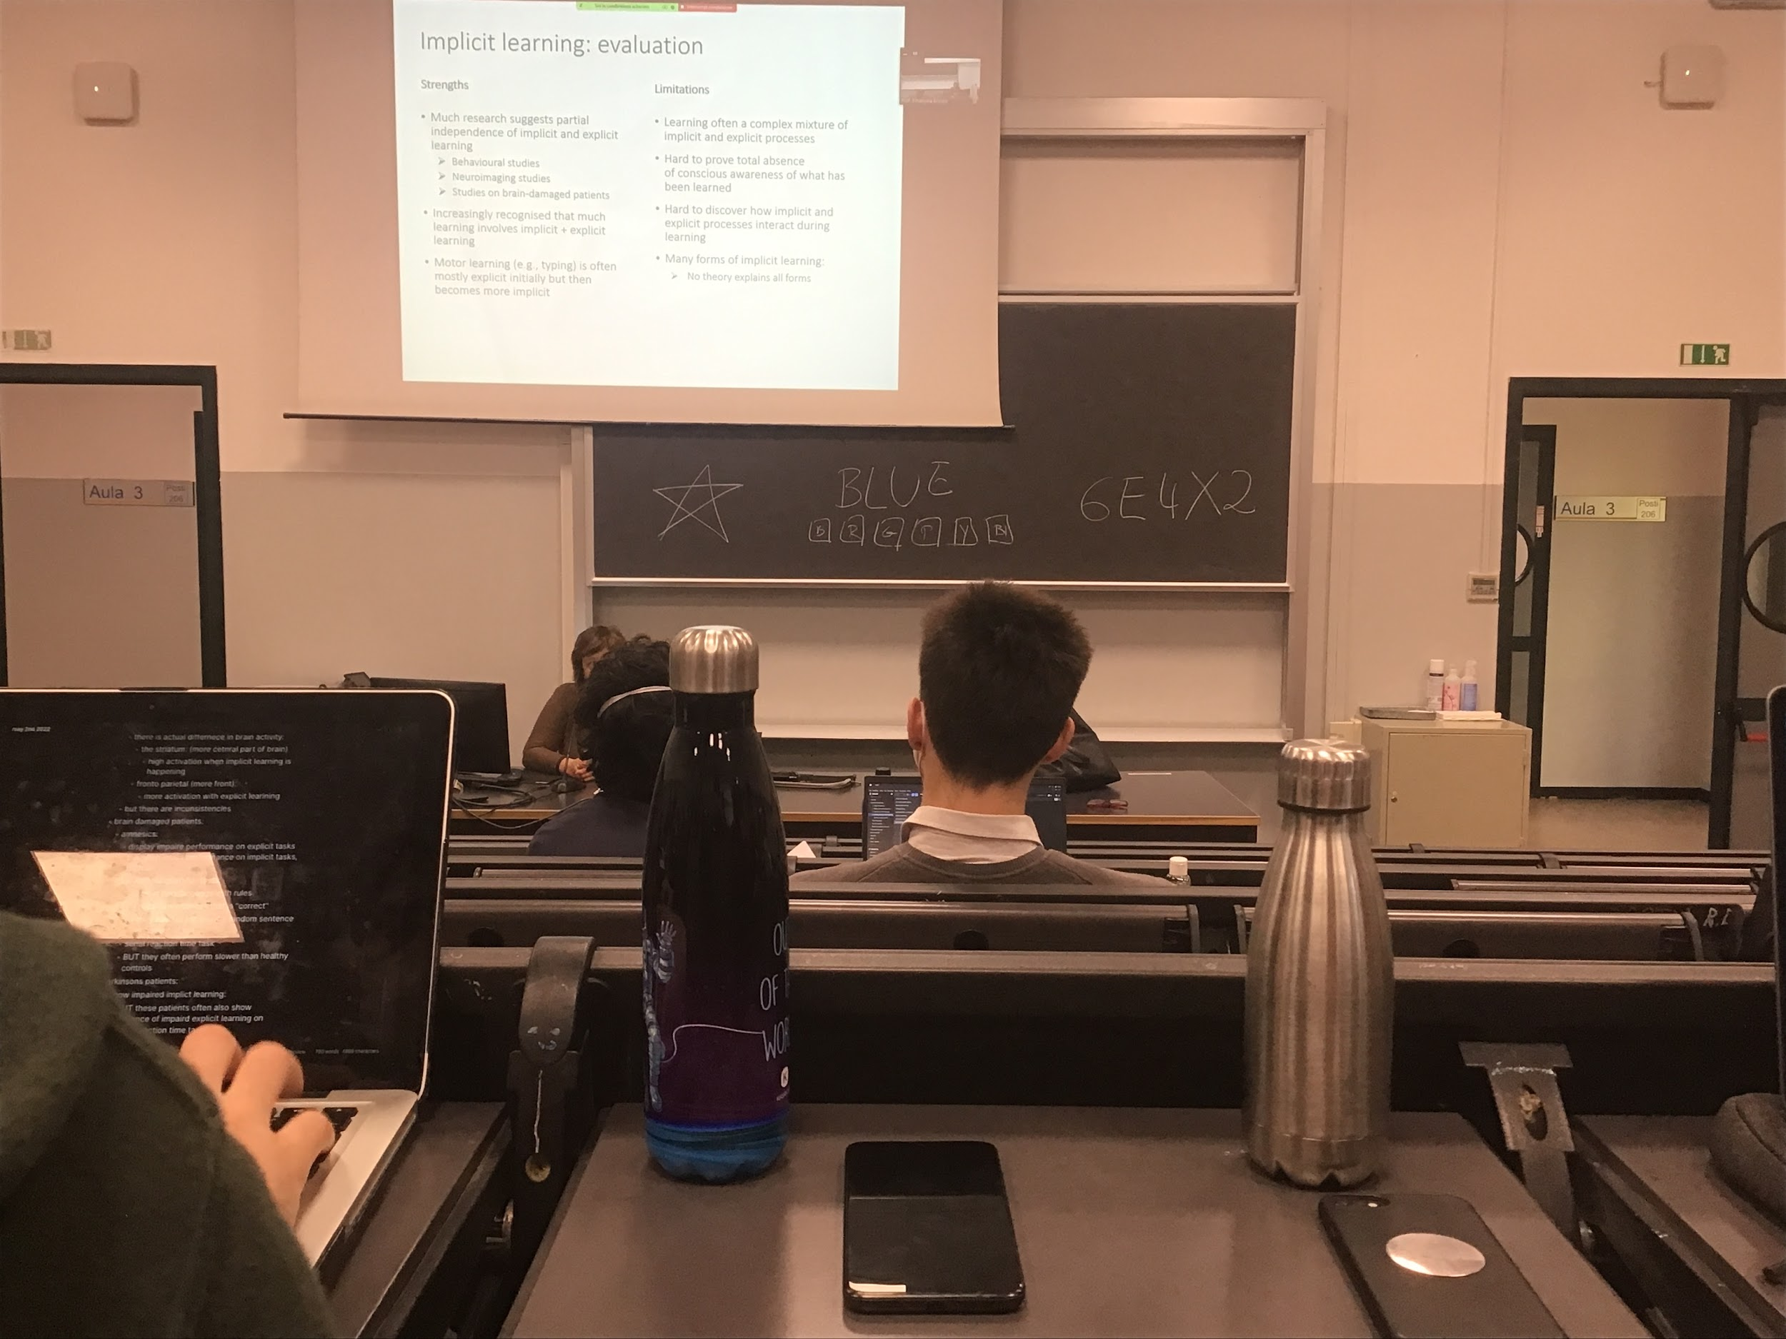

We can learn both implicit and explicitly, we can learn rules, learn support by different studies, not strictly separate type of learning, always a mixture of the two and in the specific case of motor learning (driving…) the beginning is explicit and then it modifies and get implicit

Not clear some parts: difficult to understand the interaction between implicit and explicit. Implicit learning is important, saving time and energy in reasoning. Once you learn to drive you can drive and do something else, at the beginning it is difficult. When you know an information implicitly you can spare time doing that specific task and do something else

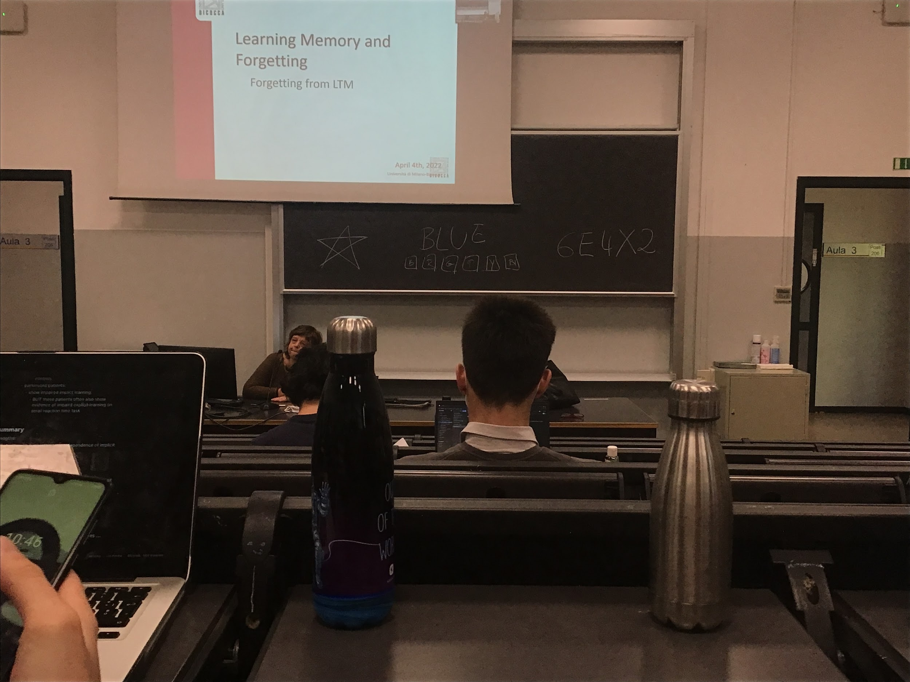

Naturally we forget

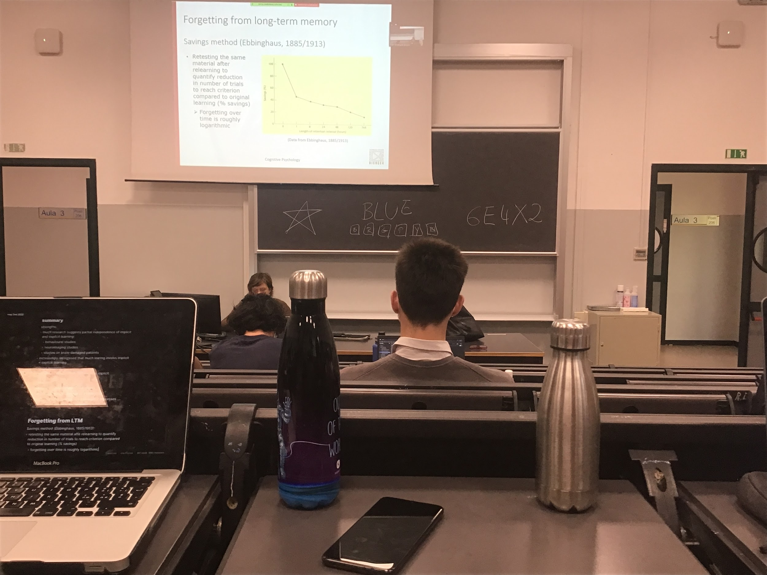

Ebbinghaus studied forgetting, experimenting only on himself.

Experiment: learning a list of 20 words (that do not make senses connected) to be able to repeat the sequences takes 100 trials. The second time after 1h I need only 40 trials, in time I need less and less repetition to remember the list. Forgetting curve is logarithmic

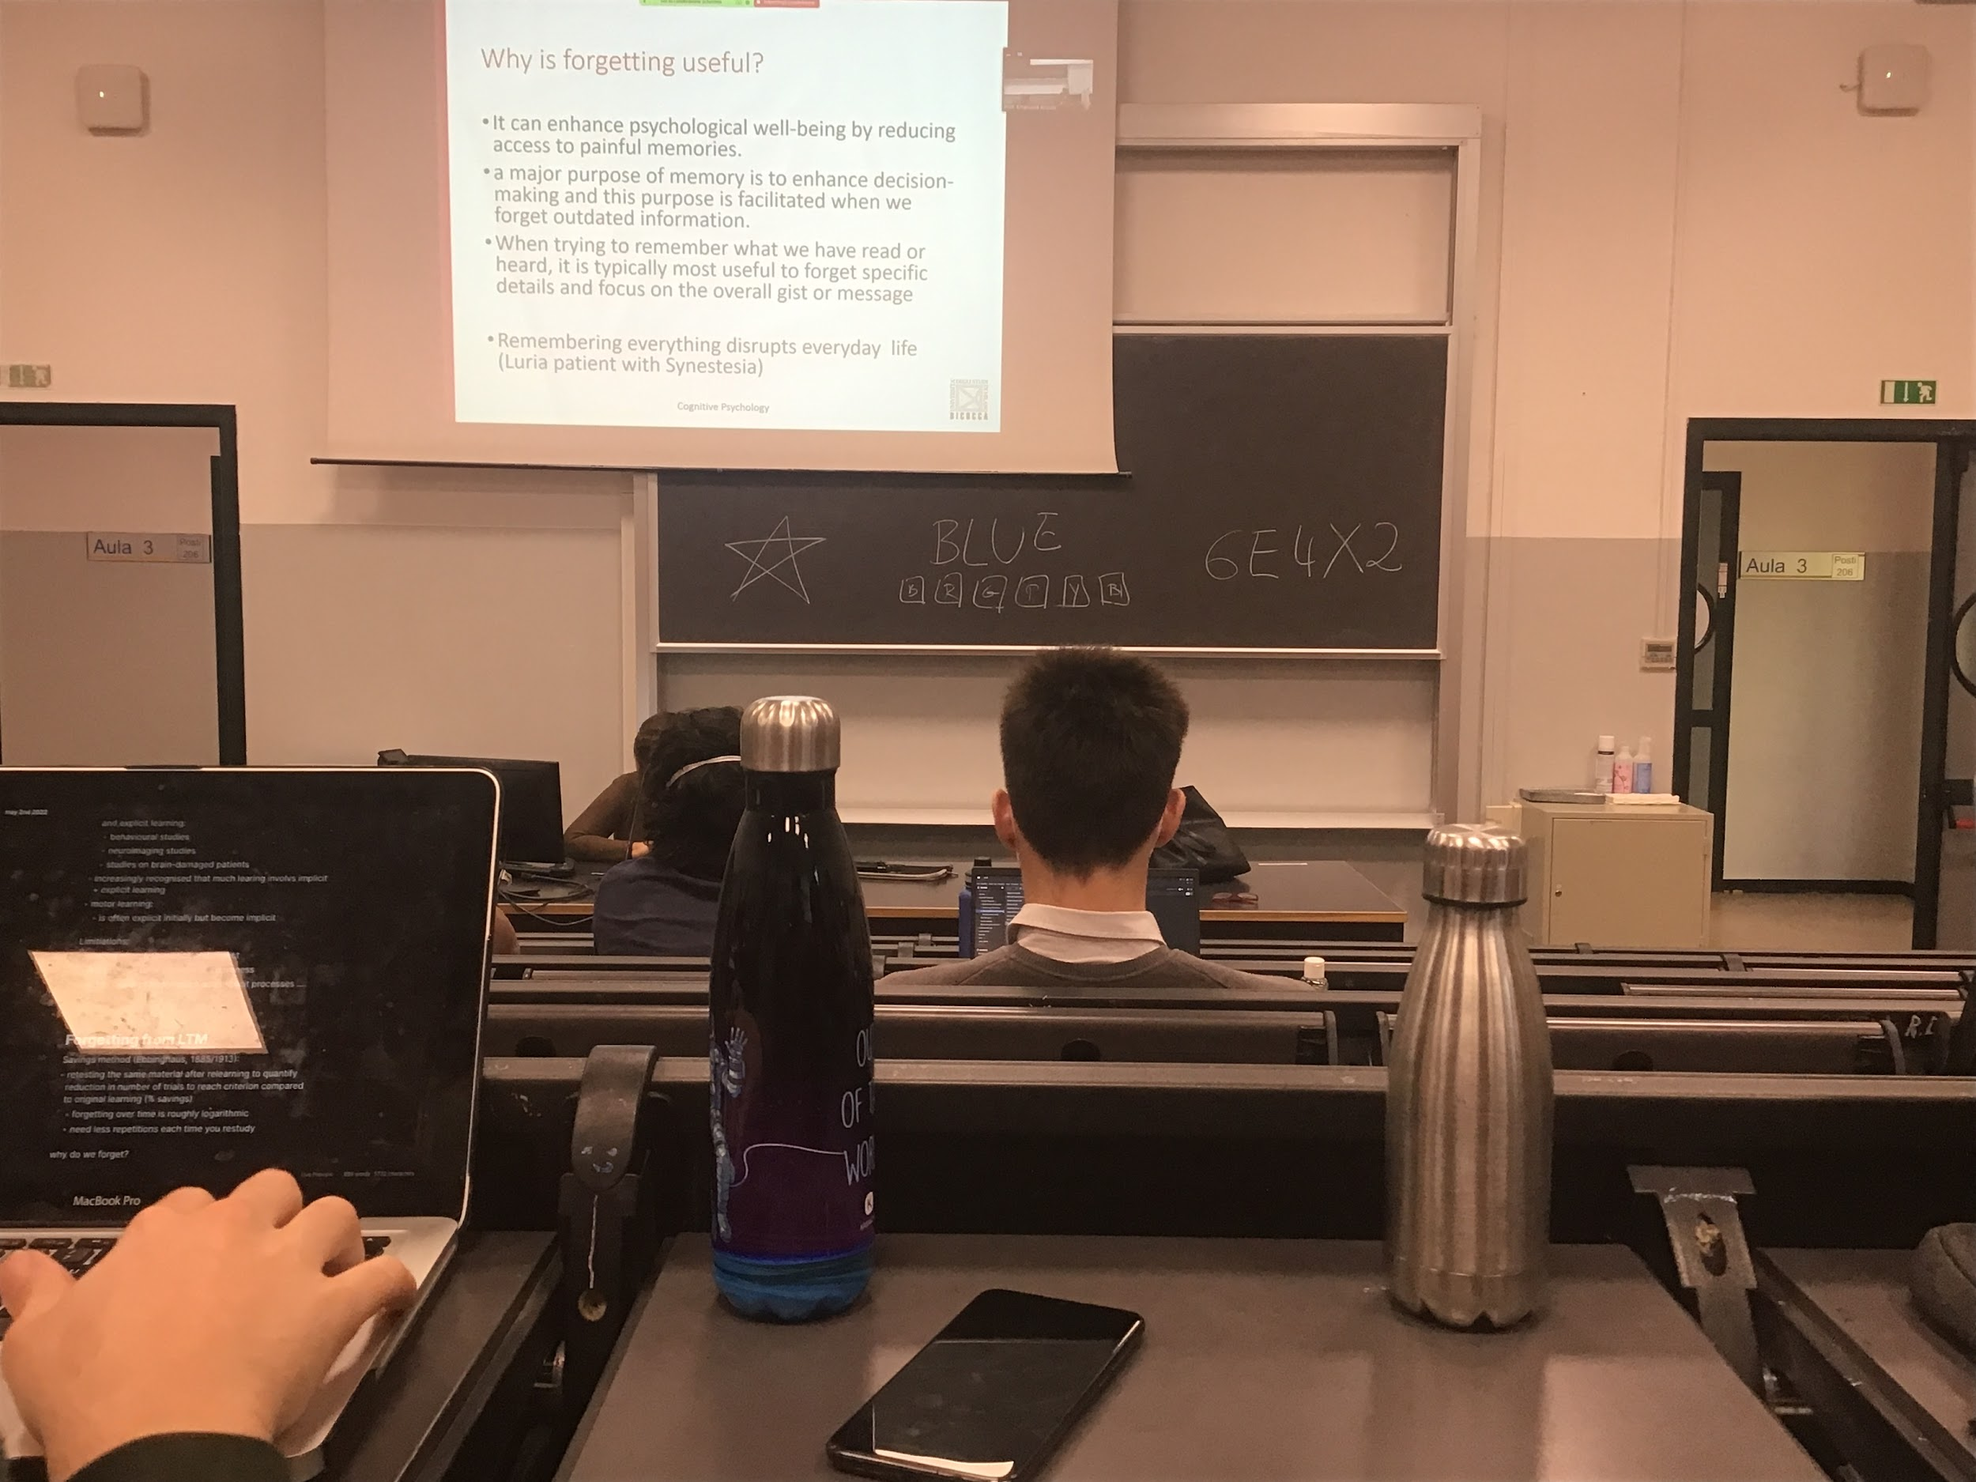

**Forget useful in many ways**, make our life easier, forget pains…

Need to remember things, need to use it to perform well in our activity

**Important to forget what is not useful**

Important since in any single time we have to make a decision, all outdated information should be lost

Most of the time what we are interested in is not the specific detail. Don’t need to know all the words in a book, need to know the concept, the gist of a scene

There are some **people with deficit that remember every single details**

Patient with strong association, the guy ended in a the asylum too much information, impossible for our brain to deal with all information

Forgetting make our life livable

**Forget faster explicit information than implicit information**. If you learn to ride a bike you can not ride for years but you are able to write even after many years. You don’t remember everything that you studied in 5th grade

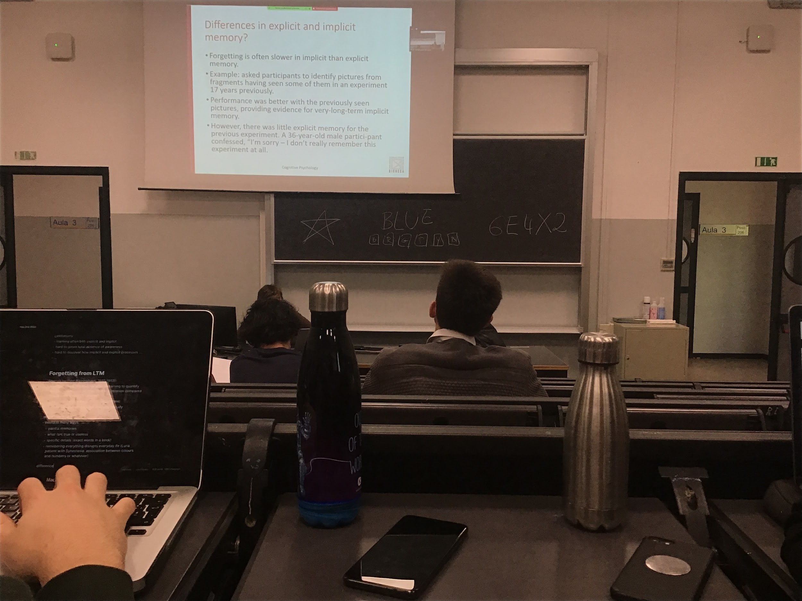

Experiment:

Recall people after 17 years after they took a test about pictures. If you show to the same people a fragment of the image they saw, these people could better classify the pictures they saw 17 years ago, even if they do not remember having performed the experiment. Some knowledge are in the brain can retrieve information

There is a difference in explicit and implicit memory

Explicit last less

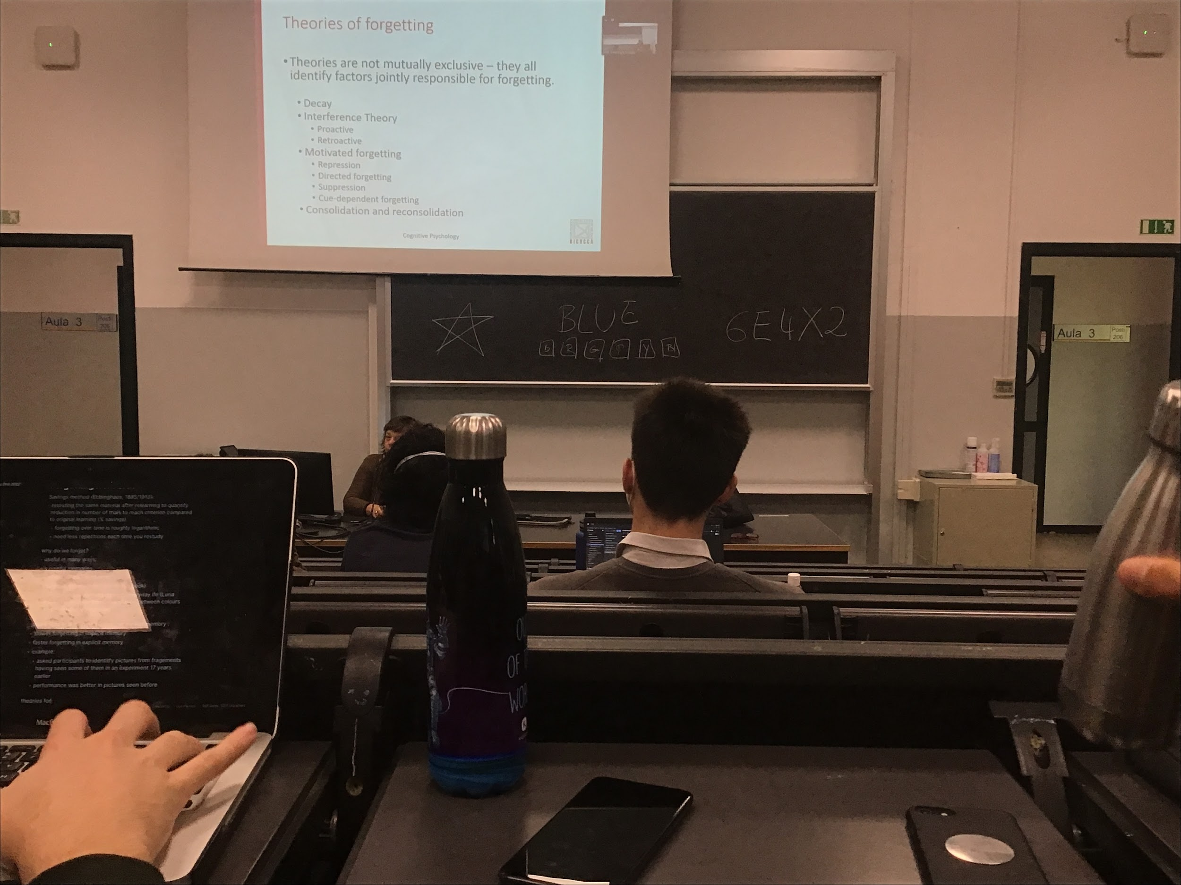

There are many theories about forgetting, not mutually exclusive, all work at the same time

* Decay: the trace loses its strength if is not active
* Interference
* Motivate forgetting
* Consolidation and reconsolidation

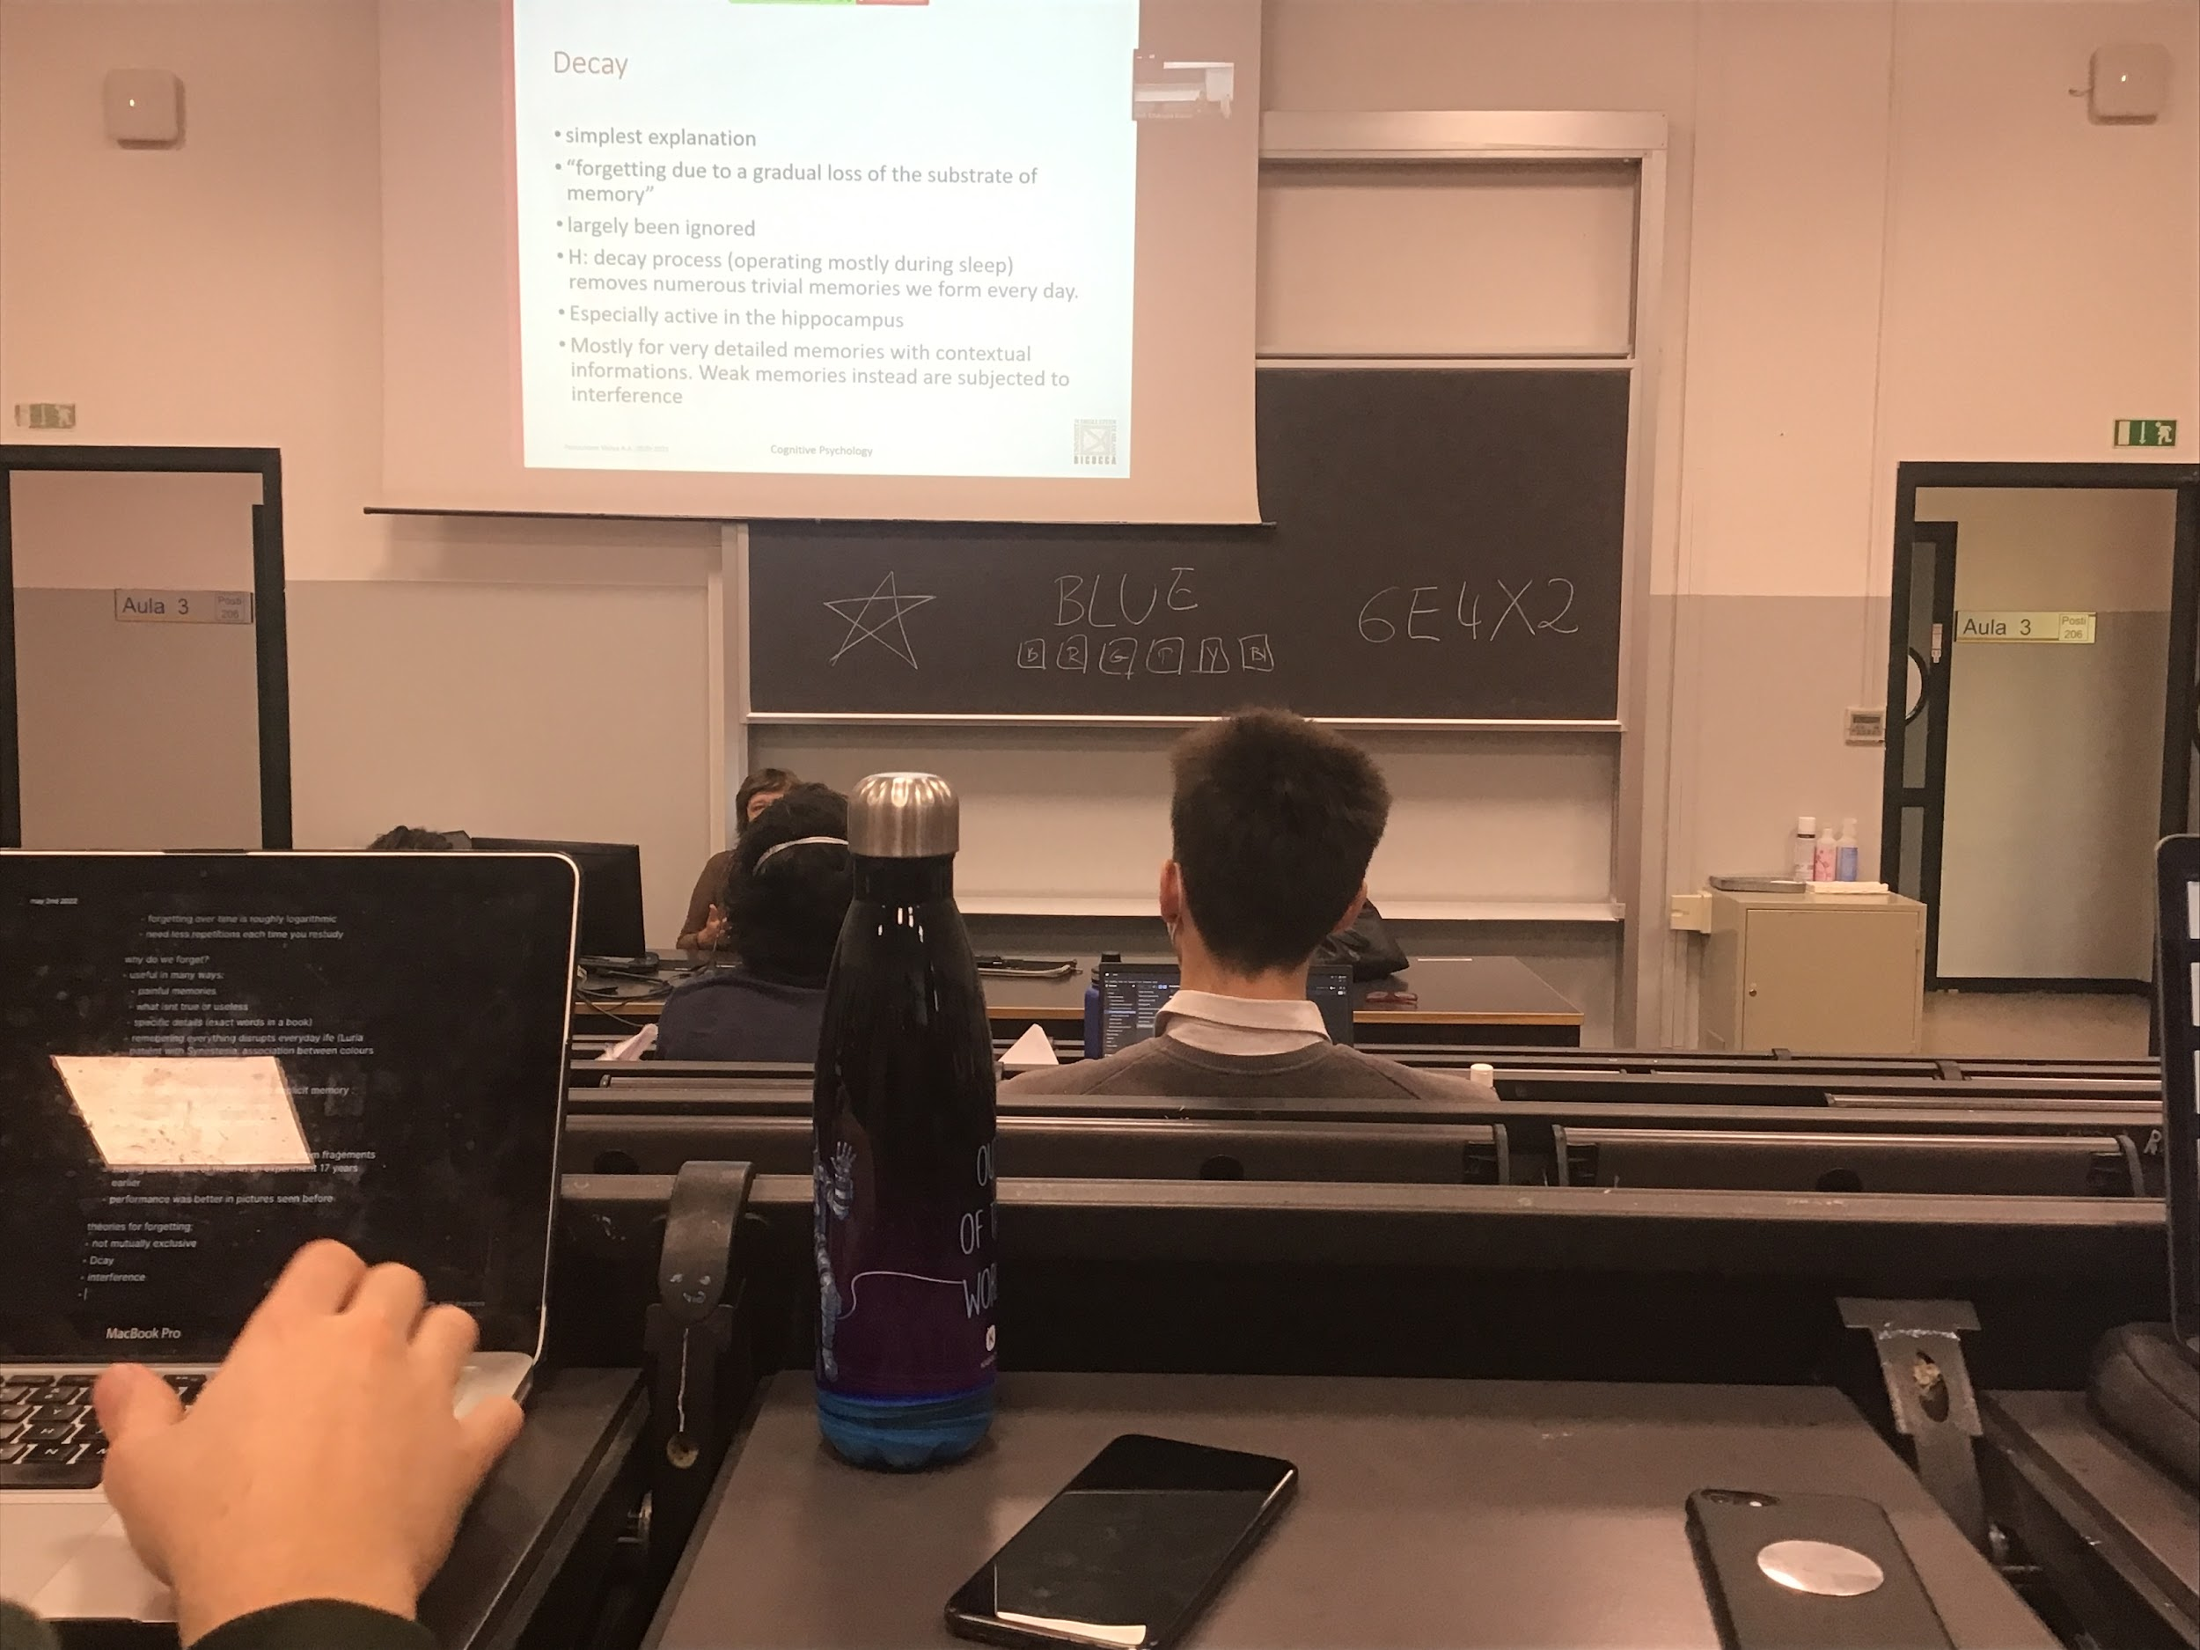

Decay: simplest explanation. Gradual loss of information when is not coded, very little studied.

It removes all details that one single day they are not important, **mostly work during sleep**. The hippocampus (low level part of the brain) is activite, we lose the details of the memories. I am able to repeat a sentence that I just heard. But in 1 hour I will remember what it was saying in general but not the specific words. Lose the detail information of what you have stored